Title of Thesis

Felipe Zapata

Contents

Preface i

Acknowledgements ii

Abstract iv

Chapter 1: Introduction 1

Chapter 2: Methods 6

**2.1** **Molecular Dynamics** 7

**2.1.1** **Born-Oppenheimer Molecular Dynamics** 9

2.1.2 Non-Adiabatic Molecular Dynamics 11

2.1.3 Classical Molecular Dynamics 12

2.2 Electronic Structure Methodologies 19

2.2.1 The Complete Active-Space Self-Consistent Field Method 20

2.2.2 Density Functional Theory 22

2.2.3 Crossings between Electronic States 23

**2.3** **Spectroscopic Properties** 26

2.4 Interpolation Methods 28

**2.4.1** **Quadratic approximation** 28

**2.4.2** **Multicenter Interpolation Methods** 30

2.5 Geometry Optimization 30

2.6 Programming Methods 31

2.6.1 A brief Haskell tour 32

**2.6.2** **Parallelism and concurrency** 36

2.7 Software in Quantum Chemistry 37

2.8 Electronic Structure Packages 38

Chapter 3: Aims 45

Chapter 4: Triplet Energy Transfer 48

**4.1** **Introduction** 49

**4.1.1** **Energy Transfer Mechanisms** 49

**4.1.2** **Energy Transfer Reaction Coordinate** 51

**4.1.3** **Energy transfer Processes** 52

4.2 Results 53

4.2.1 Definition and determination of the triplet-triplet energy transfer reaction coordinate 54

56

**4.2.2** **A Dynamical approach to the triplet-triplet energy transfer reaction coordinate** 64

**4.2.3** **Triplet energy transfer space** 64

Chapter 5: Optomechanical Control of Spectroscopy Molecular Properties and Photoinduced Mechanical Work 74

5.1 Introduction 75

5.1.1 Mechanochemistry 76

5.1.2 Molecular Switches and Motors 77

5.2 Results 78

5.2.1 Structural Substituent Effect 78

5.2.2 Towards an Optomechanical Control of Photoswitches by Tuning the Spectroscopical Properties 90

5.2.3 External forces effect on the photochemical reactions 104

5.2.4 Design of molecular devices 104

Chapter 6: PhotoChemical Dynamics 118

**6.1** **Introduction** 119

**6.1.1** **Chemiluminescence** 119

**6.1.2** **Modulation of Excited-State Properties of Fluorescent Proteins** 120

**6.2** **Results** 122

**6.2.1** **Revisiting the Non-Adiabatic process in 1,2-dioexetane** 122

124

**6.2.2** **QM/MM Simulations of IrisFP** 132

**6.2.3** **Excited State Intramolecular Proton Transfer** 135

Chapter 7: Summary and Conclusions 139

Chapter 8: Resumen y Conclusiones (Spanish Version) 142

8.1 Transferencia de Energía Triplete 143

8.2 Control Opto-Mecánico de Propiedades Espectroscópicas y Generación de Trabajo foto-Inducido 147

8.2.1 Control opto-mecánico 147

8.2.2 Interruptores y motores moleculares 148

8.3 Dinámica de Procesos Fotoinducidos 150

8.3.1 Quimioluminiscencia y bioluminiscencia 150

8.3.2 Estudios QM/MM de la irisFP 151

Chapter 9: Appendices 154

9.1 A General Molecular dynamics interface program: HsDynamics 154

List of Publications 157

List of Abbreviations 158

Table of Figures

Preface

Acknowledgements

First I would like to thank my supervisor, Professor Luis Manuel Frutos, for his guidance and support during this research and for encouraging me to do both science and software development. His patience and charisma have been .a well of inspiration.

The RESMOL group headquarters has provided a great environment to learn, talk about science and computers, discuss of politics and taste some good wines. None of this would have been possible without Professor Obis Castaño. I also want to thank the group members, especially to Cristina García-Iriepa, Alessio Valentini and Daniel Rivero, for all the constant feedback and interchange of ideas.

A special thanks to Professors Roland Lindh and Marcus Elstner, who kindly hosted me during my short research stay in their groups respectively at the University of Uppsala (Uppsala, Sweden) and the Karlsruhe Institute of technology (Karlsruhe, Germany).

I would like to thank my friend Angel Alvarez, whom is the one responsible for introducing me to the world of computer science.

Also I would like to thank my friend Marco Marazzi for his invaluable help and constant support.

I thank my mother and aunts, for their love and support.

Finally my gratitude and love to Natalia, for all her support.

*To my*

*Mother*

Abstract

In this thesis we present a set of theoretical methodologies focus on photophysical and photochemical phenomena, which were implemented and subsequently applied to a collection of chemical and biological relevant systems.

The developments and applications are divided in three sections which are: energy transfer, Optomechanical control of spectroscopical molecular properties and photochemical dynamics.

In the energy transfer section it is tackle the problem of finding which molecular coordinates modulates more efficiently the triplet energy transfer, together with a dynamical approach to the energy transfer at constant temperature.

The optomechanical section contains a discussion on the effect of the external forces over the electronic gap between two states, being the external force interpreted both as the substituent effect on a reference compose or a mechanical external force. Subsequently it is considered the design and operation of molecular motors, control by light irradiation.

Finally, the photochemical dynamics section firstly deals with the static and dynamical characterization of a minimal molecular model to study the phenomena of chemiluminescence and bioluminescence. Then the preliminary results of the simulations of fluorescence in the IrisFP are shown.

Additionally, it was develop a set of programs focus on modularity, parallelism and readability, aiming to perform the numerical simulations described in this thesis.

# Introduction



“...how do we know what the ultimate good of Humanity will entail? We haven’t at our disposal the infinite factors that the Machine has at its! Perhaps, to give you a not unfamiliar example, our entire technical civilization has created more unhappiness and misery than it has removed. Perhaps an agrarian or pastoral civilization, with less culture and less people would be better. If so, the Machines must move in that direction, preferably without telling us, since in our ignorant prejudices we only know that what we are used to, is good — and we would then fight change. Or perhaps a complete urbanization, or a completely caste-ridden society, or complete anarchy, is the answer. We don’t know. Only the Machines know, and they are going there and taking us with them.”

*I, Robot. Isaac Asimov*

*In the picture: Alan Turing slate statue at Bletchley Park museum*

In nature everything is in motion, change is the only permanent thing and we as humans try to understand the principles that govern such behaviour. In doing so, we create our own mental universes where we are free to subdivide the whole natural system into swallowable pieces. Once we have defined the boundaries of the subsystem of interest, we then endow the system with several ideal features (e.g. thermodynamic equilibrium, adiabatic electronic states, etc.) which allow us to reproduce some measurable properties using a mathematical framework.

This Ph.D. Thesis is then framed in the context of dynamical simulation of photoinduced physical and chemical processes. Where the Born-Oppenheimer approximation is the basic theoretical support for the developments presented in this work. Together with it, Hamiltonian and non-Hamiltonian dynamical simulations were carried out to obtain statistics belonging to either microcanonical (NVE) or canonical ensembles (NVT).

In order to establish a framework in which the arguments of the present work are expanded, it is initially presented a chapter with a brief survey of the main methodologies used, as they are the Born-Oppenheimer molecular dynamics and the electronic structure methods. Also there are included the methods used to interpolate potential energy Surfaces (PES) as an alternative to expensive “on the fly” molecular dynamics. Finally in this methodology chapter is discussed the programming methods applied in the implementation of the discussed algorithms.

The set of problems tackle in this Thesis are divided in three chapters. In the first part it is studied the energy transfer phenomenon, specially the triplet-triplet energy transfer (TET). While the second chapter explores the control of spectroscopical properties through the application of external forces, together with the design of molecular devices which can generated work as a part of a photoinduced process. Finally the last chapter deal with photochemical process as are the bioluminescence and the transformations that take place during the fluorescence emission in the fluorescent proteins, specially the IrisFP.

Triplet-triplet energy transfer is the most common and most important type of energy transfer, for instance in photosynthesis and energy transfer in molecular wires (Barigelletti and Flamigni 2000, Fraser, et al. 2001, Speiser 1996, You and Hsu 2011). Also, it is worth to notice that in the development of organic and polymer light-emitting diodes (OLEP/PLED), where triplet formation leads to a significant reduction in the theoretical efficiency of the device, being the modulation of triplet-triplet energy transfer a main objective in its improvement (Vura-Weis, et al. 2010). It has been previously postulated that some molecular distortions of both donor and acceptor moieties involved in the process, lead to change in the amount of energy transferred, accounting for the experimental rate measures of TET and suggesting the possibility to module it (Frutos and Castano 2005). Since the early sixties it has been an intense debate about the nature of the internal coordinates involved in the modulation of TET, being still an open question the identification of such coordinates and the qualitative contribution of them to the process. In this Ph. D. thesis we have addressed that question.

On the other hand, the application of external forces to a molecular system, can result in quite interesting features as it is the geometric and energetic adjustment of both minima and transition states, due to the disruption generated by a mechanical force in the equilibrium geometries, enabling to modify the structure and the energy of both minima and transition states, which favor or hinder the reaction path of a molecule, changing completely the reactivity of a system (Konda, et al. 2013). In this context, a substituent can be considered as external perturbation acting over a reference compound, assuming that the substituent does not affect the electronic nature of the reference molecule, as will be discussed on the chapter of control of spectroscopical properties.

Also these geometrical disruptions can lead to significant change in the spectroscopical properties of the molecular system, opening the possibility to the design of optomechanical control devices. Such possibility was explored using the azobenzene as a photoswitch under external forces. Likewise the design of molecular devices as molecular motors and switches, which operate only in photoinduced cycles without any thermal step, was carried out using a chiral environment as the asymmetric agent responsible for the unidirectional rotation in the case of the molecular motors.

Finally, it has been explored a set of photoinduced process of biological interest. The first phenomenon studied is the chemiluminescence, which is process of light emission by an excited product of a chemical reaction, that when happens in living beings is called bioluminescence. In this last process it has been appointed the family of the 1,2-dioxetanes as responsible for the light emission . A minimal model of this molecule has been used to supply further information about the bioluminescence process.

Furthermore, the fluorescent proteins have become invaluable tools as biological markers(Shaner, et al. 2007), thanks to its versatility to emit a different wavelength. Nevertheless, it is still a big challenge to design a fluorescent protein that absorb or emit to a given wavelength, since the mutations done in the genetic material which expresses the protein can result in a significantly environmental change, altering the behavior of the chromophore. A first step towards the design of such complex system is to understand the effect of the surroundings in spectroscopic properties of the chromophore. In this Ph. D. we carried out a preliminary studied in this line of reasoning.

It is import to notice that regarding the programming tools developed to compute the results presented in this Ph.D. thesis, we made a special effort to introduce one of the most outstanding languages in regard to abstraction level, readability, parallelism, concurrency, automation, etc. Besides, most important that the used language “per se” is the uses of standard techniques in computer science to approach several well-known problems, which computational chemists usually tackle in work.

Chapter Bibliography

Barigelletti, F.; Flamigni, L., Photoactive molecular wires based on metal complexes. *Chem. Soc. Rev.* **2000,** *29*, 1-12.

Fraser, N.; Hashimoto, H.; Cogdell, R., Carotenoids and bacterial photosynthesis: The story so far. *Photosynth. Res.* **2001,** *70*, 249-256.

Frutos, L. M.; Castano, O., A new algorithm for predicting triplet-triplet energy-transfer activated complex coordinate in terms of accurate potential-energy surfaces *J. Chem. Phys.* **2005,** *123*, 104108-104111.

Konda, S. S. M.; Brantley, J. N.; Varghese, B. T.; Wiggins, K. M.; Bielawski, C. W.; Makarov, D. E., Molecular Catch Bonds and the Anti-Hammond Effect in Polymer Mechanochemistry. *J. Am. Chem. Soc.* **2013,** *135*, 12722-12729.

Shaner, N. C.; Patterson, G. H.; Davidson, M. W., Advances in fluorescent protein technology. *J. Cell Sci.* **2007,** *120*, 4247-4260.

Speiser, S., Photophysics and Mechanisms of Intramolecular Electronic Energy Transfer in Bichromophoric Molecular Systems:  Solution and Supersonic Jet Studies. *Chem. Rev.* **1996,** *96*, 1953-1976.

Vura-Weis, J.; Abdelwahed, S. H.; Shukla, R.; Rathore, R.; Ratner, M. A.; Wasielewski, M. R., Crossover from Single-Step Tunneling to Multistep Hopping for Molecular Triplet Energy Transfer. *Science* **2010,** *328*, 1547-1550.

You, Z.-Q.; Hsu, C.-P., Ab Inito Study on Triplet Excitation Energy Transfer in Photosynthetic Light-Harvesting Complexes. *The Journal of Physical Chemistry A* **2011,** *115*, 4092-4100.

1. **Methods**

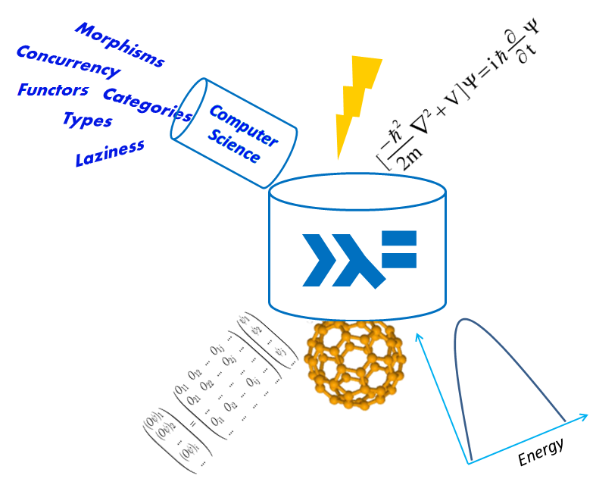

Computers are magnificent tools for the realization of our dreams, but no machine can replace the human spark of spirit, compassion, love, and understanding.

*Louis Gerstner*

* 1. **Molecular Dynamics**

In Principle the behaviour of a molecular system can be obtained solving the time-dependent Schrödinger equation, which completely determines the dynamical behaviour of all system’s particles. Nevertheless, due to its enormous computational cost this mathematical treatment is restricted to system with few atoms (Clary 2008). A bypass to ease the computational cost is the so called Born-Oppenheimer approximation, where the nuclei motion is decoupled from the electrons, as a consequence of the different time scales of motion between them, due to their mass difference (Born and Huang 1954). This approximation enables to simulate the molecular system dynamics using classical mechanics, constrained to an accurately description of the Potential Energy Surface (PES), which results directly from the Born-Oppenheimer approximation (Field 2007). Moreover, this treatment apart from being deterministic (we know in every step the position and velocity of the atoms and do not have a wave package propagating), cannot take into account quantum effects like the tunnel effect or the zero point energy. Besides, it must be introduced special treatments for the molecular phenomena where the Born-Oppenheimer approximation is no longer valid, like conical interceptions or avoided crossings (Ben-Nun, et al. 2000, Worth and Cederbaum 2004). Despite the mentioned limitations, the Born-Oppenheimer molecular dynamics provides faithful results for the vast majority of chemistry.

The reliability of the dynamics depends on the PES accuracy to describe interactions among the system particles (Frenkel and smit 2002, Griebel, et al. 2007), therefore is of central importance the use of accurate PESs, providing molecular forces that describe accurately the molecular systems interactions in an affordable computational time. There have been different approximations to determine forces in molecular dynamics; the first procedure consists in approximating molecular potential energy surfaces as a contribution of different interactions (usually bonding and non-bonding) obtained from experimental data or quantum-mechanical calculations, permitting the generation of force fields capable of reproducing many properties of the systems (Field 2007, Norrby and Brandt 2001). In these cases, there exist different force fields for different kind of systems, and usually they are limited to describe conformational changes rather than chemical processes. Among the existing force fields, it can be remarked AMBER for biological systems (Case, et al. 2006), CHARMM for different chemical systems (Brooks, et al. 2009), OPLS for liquid simulations (Kaminski, et al. 2001), and many others for a large variety of problems.

On the other hand, a second approximation implies the calculation of the molecular forces in every step of the dynamics simulation (i.e. “on the fly” dynamics) by using some ab-initio or any other electronic structure method, avoiding any analytical or numerical representation and describing only local properties of the PES (Bowman, et al. 2010).

There is a third possibility, which is actually a set of algorithms, to obtain an approximated PES through an interpolation of a set of points calculated at high level of theory and adjusted to minimize the error. The most outstanding interpolation methods are the Reproducing Kernal Hilbert space (Ho and Rabitz 1996), the neural networks (Witkoskie and Doren 2005), interpolating moving least squares (Maisuradze, et al. 2003), and the Modiﬁed Shepard Interpolation (Ischtwan and Collins 1994).

The disadvantage of the first strategy is its accuracy, which is in most cases limited to a qualitative description of the simulated processes and is also unable to accurately describe chemical reactions, intramolecular hydrogen bonds or predict excited state properties (Berendsen 1998, Cheatham and Young 2000); in the second strategy, the computational cost of molecular forces calculations using a high level of theory is unaffordable in many cases, especially for medium to large size systems and large simulation time (Hollebeek, et al. 1999). Moreover, the construction of a grid for the determination of PESs involves a very large set of parameters which are usually limited to few coordinates in small molecular systems. Besides, these mathematical approaches can produce different dynamical behaviour, due to small changes in the energy derivatives (Espinosa-Garcia, et al. 2012).

Moreover, the standard formulation of molecular dynamics results in trajectories belonging to the micro-canonical (NVE) ensemble. In this ensemble the number of particles, volume and total energy of the system is preserved. Nevertheless, most of the chemical experiments are carried out at constant temperature, which statistical behaviour is described by the canonical (NVT) ensemble. An approximation to take into account the temperature, was addressed by Andersen, whom introduced a thermostat in which the system is coupled to a heat bath driving the temperature to the desired value, where the thermostat is represented by stochastic forces acting on some random picked particles generating a canonical distribution (Andersen 1980). The shortcoming of Anderson thermostats is its disability to calculated dynamics properties due to the stochastic forces which make the particles velocity incoherent between themselves (Frenkel and smit 2002). An alternative is the extended Lagrangian methodology (Nosé 1984), in which an additional coordinate is introduced in the Lagrangian of the system. This methodology in conjunction with the development of non-Hamiltonian integrators have evolved to the Nosé-Hoover chain of thermostats, which is a widely used algorithm in the constant temperature molecular dynamics simulations (Tuckerman and Martyna 2000).

* + 1. **Born-Oppenheimer Molecular Dynamics**

In order to establish the physical framework in which molecular dynamics is found, a brief account of the approximations starting from the non-relativist quantum mechanism formulation through the Schrödinger equation is described.

Time Dependent Schrödinger equation is given by



Where **rn** and **RN** are the vectors containing the electron and nuclei coordinates, respectively. The Hamiltonian is formulated as



The electronic Hamiltonian, the clamped nuclei part, includes electron-electron, electron-nuclear, nuclear-nuclear Coulomb interactions. Subsequently it is supposed that the exact solution for the time independent electronic Schrödinger equation can be found for a fixed position of the nuclei **RN**,



These electronic wave functions must fulfill the orthonormal condition



If all the electronic wave functions, called adiabatic eigenfunctions, are known for all possible nuclear configurations then the total wave function solution of equation can be expressed by the following approximation introduced by Born (Born and Huang 1954),



where χ are the nuclear wave functions, interpreted as the time-dependent expansion coefficients. Inserting the guess into the time-dependent Schrödinger equation and using the orthonormal condition and integration over all the electron coordinates it is obtained a system of coupled differential equations



where Ckj is the nonadiabatic coupling operator, defined by



The first term in the nonadiabatic coupling operator is the nuclei kinetic energy operator while the second depends on the momenta, whereas if the electronic wave function is real the second term equal zero.

A further approximation is needed to take into account only the kinetic matrix diagonal elements of the nonadiabatic coupling operator C*kk*, which are correction to the kth adiabatic eigenvalue according to equation. Considering only diagonal elements implies that the nuclear propagation is carried out on a single quantum state and therefore the total wave function is reduced to a product of the electronic and nuclear wave function



Born-Oppenheimer Molecular dynamics implies also to ignore the coupling nonadiabatic operator, and then equation reduces to



From this point onwards it only remains to show the feasibility to describe the molecular dynamics as classical particles, which required a more involving mathematical description as it has been shown elsewhere (Marx and Hutter 2009). The Resulting classical equation is given by



Equation describes a molecular system evolving according to the Newton Equations of motion under an effective potential Vk, which is obtained by solving the time dependent Schrödinger equation .

### Non-Adiabatic Molecular Dynamics

The dynamical behavior of the vast majority of chemical systems can be rationalized under the Born-Oppenheimer approximation, but there are a set of interesting problems when coupling between nuclear and electronic movement cannot longer be neglected (e.g. inelastic collisions atom-atom / atom-molecule or the radiationless decay of excited states (Clary 2008, Kuppermann and Abrol 2003)). In general we are interested in the case where two electronic states are degenerated and this phenomenon involves only a subset on nuclear coordinates.

Therefore it is necessary a methodology that treats the degeneracy on those regions where the nuclei and electrons coupling is considerable and use the Born- Oppenheimer approximation for the rest of the phase space. To treat the coupling between nuclei and electrons there have been introduced a set of approximations, among them the diabatic states representation has been widely used, these diabatic states are chosen such that they may cross in the region where the coupling is not negligible, coupling effectively the electronic states involved in the transition (Köuppel, et al. 2007). The coupling between nuclei and electrons can lead to conical intersections and avoided crossings which are efficient channels for the deactivation of excited states (Worth and Cederbaum 2004). For a comprehensive discussion on the application of non-adiabatic dynamics in molecular system see: (Ben-Nun, et al. 2000, Worth and Robb 2002).

In a seminal paper by Tully (Tully 1990), it was outlined the main desirable characteristics of an algorithm to carry out molecular dynamics simulations involving electronic transitions. These attributes are among others: computational affordability, branching of the trajectories in individual electronic states in weak electronic coupling areas, reversibility and inclusion of the quantum coherence. Following the afore mentioned criteria, in the present thesis we have used non-adiabatic molecular dynamics (NAMD), through application of the Tully’s fewest switches algorithm (Tully 1990) with decoherence correction for the surface hop (Granucci and Persico 2007, Jaeger, et al. 2012) as implemented by (Valentini and Frutos 2012)

### Classical Molecular Dynamics

On the other hand, Solution of the classical Hamiltonian equation depends on the chosen initial conditions, position and momenta, denoted as **R0** and **P0.**The molecular system initial configuration at t0 is a point in the phase space of dimensionality 6N (3N positions and 3N momenta), denoted as F(**X0**) where

.

and N is the number of atoms. After Δt units of time, the molecular configuration has moved to the phase space point represented by *F*(**Rt**,**Pt**), where the displacement vector can now be regarded as a coordinate transformation from t=0 to t and the phase space volume transformed according to

,

where **J** is the transformation Jacobian.

If the equation of motion is expressed in the general way,

,

then the compressibility term is defined as,

.

Hamiltonian systems are incompressible meaning that previous expression is zero and the change of Jacobian with time expressed as,

.

since the Jacobian transformation is constant in time for Hamiltonian systems, therefore Hamiltonian molecular dynamics must preserve the phase space (Tuckerman, et al. 1992). Accordingly when numerical integration is performed, an appropriate integration algorithm must be chosen such that preserved the volume of the phase space.

A Liouville Formulation of Time-Reversible Algorithms has been independently proposed by Tuckerman and Sexton (Sexton and Weingarten 1992, Tuckerman, et al. 1992). From the Liouville formulation and trotter Factorization it can be shown that the Velocity-Verlet algorithm is a volume preserving algorithm (Frenkel and smit 2002), therefore the integration of the motion equations for molecular dynamics belonging to the microcanonical ensemble was carried out using the velocity-Verlet algorithm as described elsewhere (Swope, et al. 1982). The first step advances the positions and semi advances the velocities and then the force is calculated using the new positions. Finally, the velocity is semi advanced with the calculated forces.

In order to achieve the desired temperature, the initial conditions for constant energy simulations were obtained by scaling the velocity randomly and periodically, in such a way that the system increases its energy in small quantities followed by a relaxation period, until the system acquires the total required energy.

### Non-Hamiltonian Dynamics

As it has been shown in section 2.1.3, Hamiltonian molecular dynamics preserved the phase space, but for non-Hamiltonian dynamics  formal Integration of equation results on the following expression,



Assuming that the compressibility can be regarded as the total time derivative of some function W, then  and the Jacobian is expressed by

.

Therefore for non-Hamiltonian dynamics the volume of the phase space transforms according to



which after integration, results in the following conservation law,



the invariant metric introduced, named, can be used to formulate the general Liouville equation for non-Hamiltonian dynamics as follows,



where *f(****X****)* is the phase space distribution. The ensemble average corresponding with this general Liouville equation is



if there are Nc quantities that must be conserved represented by



the partition function for non-Hamiltonian system is then given by,



using the previous partition function it is possible to obtain the canonical partition function (NVT) integrating over the dummy variables introduced to represent the thermostat as it will be described subsequently. For a detailed mathematical derivation of previous equations see (Tuckerman, et al. 2001).

In order to introduce the temperature as a constraint in the system, Nosé introduced a “dummy” coordinate in the classical Lagrangian in such a way that the new formulation can be expressed as,



Where *s* is the additional variable which represents a thermostat, Q is a fictitious mass associated with *s,* L a parameter to be adjusted and β is the reciprocal temperature (1/kBT). These kinds of Lagrangians are representative of those molecular dynamics simulations where the forces depend on the velocities. Further simplifications introduced by Hoover shown, that this Lagrangian produces a quantity that is conserved (Hoover and Hoover 2005), which is not a Hamiltonian since motion equations cannot be deduced from it, which can be formulated as



Where *L=3N* and. Hoover has shown that this equation is unique, meaning that other equation of the same form cannot produce a canonical ensemble (Hoover and Hoover 2005). A shortcoming of this development is that Nosé-Hoover algorithm can only generates a correct distribution if there is only one constant of motion. Tuckerman and co-workers proposed to couple the Nosé-Hoover thermostat to a chain of *M* thermostats to overcome this drawback (Tuckerman and Martyna 2000), resulting in the following motion equations















Where the quantity conserved is formulated as



using the partition function for non-Hamiltonian dynamics and the previous example the partition function for the canonical ensemble can be generated as shown by Tuckerman (Tuckerman and Martyna 2000).

Non-Hamiltonian Molecular dynamics required special integration methodologies, considering that forces depend on the velocities and subsequently algorithms as the velocity-Verlet must be iteratively resolved, losing time reversible properties. Therefore were introduced reversible integrators to extended systems, using the Liouville operator and the trotter factorization. A derivation of a family of integrator for the Nosé-Hoover Chain is described by (Martyna, et al. 1996).

On the other hand, the initial conditions for simulating the canonical ensemble are prepared getting random velocities from a Maxwell-Boltzmann distribution, assuming that every component of the velocity can be considered as an independent Gaussian random variable (Field 2007). In order to avoid misinterpretation and numerical drifting in the temperature, the motion and rotation of the center of mass is removed when there are not involved chemical reactions.

### Quantum Mechanism/Molecular Mechanism Method

A hybrid Quantum Mechanics/Molecular Mechanics (QM/MM) model is composed by two subsystems: a QM region is focused on the description of a chemical reaction and the surrounding MM region is treated classically. Therefore, QM/MM methods are suitable to describe the environment effect on a particular molecular system, e.g. surrounding it by explicit solvent molecules, or considering the actual biomolecule where it is included (a base pair in DNA, an amino acid in a protein, etc.).

Different QM/MM schemes were designed and developed (Lin and Truhlar 2007). In this Thesis, we adopted an approach by which the Hamiltonian of the QM/MM model () is a sum of three components:



is the Hamiltonian of the QM system in vacuum, while refers to the MM region treated with a classical force field. The interaction between QM and MM regions is described by the term:



by which electrostatic, nuclear, van der Waals and bonding interactions are taken into account, respectively. Especially, the electrostatic and nuclear terms are given by the following relations:





 describes the interaction between the electrons of the QM region with the point charges (qA) in the MM region; while is responsible for the interaction between the nuclei of the QM region (with ZA being the proton number of nucleus A) and the B point charges of the MM region. For both electrostatic and nuclear terms the Electro-Static Potential Fitted (ESPF) method is applied (Ferré and Ángyán 2002): one-electron operators are added to  in order to calculate the interaction between the QM charges distribution and the MM electrostatic potential field, considered as an external field, resulting in the following interaction energy,



where and are the density matrix and multipole-like matrix elements interacting with the electrostatic potential calculated at the point center.

Van der Waals interactions are taken into account by a short-range Lennard-Jones term, assigning parameters to both QM and MM atoms,



where for every AB couple,is the potential well,is the finite distance at which the potential between A and B is zero, and is the distance between A and B.

If the frontier between QM and MM regions involves covalent bonds, an additional term is added to, including some empirical bonded terms. The scheme used to treat the frontier bonds is called Link Atom (LA), where a monovalent atom (usually hydrogen) is used to saturate the QM system. Applying the Morokuma’s scheme for LA positioning, the distance between LA and the first linked AM atom  is modified with respect to the frontier QM and MM atoms while optimizing, thanks to a scaling factor (SLA):



## Electronic Structure Methodologies

Ab initio electronic structure calculations are mathematical approximation only based in physical constants (i.e. they do not depend on empirical parameterizations), which aim to solve the time-independent Schrödinger equation . The initial starting point for most method is the Hartree-Fock approximation, which established that the ground-state wavefunction  is determined by products of monoelectronic wavefunctions of the molecular orbitals. Within this approximation, the electronic field is determined by a self-consistent field method, where every single electron is moving under the mean-potential created by the other electrons. The wavefunction is built from Slater determinants as an antisymmetrized product of spin orbitals (i.e. the product of a spatial orbital and a spin function):



The expected value of the energy is then calculated as



Where the Hamiltonian can be expressed as follows:



where *n* stands for the number of electron and N represents the number of nuclei. The first, second and third term on the right hand side of are the electron kinetic energy operator, the nuclei-electron attraction potential operator and the electron-electron repulsion potential operator, respectively. This corresponds to the electronic Hamiltonian, since the nuclei kinetic energy is omitted, based on the Born−Oppenheimer approximation. Now we have all the elements to determine the energy of the system, by replacing and in , obtaining the following expression for the energy:



Where  is the electronic energy of a single electron moving under the attraction of a nuclear "core", without interact with other electrons;  is the so-called Coulomb integral, representing electrostatic repulsion between the electrons;  is called the exchange integral, which is a pure quantum effect without similar in classical physics, standing for the correlation in the motion of the electrons with parallel spin which are correlated in the single determinant approximation of Hartree-Fock. The terms  and  take into account for the average electrostatic repulsion between electrons. The energy is finally calculated by applying the variational principle (Szabo and Ostlund 1996).

### The Complete Active-Space Self-Consistent Field Method

The principle of all Multiconfigurational Self-Consistent Field (MCSCF) methods is the expansion of a monoconfigurational HF wavefunction as a linear combination of Slater determinants. Among all MCSCF methods, the CASSCF method results in a MCSCF wavefunction generated by linear combination of configurations , considering that each configuration corresponds to a different occupation of the molecular orbitals  included in the so-called active space (Roos 2007), where each molecular orbital is a linear combination of atomic orbitals  :







The optimization of  is based, therefore, on the simultaneous variation of orbital coefficients  and configuration coefficients, until reaching self-consistency. Once  is optimized, the energy of the system is calculated as follows:



Where  and are the monoelectronic and bielectronic integrals, respectively:





Where **r** is the position vector and **D** is the first order reduced density matrix, which is defined as a function of the expansion coefficients given by :



**P** is the second order reduced density matrix, with elements:



where  are defined as the bielectronic coupling coefficients. One of the characteristics of the CASSCF method is the selection of the configurations (i.e. the orbitals) to be included in the wavefunction. In principle, the active space could include all the orbitals, leading to a so called full CI (Configuration Interaction) treatment. Unfortunately, a full CI requires an unfeasibly high computational cost even for small size molecules, and therefore a limited number of orbitals have to be selected. The number and type of orbitals will depend on the chemical nature of the problem to be studied, in any case being necessary that all chemically relevant orbitals are part of the active space (e.g., for a conjugated hydrocarbon the active space should include all π and π* orbitals). Therefore, when applying the CASSCF method all orbitals will be divided into three groups: (i) inactive orbitals, which remain doubly occupied; (ii) virtual orbitals, which stay unoccupied; (iii) active orbitals, where all possible electronic excitations are allowed, resulting in a total number *N* of configuration state functions which form, given by the following formula (for a defined state multiplicity) (Cramer 2004):



where n is the number of electrons and m the number of orbitals, usually indicated as CASSCF(*m*,*n*). With state-of-the-art computational resources, a CASSCF(4,4) is a straightforward task, being *N*=20, while a CASSCF(14,12) is highly demanding, being *N*=169884. Considering that the computational feasibility depends also on the basis set applied, we can nowadays set the upper limit to the size of the active space as a CASSCF(20,20).

### Density Functional Theory

As a quantum chemical methodology, DFT is based on two theorems proved by Hohenberg and Kohn in 1964. The Hohenberg-Kohn existence theorem states that the energy of a molecular system depends on the ground-state electron density, since this density determines the Hamiltonian operator. Integration of the ground-state density gives the number of electrons that interact with each other and within an external potential (i.e. the attraction to the nuclei). The Hohenberg-Kohn existence theorem proves that the ground-state electron density determines the external potential, and therefore the Hamiltonian (Cramer 2004, Hohenberg and Kohn 1964).

By this formulation, the energy depends on the electron density, i.e. it is a density functional :



where  is the electron kinetic energy, the second and third term on the right hand side are related to the classical electrostatic interaction between electrons, which is the correlation and exchange energy term, containing all non-classical electronic interactions. The exact formulation of this last term is not known; therefore it requires an approximate expression giving rise to different possible types of density functional.

The existence of an electron density as a fundamental quantity is thus a first step, which is followed by a demonstration that the electron density obeys to the variational principle, and it can be optimized. The Hohenberg‒Kohn variational theorem assumes that a guess ground-state electron density is provided (thanks to the existence theorem), by which the proper number of electrons can be integrated. As a consequence, such electron density determines a guess wavefunction and Hamiltonian  , permitting the evaluation of the expected energy , being greater than or equal to the ground-state true energy :



By this procedure, it can be avoided to solve the Schrödinger equation to compute the energy, even if it does not have a consistent criterion to follow in order to choose the best electron densities that leads to reliable ground-state energy. Especially, a different approximation of can lead to a different final energy value, being necessary a careful decision of the density functional to be applied (i.e. a suitable density functional has to be calibrated for each set of molecules).

### Crossings between Electronic States

As it has been discussed previously in the vicinity of an electronic state crossing the Born-Oppenheimer approximation is no longer valid, and it is necessary to take into account non-adiabatic effects to correctly describe photodynamical processes.

Two potential energy surfaces  and  intersect in a set of coordinates **q** where the energy for both states is equal. The subspace spanned by these coordinates could be expected a subspace of *3N-7* dimensions (being *3N-6* the degrees of freedom of the system). However, and are two solutions of the same eigenvalue problem given by a single Hamiltonian ***H***, and therefore they are not independent of each other, leading to an additional condition (Neumann and wigner 1929, Teller 1937).

The two intersecting adiabatic states  and can be expressed as linear combinations of two diabatic orthogonal states  and  in the complementary hyperspace to the one spanned by all other eigenstates  , for which the energies   are non-degenerated with and :



By solving the eigenvalue problem given by the  matrix, the expansion coefficients and the corresponding energies ( and ) can be determined. The matrix elements are therefore:



It can be demonstrated that  and  have the following expressions (Schelegel 1987):



Therefore, in order to fulfill that , two independent conditions have to be satisfied:



leading to the existence of at least two independent coordinates,  and.

In a diatomic molecule,  is always zero for states of different symmetry, thus only has to be satisfied. This is coherent with the existence of only one internal coordinate (i.e. the interatomic distance), being a necessary value to satisfy the condition. If the two states belong to the same symmetry, an intersection is therefore not possible.

In a polyatomic (three or more atoms) molecule, the increased number of degrees of freedom allows both conditions of to be satisfied simultaneously (even for the same symmetry) for suitable values of  and . This means that a branching plane spanned by  andvectors can be defined (with the origin at the point where both conditions of are satisfied), where energy degeneracy is left. On the other hand, the *3N-8* hyperspace defined by all degrees of freedom but  and  determines the coordinates which can be varied remaining in the crossing region (i.e. energy degeneracy holds).

Imposing the conditions of two eigenvalues are found, resulting in the equation of a double cone with vertex at the origin. This is why crossing points between electronic states are called conical intersections (CIs).

The crossing can be real or avoided: considering the two diabatic orthogonal statesandwhich form the two adiabatic states  and  as depicted in , the crossing condition is fulfilled when andcross each other, meaning that . At this point the energies of the adiabatic functions are  and . The energy gap is therefore . If  the crossing is real (a CI), on the other hand if  the crossing is avoided, meaning that both PESs involved in the process become near in energy but do not cross and instead repel each other.

In the adiabatic basis,  andare defined as follows:





corresponds to the gradient difference (**GD**) vector, while is parallel to the direction of the derivative coupling (**DC**) vector:



Apart from their mathematical description, **GD** and **DC** vectors have a physical meaning: the **GD** vector measures the distortion of the system leading to the largest variation of the energy difference between the two electronic states involved in the crossing. The **DC** vector measures the distortion of the system providing the maximum coupling between the two electronic states involved in the crossing.

* 1. **Spectroscopic Properties**

In electronic spectroscopy, two quantities are fundamental in order to reproduce absorption and emission spectra: the energy difference between distinct electronic states and the oscillator strength. Indeed, an experimental UV/visible spectrum is characterized by absorption or emission wavelengths (corresponding to the energies of the electronic transitions) and absorption or emission intensities (which depend on oscillator strengths and indicate the transition probabilities).

An electronic transition is intended from an initial state *i* to a final state *f*, being usually (but not necessarily) *i* the ground-state and *f* one of the excited-states for absorption, while *i* is one of the excited-states and the *f* the ground-state for emission. More in general for absorption, while  for emission. The transition dipole moment couples the wavefunctions of initial and final states (and), resulting in a vector  which expresses the redistribution of electrons in the molecular system after the transition:



Being **q** the position vector. It may be shown that the square of module is, in case of emission:



where the dielectric constant is in vacuum, h the Planck’s constant, *c* the speed of light, the resonance frequency of the transition and is the Einstein coefficient to describe the total rate of spontaneous emission. The emission oscillator strength  can be then defined by the relation (Hilborn 1982):





where *e* and *me* are charge and mass of the electron.determines the classical radiative decay rate of the single electron oscillator at frequency.

The absorption oscillator strength is then defined by:



whereandare the degeneracy factors of the two electronic states (upper and lower energy). The *f* values have been defined like this: if *(i)* =1 (i.e. the angular momentum of the lower state in energy, *(ii)* =3 (i.e. =1) and *(iii)*, then =1 and. Tables of  values can be found in literature (Hilborn 1982).

The absorption oscillator strength can be finally related to A*if*



As alternative procedure,can be determined by comparing the absorption cross section of a classical oscillator with the one determined by the Einstein B coefficients (which are defined in terms of transition rates for induced absorption and stimulated emission).

## Interpolation Methods

* + 1. **Quadratic approximation**

In order to construct the potential energy surfaces of a molecule in a given state we have to perform, as a first approximation, a quadratic expansion of the potential energy function in terms of internal coordinates:



Where **q** is a vector in internal coordinates denoting any configuration (i.e. molecular structure), **q0** is also a vector in internal coordinates corresponding to the reference configuration for the expansion **gq0***(n)* and **Hq0***(n)* are the energy gradient vector and hessian matrix of the (*n*) electronic state evaluated for the **q0** geometry, both expressed in internal coordinates. From the approximate PES given in (1.1), the energy gradient vector obtained is



The election of internal instead of cartesian coordinates for deriving the force field has some advantages, since the curvilinear coordinate system, if correctly chosen, preserves more accurately the quadratic approximation, making the spanned PES more precise as the displacement vector (**q-q0)** increases (Bakken and Helgaker 2002). Selecting a set of internal coordinates for the PES expansion with chemical meaning is necessary in order to predict accurately the energy of the extrapolated points. Since usually first and second derivatives are available in cartesian coordinates, it is necessary to transform the cartesian derivatives into internal derivatives. The relation between the derivatives of the energy with respect to internal and cartesian coordinates is described by the Wilson B matrix which elements , are given by the derivatives of the internal coordinates with respect to de cartesian coordinates (Wilson 1955). Using this matrix the relation between the gradients are given by





Where **gx**(n) is the energy gradient vector in cartesian coordinates, evaluated for an arbitrary **x** configuration, which is also expressed in cartesian coordinates. Since the **B** matrix is not square, its inversion requires to find the generalized inverse of a **G** matrix given by **G** = **BUB**t where **U** is a unitary matrix. In the case of using a set of redundant internal coordinates, the inversion of the **G** matrix required a previous diagonalization followed by the elimination of the zero eigenvalues resulting from the redundant internal coordinates, keeping only those eigenvectors corresponding with the 3N-6 degrees of vibrational freedom (Peng, et al. 1996). The relations between hessian matrices in both set of coordinates are obtained after differentiating equation (1.3) and (1.4)





where **Hx0***(n)* is the Hessian matrix in cartesian coordinates evaluated for the **X0** configuration, and **B'** is a three dimensional array whose elements $B_{ijk}^{'}={∂^{2}q_{i}}/{∂x_{j}∂x_{k}}$ are the second derivatives of the *ith* internal coordinates with respect to the *jth* and *kth* cartesian coordinate.

In order to obtain the numerical values of the gradient and Hessian matrix in internal coordinates, analytical expressions were obtained and implemented for the first and second derivatives of the internal coordinates with respect to the cartesian coordinates (i.e. Bij and B’ijk terms).

In order to calculate the forces in each integration step when this potential is applied to molecular dynamics, it is necessary to transform the gradient vector from internal to cartesian coordinates, using the relations given by Equations (1.3.3) and. (1.3.4).

* + 1. **Multicenter Interpolation Methods**

## Geometry Optimization

Central in theoretical quantum chemistry is the optimization of minima and transitions states. A big number of optimization algorithms have been developed using both internal and Cartesian coordinates, each one offering a set of advantages and drawbacks, for a comprehensive discussion see (Bakken and Helgaker 2002).

The Newton-Raphson method provides a very fast convergence algorithm, but is very expensive since it requires the calculation of the Hessian matrix. An approximation to bypass this shortcoming is the Broyden-Fletcher-Goldfarb-Shanno (BFGS) updating scheme (Fletcher 1987), in which an initial inexpensive hessian is updated in each optimization step, using the following equation:



Where





Using the previous procedure and changing the gradient for a new one that takes into account both an external force and the internal force:



It is possible to optimize geometries subjected to an external stress.

## Programming Methods

Since the computational chemistry field directly address a set of common problem in scientific computing, there is a kind of folklore with respect to the design of scientific software, for an excellent review of this topics see (Wilson, et al. 2014). These guidelines includes: the automation of work, extensive use of heavily optimized libraries, planning the development of a software, documentation and code readability and, among others, using the highest-level language possible. In this section we elaborated more in the last point.

Mainstream Languages like C, C++, Python, Java, FORTRAN etc. are classified as imperative Language in computer science. This means that a program in the imperative paradigm is a sequence of commands describing what is to be done, these commands are execute in the preset order while changing the state of a set of variables. Although it is undeniable the impact of those languages in modern software application and particularly FORTRAN in the field of computational physics and chemistry, this language still lack some properties as explain in Table 1.

|  |  |
| --- | --- |
| **Property** | **Explanation** |
| Scalability | It is hard to parallelize and distribute the computations |
| Modularity | Programs tend to be large monolithic blocks, difficult to compose. |
| Refactoring | It is difficult to reuse functions. |
| Side Effects | There is not difference between input/output actions and pure mathematical functions. For a given function the same input is not always returning the same output. It is impossible to apply a broad set of optimization at compile time. |
| Mutable data | There is not a clear control of the program state, leading to obscure code. |
| Composition | There is not an easy way of compose function or data structure. |
| Readable code | Programs tend to be hundreds of unintelligible lines. |
| Polymorphic and high level functions | It is quite hard (if possible at all) to implement function that work on different kind of data and that functions can return functions as answer. |

Table . Listing of the main disadvantages of using FORTRAN.

On the other hand the functional programming Languages as Haskell, Erlang, Ocaml, Scala, Lisp, etc. (Armstrong 2007, Marlow and Jones 2012), are focused on specifying what needs to be done instead of “how”, generating functions which are composed in a primary function which is the actual program. The main advantages of this paradigm are that programs tend to be modular and easy to compose. This increases readability and maintainability, since functions are pure in a mathematical sense they can be tested isolated from the context. Immutable data does not lead to race conditions in concurrency. Polymorphism and higher order function enhance the reusability of code. The separation of input/output code from the pure mathematical functions enable the compiler to make aggressive transformations which results in more efficient code (O'Sullivan, et al. 2008). For a comprehensive discussion in the utility and advantages of functional programming see (Hughes 1990).

Even though the computational theory behind programming languages is beyond the scope of this thesis, we want to present in this section a brief description of Haskell. It is not the objective of this section to compare extensively the advantages of one languages with respect to others languages, but to introduce some concepts regarding the functional paradigm. However, from time to time differences between the imperative and functional paradigms are pointed with pedagogical purposes.

### A brief Haskell tour

Haskell is the result of an academic research project that begins in the early 1990’s, which has been incorporating the result of the researching to produce a programming language that has leading scientific ideas and production quality. The Glasgow Haskell Compiler (GHC) is the “de facto” implementation of Haskell and because of its fundaments are deeply rooted in the mathematics is spreading not only in academic environments by also in industrial production (see <http://www.haskell.org/haskellwiki/Haskell>).

The most outstanding feature of Haskell is its type system. Types are a ubiquitous concept in computer science, it can be thought as a mathematical object that represents some structural properties of a set of values. Another point of view is that a type is a value with only partial information, meaning that you can specify the intended context to use the value, but you cannot compute a specific value with a type. Types naturally arise from the fact that certain values can be meaningfully used only in certain contexts. Therefore all programming languages use some kind of *Type System* for reasoning about types (Turbak, et al. 2008). Another interesting way to look at types is through the *Curry-Howard isomorphism* (Thompson 1999), which in plain language is a formal proof that types can be regarded as propositions in a formal logical framework, while programs are “proofs” of those propositions, then a compiler can be regarded as a theorem checker.

Haskell type system enables to rule out spurious declarations, bypassing the use of extensive debugging protocols, providing an equational reasoning framework to deduce properties about the given implementation. equational reasoning refers to the fact of introduce any possible simplification using mathematical reasoning, replacing equal by equals, which as obvious as it seems is not always possible in common languages (Harper 2013).

Another startling feature of Haskell is that has variables that do not vary, once defined they never change, they are immutable. The reason behind this behaviors is that in Haskell a variable is a name bound to some value, like an equation where expressions are named, for instance *y=5* and *x=3*, but it does not make sense that in the same equation *x=3* and *x=6,* are defined simultaneously. On the contrary, variables in imperative languages like C or FORTRAN are directions pointing to locations in a variable computer memory.

Since Haskell is a strong typed Language, meaning that every expression must have a type at compilation time, the compiler can provide the types of the expressions declared, but for documentation and clarity reason is customary to provide the signature of the function declared. The signature refers to the number of arguments takes by a function, known as *arity*, and the types of the arguments of the function, as is exemplify below:



The first line in the previous equation states that *MultiplyBy5* is a function which takes an integer as argument and returns another integer as result, while the second line declares the actual computation.

A more involving concept is the polymorphism. Polymorphism permits procedure declarations that are parameterized over the types of their inputs, meaning that a polymorphic function is a function that works for many different types. For instance the *times* function is given by:



The signature declares that the function takes two arguments (called parameters) which must belong to the Numerical type class (e.g. integers, floating points, etc.) and finally return a third number which also must belong to the Numerical type class. A class member in Haskell can be defined as a set of functions which are implemented depending on the kind of types on which those methods are applied. Therefore the *times* function belongs to the numerical type class have a different implementation if it is intended to be applied over integers or floating points.

A big difference between imperative language and Haskell is the way in which it takes the arguments in functions. Haskell use a mechanism called curryfication which means that only one argument is take into the function at a time, for instance the plus function operating over two integers is expressed as:



If you supply only one number to the above function we obtain a new function, for example if we apply 4 to *plus* we get:



Functions are first order expressions, meaning that functions can be returned as the actual result of function application, as has been pointed in the previous equations. If you supply a function with less arguments that the total number of arguments that a function is waiting, you are returned with a new function which takes the missing arguments.

Imperative languages rely on explicit loops declaration (represented with keywords like *For*, *While*, etc.), functional languages lack any explicit loops declaration and all the iterative tasks are carried out by general polymorphic functions as map and folds see (O'Sullivan, et al. 2008). A map is a *polymorphic higher-order* function which applies a chosen function to every element of a list and returns a new list with the results. For example the following function multiplies every element by 3,



When using these functions some mathematical properties must be enforced, for instance the multiplication of all the elements of a list by 5, followed by the sum of 2 can be expressed as



Where the dot operator (.) denotes functions composition, meaning that. Even though mathematically equivalent, left and right hand side are from “the implementation point of view” not equally efficient, since the right hand function avoids the building and memory representation of the intermediate result, fusing (*5) and (+2) in only one function, eliminating an intermediate list. Fusion is an important property when many operations are applied to an array, for a detailed description see (Lippmeier, et al. 2012).

Haskell has a good deal of libraries which allows encapsulating and reutilizing computation patterns, making possible to recycle function, avoiding the usual plague of the identical functions performing slightly different task, allowing to easily recognize a pattern which can be made a general function. There is a Common tendency among in computational chemistry of “reinventing the wheel”, meaning that each software has its own non-standard way of tackle a common situation leading to confusion, Haskell libraries on the other side make a strong point providing standard tools for common computations.

In this Thesis we have used GHC and the Haskell platform for the algorithms implementation (Marlow and Jones 2012), making heavy use of the high performance library REPA (Lippmeier, et al. 2012).

* + 1. **Parallelism and concurrency**

The free lunch is over (Sutter 2005). This sentence marked the end of an era and it is only the rephrasing that transistor miniaturization has reached the physical limits. The empirical fact that every 18 month the performance of integrated circuits double, called the Moore’s law, was the driving force of the software development for the last 50 years, where increasing clock frequencies and symmetric multiprocessing tried to manage the ever increasing demands of computing power among science and even commonly used information systems. Having reached the physical limits of miniaturization, chips manufacturers have focused on producing devices with many cores and smaller CPU frequencies, saving electric power. Some years ago you only needed to wait some months in order to improve the performance, but now the new challenge is software parallelization (Breshears 2009, Fayez 2011), meaning that sequential applications are doomed to disappear and be replace by parallel and concurrent software.

A concurrent program can be roughly defined as one that reacts properly to independent input sources dealing with every task independently; having multiple threads of control and non-deterministic behavior, and the quantity of cores that the program can handle only improves performance and responsiveness. Parallelism on the other hand, can be classified as a special case of concurrency since a parallel program solves a single problem and has a deterministic behavior (e.g. stream in data, makes calculation and output result), which takes advantages of multiplicity of hardware to improve the speed of a computation (Jones 2007).

Current efforts in mainstream languages (Java, C, C++ andq FORTRAN in chemical physics simulations) do not directly address distributed concurrency; instead they focus on a shared memory models where locks and condition variables are in charge of updating the data. Since threads will be working together in shared memory, there may be times when two or more threads need to access the same memory location, phenomenon called race condition. If one or more of these threads is trying to update some memory location (e.g. one thread wants to evaluate *x = x+1* and the other *x = x+2*), you will have a race for the resources. These issues have been traditionally tackled through the implementation of locks and semaphores, resulting in extremely complex and costly software. One example of such programs are most of the operating systems (Marlow 2013).

Concurrently software must cope with the scheduling of threads, which are managed by rather complex algorithms which depend on many factors (current load of the system, priority of the tasks, etc.), and therefore scheduling appears to be nondeterministic or asynchronous. And more import, it is the programmer responsibility to handle all these events simultaneously, in order to produce a correct program. Besides, the cost of moving data from one processor to another as you want to distribute calculations, becomes a dominant factor, because all the caches of the all the processors must be kept updated of all the changes in the shared variables and data, independently of the architecture, using high-performance buses for example (Vadja 2011).

The functional programing paradigm makes a strong point on having multiple entities which can shared or not memory managing to accomplish the computations by several mechanisms, being the message passing one of the most successful in handling hundreds or even millions of independent computations (Armstrong 2007)

## Software in Quantum Chemistry

In his lecture of the Turing award the physician Edsger W. Dijkstra said that: “The sooner we can forget that Fortran has ever existed, the better, for as a vehicle of thought it is no longer adequate: it wastes our brainpower, is too risky and therefore too expensive to use. FORTRAN’s tragic fate has been its wide acceptance, mentally chaining thousands and thousands of programmers to our past mistakes” (Dijkstra 1972). No longer after, John Backus, leader of the team which developed FORTRAN, in his Turing award Lecture deeply questioned the strategies of programming in vogue during that period, 40 years later these practices still pervades the chemical physical simulation branch.

For years the FORTRAN programming style has been sustained only by the steady increase in the velocity of the transistors, but once the future has opened to highly distributed architectures and highly parallelized software, maybe it is time to switch to more robust computation theories. If giants of computer performance such as Google make use of the functional paradigm why physical simulations cannot take advantages of it?

## Electronic Structure Packages

* A development in the Molcas-7 quantum chemistry package was carried out in order to perform constant temperature “on the fly” molecular dynamics. Besides, the same package was used to perform CASSCF and CASPT2 calculations (Aquilante, et al. 2010).
* The Gaussian 09 software was used for the DFT and TD-DFT calculations (M. J. Frisch, et al. 2009).
* The Gromacs package was used to perform simulation of large scale systems as biomolecules (Hess 2008).
* Our own set of packages was tailored to carry molecular dynamics at constant temperature, external forces and surface hopping. Besides other set of algorithm as constrained optimizations, data analysis and several miscellaneous tasks were also implemented (see appendixes).

Chapter Bibliography

Andersen, H. C., Molecular dynamics at constant pressure and/or temperature. *J. Chem. Phys.* **1980,** *72*, 2384–2393.

Aquilante, F.; De Vico, L.; Ferré, N.; Ghigo, G.; Malmqvist, P.-å.; Neogrády, P.; Pedersen, T. B.; Pitoňák, M.; Reiher, M.; Roos, B. O.; Serrano-Andrés, L.; Urban, M.; Veryazov, V.; Lindh, R., MOLCAS 7: The Next Generation. *J. Comput. Chem.* **2010,** *31*, 224-247.

Armstrong, J., *Programming Erlang*. Pragmatic Bookshelf: Raleigh, North Carolina, 2007.

Bakken, V.; Helgaker, T., The efficient optimization of molecular geometries using redundant internal coordinates. *The Journal of Chemical Physics* **2002,** *117*, 9160-9174.

Ben-Nun, M.; Quenneville, J.; Martínez, T. J., Ab Initio Multiple Spawning:  Photochemistry from First Principles Quantum Molecular Dynamics. *The Journal of Physical Chemistry A* **2000,** *104*, 5161-5175.

Berendsen, H. J. C., Molecular Dynamics Simulations: The Limits and Beyond. In *Computational Molecular Dynamics: Challenges, Methods, Ideas*, Deuflhard, P.; Hermans, J.; Leimkuhler, B.; Mark, A. E.; Reich, S.; skeel, R. D., Eds. Springer: Berlin, 1998.

Born, M.; Huang, K., Dynamical Theory of Crystal Lattices. Oxford University Press: New York, 1954.

Bowman, J. M.; Braams, B. J.; Carter, S.; Chen, C.; Czakó, G.; Fu, B.; Huang, X.; Kamarchik, E.; Sharma, A. R.; Shepler, B. C.; Wang, Y.; Xie, Z., Ab-Initio-Based Potential Energy Surfaces for Complex Molecules and Molecular Complexes. *Journal of Physical Chemistry Letters* **2010,** *1*, 1866-1874.

Breshears, C., *The Art of Concurrency*. O'Reilly: 2009.

Brooks, B. R.; Brooks III, C. L.; Mackerell, A. D.; Nilsson, L.; Petrella, R. J.; Roux, B.; Won, Y.; Archontis, G.; Bartels, C.; Boresch , S.; Caflisch, A.; Caves, L.; Cui, Q.; Dinner, A. R.; Feig, M.; Fischer, S.; Gao, J.; Hodoscek, M.; Im, W.; Kuczera, K.; Lazaridis, T.; Ma, J.; Ovchinnikov, V.; Paci, E.; Pastor, R. W.; Post, C. B.; Pu, J. Z.; Schaefer, M.; Tidor, B.; Venable, R. M.; Woodcock, H. L.; Wu, X.; Yang, W.; York, D. M.; arplus., M. K., CHARMM: The Biomolecular simulation Program. *J. Comput. Chem.* **2009,** *30*, 1545-1615.

Case, D. A.; Darden, T. A.; Cheatham, I. T. E.; Simmerling, C. L.; Wang, J. J.; Duke, R. E.; Luo, R.; Merz, K. M.; Pearlman, D. A.; Crowley, M.; Walker, R. C.; Zhang, W.; Wang, B.; Hayik, S.; Roitberg, A.; Seabra, G.; Wong, K. F.; Paesani, F.; Wu, X.; Brozell, S.; Tsui, V.; Gohlke, H.; Yang, L.; C., T.; Mongan, J.; Hornak, V.; Cui, G.; Beroza, P.; Mathews, D. H.; Schafmeister, C.; Ross, W. S.; Kollman, P. A. *AMBER 9*, University of California: San Francisco, 2006.

Clary, D. C., Quantum Dynamics of Chemical Reactions. *Science* **2008,** *321*, 789-791.

Cramer, C. J., *Essentials of Computational Chemistry. Theories and Models*. second ed.; John Wiley & Sons: 2004.

Cheatham, T. E.; Young, M. A., Molecular dynamics simulation of nucleic acids: Successes, limitations, and promise*. *Biopolymers* **2000,** *56*, 232-256.

Dijkstra, E. W., the humble programmer. *Communications of the ACM* **1972,** *15*, 859-866.

Espinosa-Garcia, J.; Monge-Palacios, M.; Corchado, J. C., Constructing Potential Energy Surfaces for Polyatomic Systems: Recent Progress and New Problems. *Advances in Physical Chemistry* **2012,** *2012*, 19.

Fayez, *Algorithms and Parallel Computing*. Wiley: 2011.

Ferré, N.; Ángyán, J. G., Approximate electrostatic interaction operator for QM/MM calculations. *Chem. Phys. Lett.* **2002,** *356*, 331-339.

Field, M. J., *A Practical Introduction to the Simulation of Molecular Systems*. Cambridge University Press: New York, 2007.

Fletcher, R., *Practical methods of optimization* second ed.; John Wiley & Sons: New York, 1987.

Frenkel, D.; smit, B., *Understanding Molecular Simulation*. second ed.; Academic Press: San Diego, 2002; Vol. 1.

Granucci, G.; Persico, M., Critical appraisal of the fewest switches algorithm for surface hopping. *The Journal of Chemical Physics* **2007,** *126*, -.

Griebel, M.; Knapek, S.; Zumbusch, G., *Numerical Simulation in Molecular Dynamics*. Springer: Germany, 2007; Vol. 5.

Harper, R., Equational Reasoning In *Practical Foundations for Programming Languages* Cambridge University Press: New York, 2013; pp 495-547.

Hess, B., GROMACS 4: Algorithms for Highly Efficient, Load-Balanced, and Scalable Molecular Simulation. *Journal of Chemical Theory and Computation* **2008,** *4*, 435-447.

Hilborn, R. C., Einstein coefficients, cross sections, f values, dipole moments, and all that. *American Journal of Physics* **1982,** *50*, 982-986.

Ho, T.; Rabitz, H., A general method for constructing multidimensional molecular potential energy surfaces from ab initio calculations. *J. Chem. Phys.* **1996,** *104*, 2584-2597.

Hohenberg, P.; Kohn, W., Inhomogeneous Electron Gas. *Physical Review* **1964,** *136*, B864-B871.

Hollebeek, T.; Ho, T.-S.; Rabitz, H., Constructing Multidimensional Molecular Potential Energy Surfaces From ab Initio Data. *Annu. Rev. Phys. Chem.* **1999,** *50*, 537-570.

Hoover, W.; Hoover, C. G., Nonequilibrium molecular dynamics. *Condens. Matter Phys.* **2005,** *8*, 247-260.

Hughes, J., Why Functional Programming Matters. In *Research Topics in Functional Programming*, Turner, D., Ed. Addison-Wesley: 1990; pp 17-42

Ischtwan, J.; Collins, M. A., Molecular potential energy surfaces by interpolation. *The Journal of Chemical Physics* **1994,** *100*, 8080-8088.

Jaeger, H. M.; Fischer, S.; Prezhdo, O. V., Decoherence-induced surface hopping. *The Journal of Chemical Physics* **2012,** *137*, -.

Jones, S. P., Beautiful Concurrency. In *Beautiful Code*, Wilson, G., Ed. O'Reilly

2007.

Kaminski, G. A.; Friesner, R. A.; Tirado-Rives, J.; Jorgensen, W. L., Evaluation and Reparametrization of the OPLS-AA Force Field for Proteins via Comparison with Accurate Quantum Chemical Calculations on Peptides. *J. Phys. Chem. B* **2001,** *105*, 6474-6487.

Köuppel, H.; Domcke, W.; Cederbaum, L. S., Multimode Molecular Dynamics Beyond the Born-Oppenheimer Approximation. In *Adv. Chem. Phys.*, John Wiley & Sons, Inc.: 2007; pp 59-246.

Kuppermann, A.; Abrol, R., Quantum Reaction Dynamics for Multiple Electronic States. In *The Role of Degenerate States in Chemistry*, John Wiley & Sons, Inc.: 2003; pp 283-322.

Lin, H.; Truhlar, D., QM/MM: what have we learned, where are we, and where do we go from here? *Theor. Chem. Acc.* **2007,** *117*, 185-199.

Lippmeier, B.; Chakravarty, M. M. T.; Keller, G.; Jones, S. P., Guiding Parallel Array Fusion with Indexed Types. In *Proceedings of the 2012 symposium on Haskell symposium*, ACM: Copenhagen, Denmark, 2012; pp 25-36.

M. J. Frisch; G. W. Trucks; H. B. Schlegel; G. E. Scuseria; M. A. Robb; J. R. Cheeseman; G. Scalmani; V. Barone; B. Mennucci; G. A. Petersson; H. Nakatsuji; M. Caricato; X. Li; H. P. Hratchian; A. F. Izmaylov; J. Bloino; G. Zheng; J. L. Sonnenberg; M. Hada; M. Ehara; K. Toyota; Fukuda, R.; J. Hasegawa; M. Ishida; T. Nakajima; Y. Honda; O. Kitao; H. Nakai; T. Vreven; J. A. Montgomery; Jr., J. E. P.; F. Ogliaro; M. Bearpark; J. J. Heyd; E. Brothers; K. N. Kudin; V. N. Staroverov; R. Kobayashi; J. Normand; K. Raghavachari; Rendell, A.; Burant, J. C.; Iyengar, S. S.; Tomasi, J.; Cossi, M.; Rega, N.; Millam, J. M.; Klene, M.; Knox, J. E.; Cross, J. B.; Bakken, V.; Adamo, C.; Jaramillo, J.; Gomperts, R.; Stratmann, R. E.; Yazyev, O.; Austin, A. J.; Cammi, R.; Pomelli, C.; Ochterski, J. W.; Martin, R. L.; Morokuma, K.; Zakrzewski, V. G.; Voth, G. A.; Salvador, P.; Dannenberg, J. J.; Dapprich, S.; Daniels, A. D.; Farkas, Ö.; J. B. Foresman; Ortiz, J. V.; Cioslowski, J.; Fox, D. J. *Gaussian 09, Revision A.1*, Gaussian, Inc.: Wallingford CT, 2009.

Maisuradze, G. G.; Thompson, D. L.; Wagner, A. F.; Minkoff, M., Interpolating moving least-squares methods for fitting potential energy surfaces: Detailed analysis of one-dimensional applications. *The Journal of Chemical Physics* **2003,** *119*, 10002-10014.

Marlow, S., *Parallel and Concurrent Programming in Haskell*. O'reilly: 2013.

Marlow, S.; Jones, S. P., The Glasgow Haskell Compiler. Brown, A.; Wilson, G., Eds. Aosabokk: 2012.

Martyna, G. J.; Tuckerman, M. E.; Tobias, D. J.; Klein, M. L., Explicit reversible integrators for extended systems dynamics. *Mol. Phys.* **1996,** *87*, 1117-1157.

Marx, D.; Hutter, J., *Ab Initio Molecular Dynamics: Basis Theory and Advanced Methods*. Cambridge University Press: New York, United States of America, 2009.

Neumann, J. v.; wigner, E., Über merkwürdige diskrete eigenwerte. *Z. physik* **1929,** *30*, 465-467.

Norrby, P.-O.; Brandt, P., Deriving force field parameters for coordination complexes. *Coord. Chem. Rev.* **2001,** *212*, 79-109.

Nosé, S., A molecular dynamics method for simulation in the canonical ensemble. *Mol. Phys.* **1984,** *52*, 255-268.

O'Sullivan, B.; Goerzen, J.; Stewart, D. B., *Real World Haskell*. O'Reilly Media: 2008.

Peng, C.; Ayala, P. Y.; Schlegel, H. B.; Frisch, M. J., Using redundant internal coordinates to optimize equilibrium geometries and transition states. *J. Comput. Chem.* **1996,** *17*, 49-56.

Roos, B. O., The Complete Active Space Self-Consistent Field Method and its Applications in Electronic Structure Calculations. In *Adv. Chem. Phys.*, John Wiley & Sons, Inc.: 2007; pp 399-445.

Schelegel, H. B., Ab initio Methods in Quantum Chemistry. Lawley, K. P., Ed. John Wiley & Sons: New York, 1987; pp 249-286.

Sexton, J. C.; Weingarten, D. H., Hamiltonian evolution for the hybrid Monte Carlo algorithm. *Nucl. Phys. B* **1992,** *380*, 665-677.

Sutter, H. The free lunch is over: A fundamental turn toward concurrency in software *Dr. Dobb's Journal* [Online], 2005.

Swope, W. C.; Andersen, H. C.; Berens, P. H.; Wilson, K. R., A computer simulation method for the calculation of equilibrium constants for the formation of physical clusters of molecules: Application to small water clusters. *The Journal of Chemical Physics* **1982,** *76*, 637-649.

Szabo, A.; Ostlund, N. S., *Modern Quantum Chemistry*. Dover Publications: Toronto, Canada, 1996.

Teller, E., The Crossing of Potential Surfaces. *The Journal of Physical Chemistry* **1937,** *41*, 109-116.

Thompson, S., *Type Thoery & Functional Programming*. Addison Wesley: 1999.

Tuckerman, M.; Berne, B. J.; Martyna, G. J., Reversible multiple time scale molecular dynamics. *The Journal of Chemical Physics* **1992,** *97*, 1990-2001.

Tuckerman, M. E.; Liu, Y.; Ciccotti, G.; Martyna, G. J., Non-Hamiltonian molecular dynamics: Generalizing Hamiltonian phase space principles to non-Hamiltonian systems. *The Journal of Chemical Physics* **2001,** *115*, 1678-1702.

Tuckerman, M. E.; Martyna, G. J., Understanding Modern Molecular Dynamics: Techniques and Applications. *J. Phys. Chem. B* **2000,** *104*, 159-178.

Tully, J. C., Molecular dynamics with electronic transitions. *The Journal of Chemical Physics* **1990,** *93*, 1061-1071.

Turbak, F.; Gifford, D.; Sheldon, M. A., Simple Types. In *Design Concepts in Programming Languages*, MIT Press: Cambridge, Massachusetts, 2008.

Vadja, A., *Programming Many-Core Chips*. Springer: 2011.

Valentini, A.; Frutos, L. M., Tully’s fewest switches algorithm with decoherence correction for the surface hop implemented in Molcas 7.6. 2012.

Wilson, E. B. J., *Molecular Vibrations: The Theory of Infrared and Raman Vibrational Spetra*. McGraw-Hill: New York, 1955.

Wilson, G.; Aruliah, D. A.; Brown, C. T.; Chue Hong, N. P.; Davis, M.; Guy, R. T.; Haddock, S. H. D.; Huff, K. D.; Mitchell, I. M.; Plumbley, M. D.; Waugh, B.; White, E. P.; Wilson, P., Best Practices for Scientific Computing. *PLoS Biol* **2014,** *12*, e1001745.

Witkoskie, J. B.; Doren, D. J., Neural Network Models of Potential Energy Surfaces:  Prototypical Examples. *Journal of Chemical Theory and Computation* **2005,** *1*, 14-23.

Worth, G. A.; Cederbaum, L. S., BEYOND BORN-OPPENHEIMER : Molecular Dynamics Through a Conical Intersection. *Annu. Rev. Phys. Chem.* **2004,** *55*, 127-158.

Worth, G. A.; Robb, M. A., Applying Direct Molecular Dynamics to Non-Adiabatic Systems. In *The Role of Degenerate State in Chemistry*, Baer, M.; Billing, G. D., Eds. JOHN WILEY & SONS, INC.: 2002; Vol. 124.

1. **Aims**

*Two roads diverged in a yellow wood,*

*and sorry I could not travel both*

*and be one traveller, long I stood*

*and looked down one as far as I could*

*to where it bent in the undergrowth;*

*Then took the other, as just as fair,*

*and having perhaps the better claim,*

*because it was grassy and wanted wear;*

*though as for that the passing there*

*had worn them really about the same,*

*and both that morning equally lay*

*in leaves no step had trodden black.*

*oh, I kept the first for another day!*

*yet knowing how way leads on to way,*

*I doubted if I should ever come back.*

*I shall be telling this with a sigh*

*somewhere ages and ages hence:*

*two roads diverged in a wood, and I—*

*I took the one less traveled by,*

*and that has made all the difference.*

Robert Frost (1874–1963). *Mountain Interval*. 1920.

The project presented in this Ph. D. Thesis concerns with the application and development of theoretical and computational methods to the description of the dynamical behaviour, photochemistry and photophysic of chemical and biologically relevant molecular systems.

The Following goals were achieved:

1. It was developed a definition of the reaction coordinate for the triplet-triplet energy transfer process, based on the minimum energy principle for modulating the singlet-triplet energy gap.
2. A generalized geometrical distortion parameter was developed to provide a quantitative measurement of the nonvertical character of a given donor or acceptor molecule in the triplet energy transfer process.
3. A Nosé-Hoover chain of thermostat was implemented to carry out molecular dynamics at a constant temperature, which produces statistics belonging to the canonical ensemble. This methodology was applied to the study of different systems and phenomena as: triplet energy transfer, optomechanical tuning, excited state intramolecular proton transfer and chemiluminescence.
4. An interpolation algorithm based on key points of the potential energy surface (minima, transition states and saddle points) was developed to accurately reproduce the force field in order to perform molecular dynamics. The methodology was applied to the excited state intramolecular proton transfer pendiente????.
5. A theoretical methodology was proposed to build molecular motors and switches based on the protonated Schiff bases of the rhodopsin, using hydrogen bonds to produce unidirectional rotation.
6. The effects of the environment on a photoswitch were treated as external forces acting at two ends of the chromophore. In the case of azobenzene (one of the most commonly applied photoswitches), cis and trans isomers show considerable photosensitivity to the applied forces, resulting in possible modulation of the maximum absorption wavelength.
7. The concept of structural substituent excitation energy effect aforementioned was applied to a wide series of S-nitrosothiols, in order to predict their ability to release nitric oxide. The final results suggest a clear tendency in favour of an absorption spectra modulation.
8. The QM/MM methodology was applied to the study of photofluorescent proteins, particularly to the fluorescent of the irisFP.
9. Most of the algorithms herein described were implemented using state of the art computational methodologies, with particular emphasis on readability, parallelization and performance.
10. **Triplet Energy Transfer**

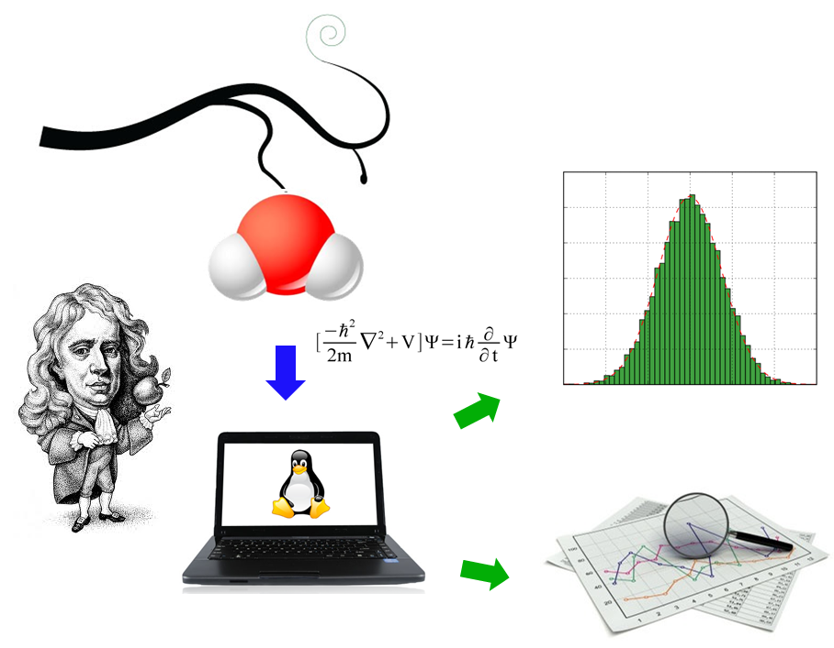

Part of the inhumanity of the computer is that, once it is competently programmed and working smoothly, it is completely honest.

*Isaac Asimov*

* 1. **Introduction**

Photophysical processes carry out a change in the electronic state of the system preserving its chemical identity. After excitation, the excess energy can be dissipated through emission or radiationless transitions. Such energy can also be transfer to other molecules through other processes, such as quenching or photosensitizing.

In this Ph. D. Thesis we explored the energy transfer process, especially the so called triplet-triplet energy transfer (TET) phenomenon. Particular emphasis has been paid to the identification and quantification of the contribution of each coordinate to the TET reaction coordinate, as will be detailed in section 4.2.1,. Subsequently in section 4.2.2, we have tackled the dynamical study of the TET, focusing on the temperature role to drive the sampling of the phase space.

Finally in section 4.2.3, it is discussed in detail the algorithms to explore the geometrical space which modulates the TET process.

* + 1. **Energy Transfer Mechanisms**

An energy transfer can take place between an electronically excited donor (D*) and a ground-state acceptor species (A) without the emission of a photon while transferring energy, where D and A can be two molecules (intermolecular process) or two parts of the same molecule (intramolecular process). The probability of intramolecular energy transfer between two electronic states is inversely proportional to the energy gap ΔE, between the two states. The rate constant value for radiationless transitions decreases with the size of the energy gap between initial and final electronic states.

An Intramolecular Energy transfer process with the same multiplicity and close vibrational level from an upper to a lower excited state is called internal conversion. Since the probability of energy transfer is proportional to the difference between the two electronic states, internal conversion is highly favoured from upper excited electronic states. Moreover, intramolecular energy transfer involving two electronic states of different multiplicity (spin-forbidden) is called intersystem crossing.

Energy transfer processes can be divided into two main classes, both of increasing importance in chemistry and biochemistry: Förster resonant energy transfer (FRET) and Dexter-type energy transfer. For some relevant applications see: (Langhals, et al. 2010, Muñoz-Losa, et al. 2009)(FRET) and (Monguzzi, et al. 2008, Reineke, et al. 2009)(Dexter-type). The Förster model is based on the idea that a Coulomb interaction stands between D* and A, by which the energy released by D* can simultaneously excite A, finally resulting in D and A* species. Exchange interaction or Dexter mechanism can be visualized as electron transfer where one electron moves from the excited donor highest occupied molecular orbital to the acceptor lowest unoccupied molecular orbital, while an electron moves from the acceptor highest occupied molecular orbital to the donor lowest unoccupied molecular orbital, Therefore in exchange energy is transfer. The exchange resonance interaction of D* and A occurs via overlap of electron clouds and requires close contact between the molecules. The transfer rate constant can be obtained through the golden rule formalism (Serpa, et al. 2003), which is expressed by:



where U2 represents the electron exchange coupling, depending only on the electronic configuration of the initial and final transfer states; J is a vibrational term that can be approached by the overlap integral between the normalized spectra of the donor phosphorescence (3D→1D) and acceptor ground-state triplet absorption (3A←1A) (Serpa, et al. 2003).

The electron exchange coupling term (U) for TET corresponds to the electronic exchange integral (Speiser 1996, You and Hsu 2010):



which mainly depends on the donor and acceptor molecular orbitals overlap (frequently HOMO and LUMO of donor and acceptor respectively), giving rise to an exponential decrease of the coupling as originally proposed by Dexter(Dexter 1953). Because of the non-vanishing coupling, adiabatic potential energy surfaces of both electronic states (i.e. before and after the transfer) do not present real crossings (i.e. conical intersections see section **Error! Reference source not found.**), showing slightly avoided crossings in the intersection space defined by the diabatic states as a result of the weak coupling. Since triplet-triplet energy transfer (TET) is forbidden by the dipole-dipole energy transfer, the Dexter model is the only mechanism for TET. In Figure 1, it is shown a schematic diagram of the triplet energy transfer through the Dexter exchange mechanism.

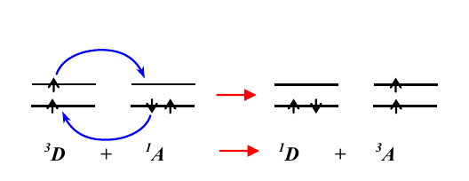

Figure Electron and spin exchange between a triplet donor (D) and a singlet acceptor (A) in triplet-triplet energy transfer.

* + 1. **Energy Transfer Reaction Coordinate**

It was early realized that in some highly endothermic TET reactions, the experimental value of the rate constant was much larger than that expected from the unfavorable energy balance, computed using singlet-triplet optical transition energies (Saltiel and Hammond 1963, Saltiel, et al. 1984). These anomalous cases had in common acceptor compounds with flexible molecular structure, like e.g. cis-stilbene, for which nonvertical 3A←1A excitation processes were initially postulated (Saltiel, et al. 1984). It was later shown that excitation transitions in these cases do not depart from the classical vertical behavior, but the (unfortunate) nonvertical term became firmly established. These apparent deviations from classical TET are explained by postulating acceptor geometries for which the energy of the lowest triplet state is substantially lower than the optically recorded value and which are thermally accessible even at room temperature (Ramamurthy and Liu 1976). The overlap integral J in , for the kind of molecules discussed previously cannot be computed due to the absence of spectroscopic information on the electronic transitions of the thermally activated acceptor states. The geometrical distortions which are effective in lowering the triplet state energy of a flexible acceptor result from displacements along internal vibrational molecular coordinates, and provide the reaction path for the transfer process. There have been several attempts to identify experimentally these favorable molecular deformations, e.g. for the paradigmatic case of cis-stilbene but, unfortunately, the results were contradictory (Brennan, et al. 1994, Caldwell, et al. 1992, Lalevee, et al. 2005, Saltiel, et al. 2003). This ambiguity may be removed by theoretical modeling of the transfer step, and this also has been carried out at different levels of approximation (Catalán and Saltiel 2001).

In this thesis is developed a formalism to characterize and quantify the contribution of each molecular coordinate to the reaction path for the transfer processes, as well be developed in section 4.2.1.

* + 1. **Energy transfer Processes**

TET process plays a fundamental role in several important applications as it is the photodynamic therapy (PDT), where a photosensitizer as porphyrin and its derivatives (Brasseur 2003), is administered to the patient in different ways. When the substance has its maximum accumulation in the target tissue, the affected area is irradiated at wavelength around 600-800 nm populating the singlet excited state Sn of the photosensitizer. After a vibrational decay to the S1 state, the system carry out an intersystem crossing to T1 which transfer the excitation energy to the 3O2 molecule generating 1O2 (1Δg). The singlet oxygen has been appointed to be the cytotoxic agent (Ethirajan, et al. 2011, Redmond and Kochevar 2006). A schematic representation of the TET in the photodynamic therapy is shown in figure 2.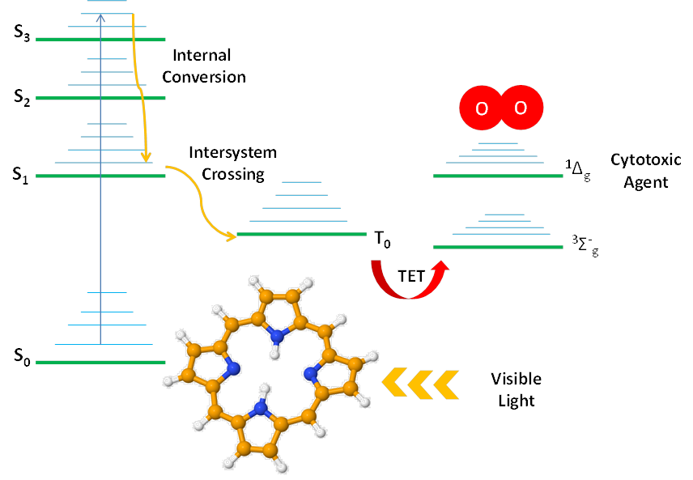

Figure 2. Pictorial representation of the photophysical process underlying the generation of the cytotoxic agents in the photodynamic therapy.

The key step in the TDP is the energy transfer from the donor to the molecular oxygen. Because this process happens in solution, as most of the TET applications, where it is established a thermal equilibrium between the acceptor, donor and/or solvent. It is highly desirable to describe the geometrical and energetic changes at molecular level, which are carried out the available energy at a given temperature.

In the section 4.2.2, we explored the dynamical behaviour of the system porphyrin-oxygen as a minimal model in the process of PDT.

## Results

### Definition and determination of the triplet-triplet energy transfer reaction coordinate

Taking into account the weak electronic coupling limit, is was developed a theoretical methodology to identify and quantify the contribution of each internal molecular coordinate to the TET reaction coordinate, through the definition of the so called geometrical distortion parameter, which takes into account both the change in the singlet-triplet energy gap as the activation energy associated with each internal coordinates. The uncoupling of both PESs for the donor and acceptor moieties, resulting from the weak electronic coupling limit, allows to describe separately in terms of geometrical distortion, the change that an acceptor (or donor) must undertake in order to favour the TET constrain to a minimal activation energy. The developed methodology was applied to a paradigmatic case of the cis-stilbene.

Using a quadratic expansion of the PESs it was possible to calculate the geometrical distortion parameter for each coordinate and accordingly, there were identified the coordinates which contribute significantly to the overall reaction coordinate. These coordinates are characterized by having different force constants in both singlet and triplet states (under a quadratic approximation of the PES), resulting in the possibility to modulate the singlet-triplet energy gap since changes in one electronic molecular state due to geometrical distortions are not mirror by the other electronic state, resulting in a deviation from the vertical singlet-triplet energy gap. Moreover these geometrical distortions must be reachable with a limited quantity of kinetic energy. Because of the limited supply of thermal energy, the TET reaction coordinate is defined as the set of internal coordinates which efficiently increase or decrease the singlet-triplet energy gap, with the minimal activation energy.

For the case of the cis-stilbene it is shown that the central C=C bond stretching vibration, together with the phenyl-vinyl torsions are the main coordinates responsible for the non-vertical behaviour of cis-stilbene.

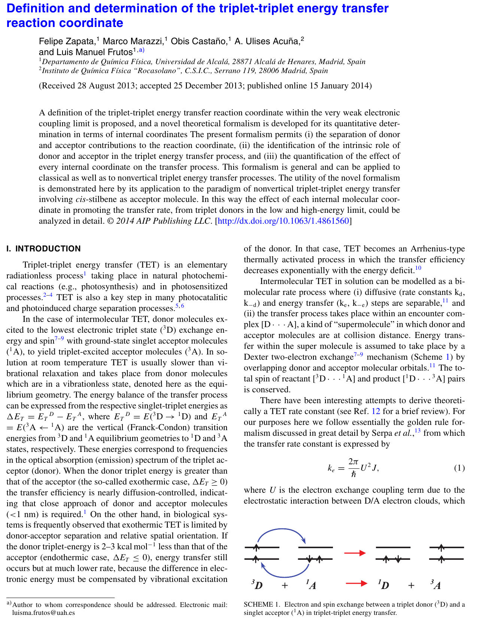

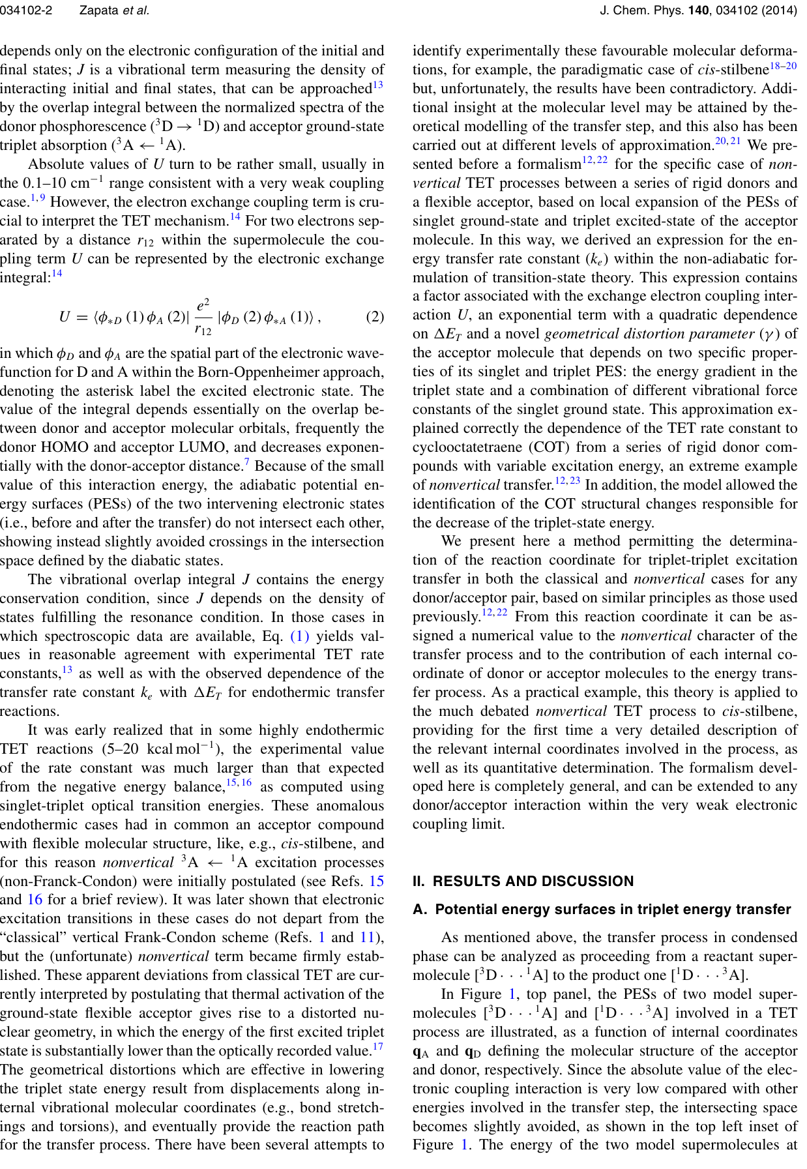

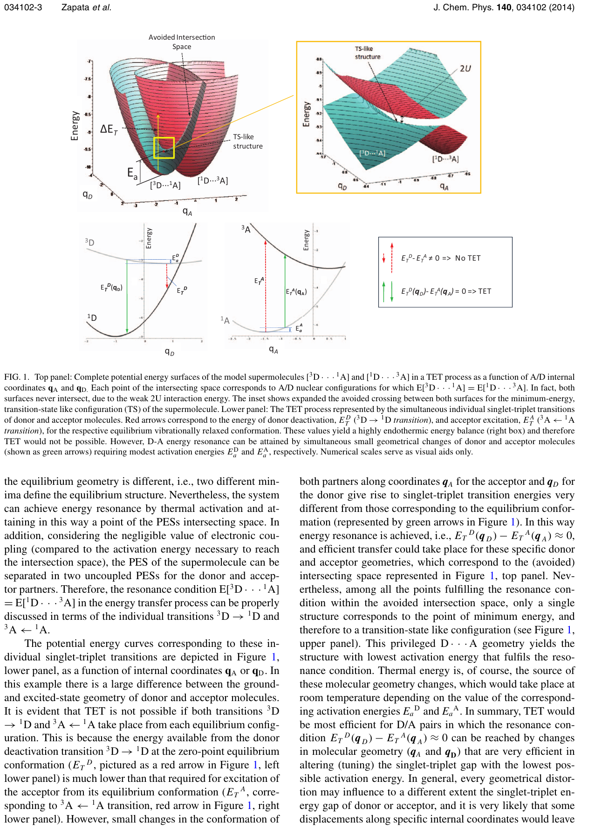

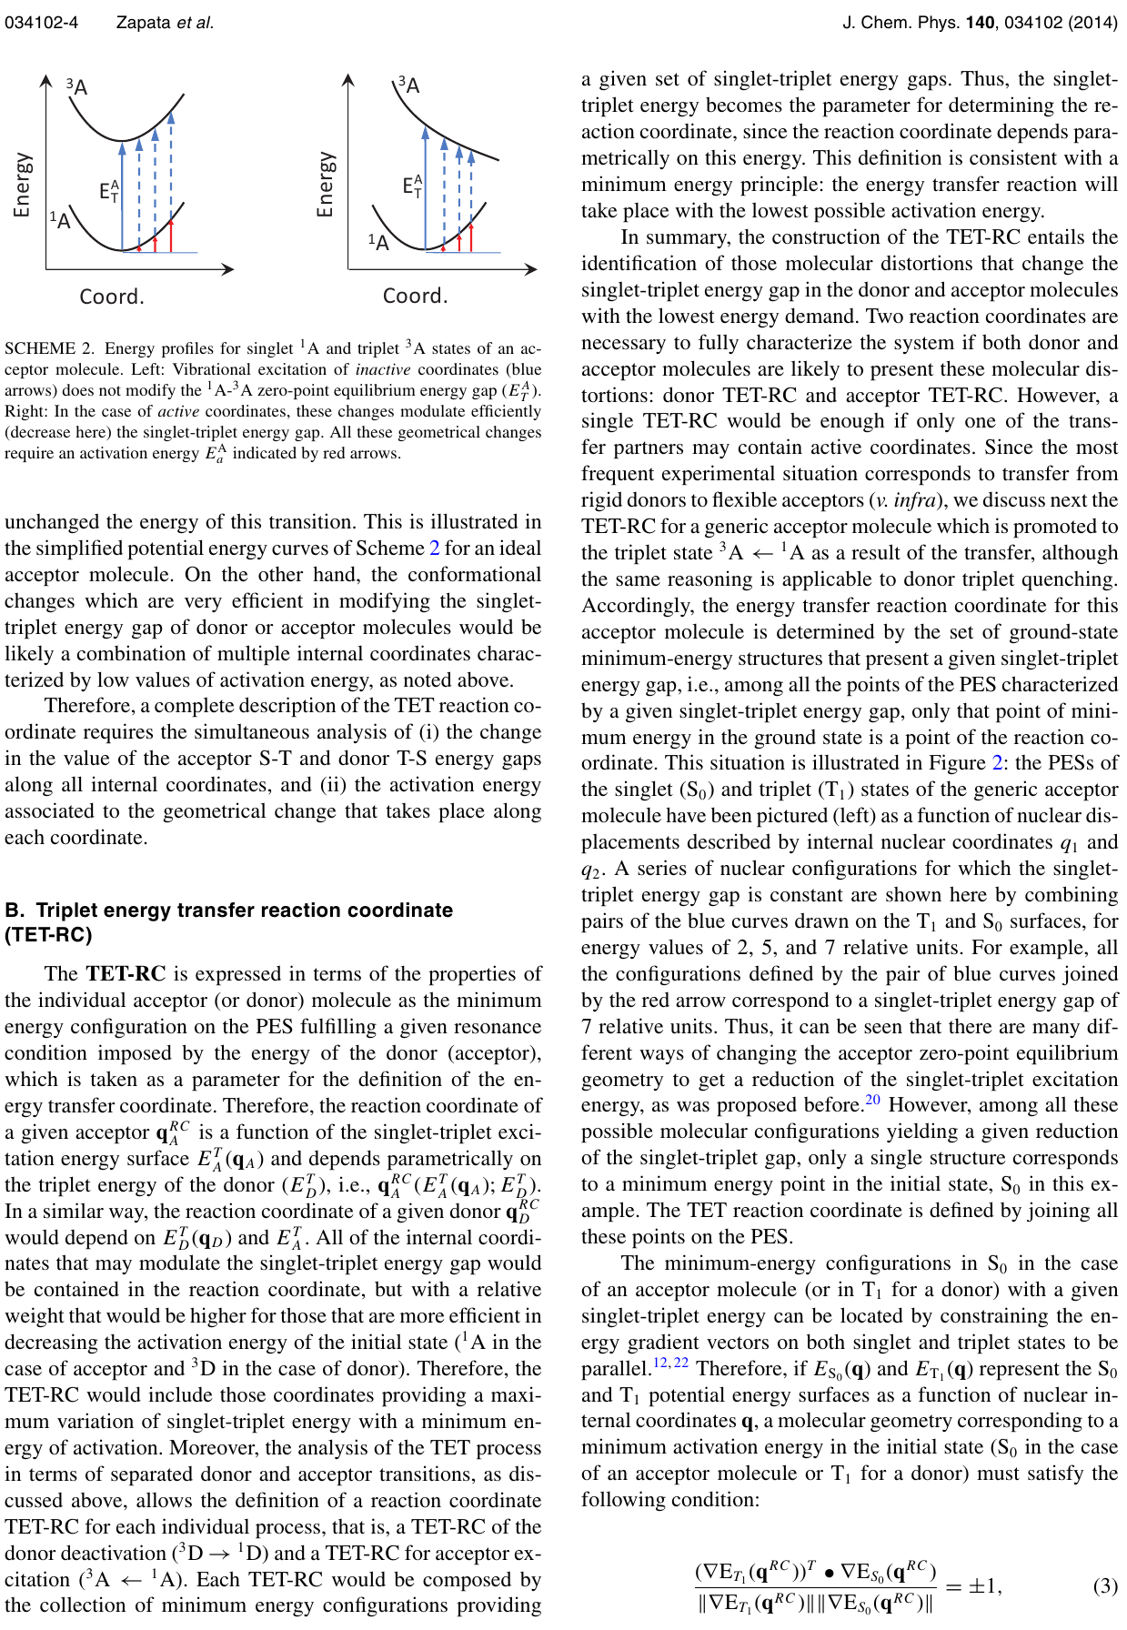

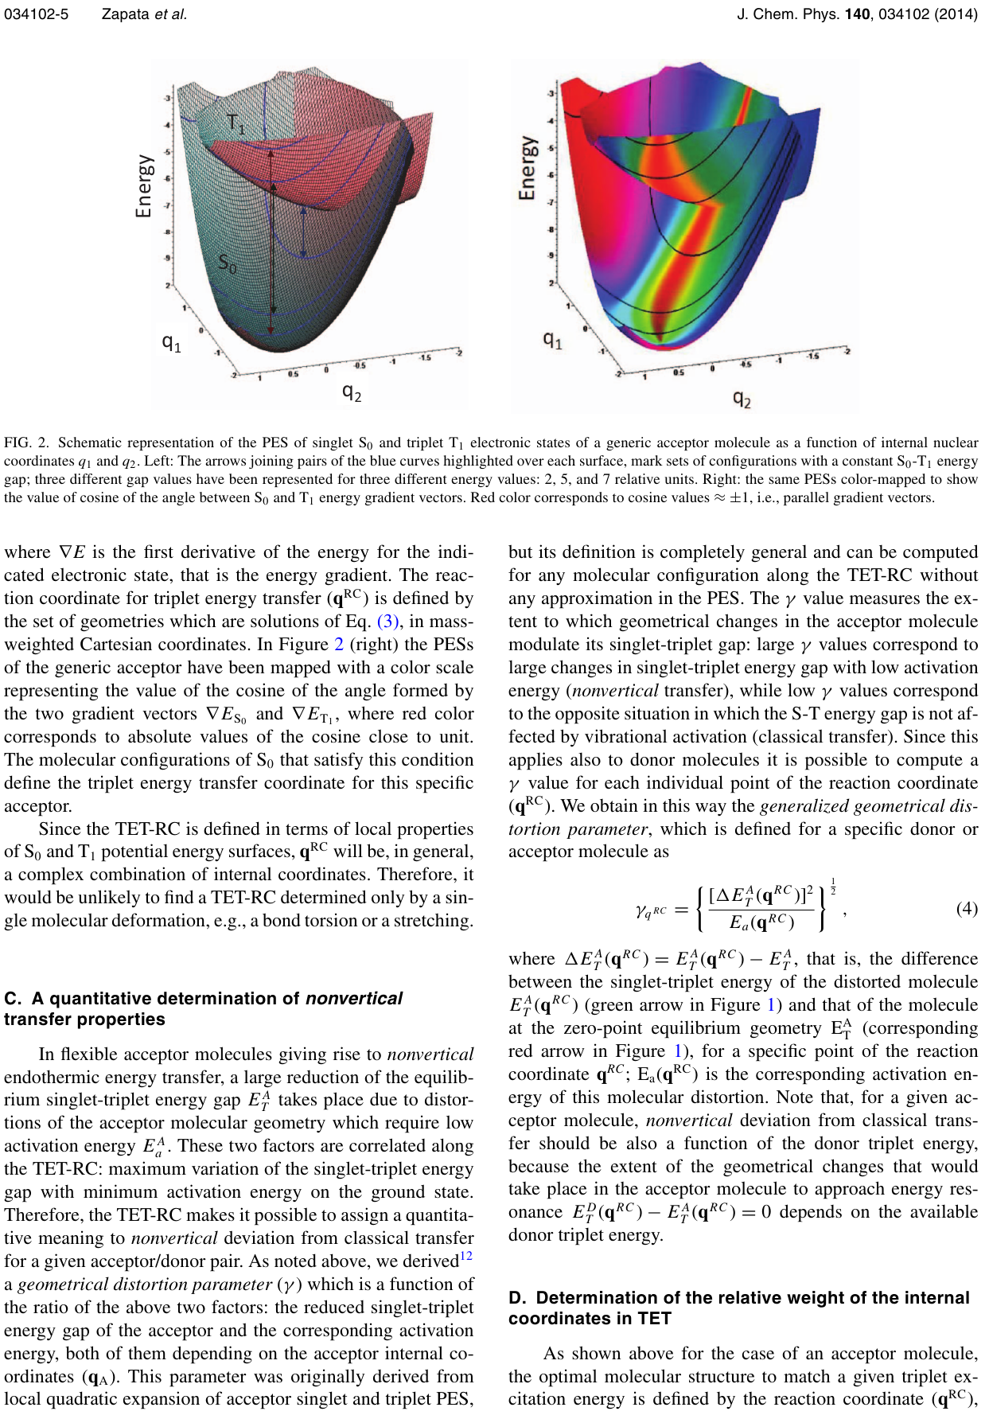

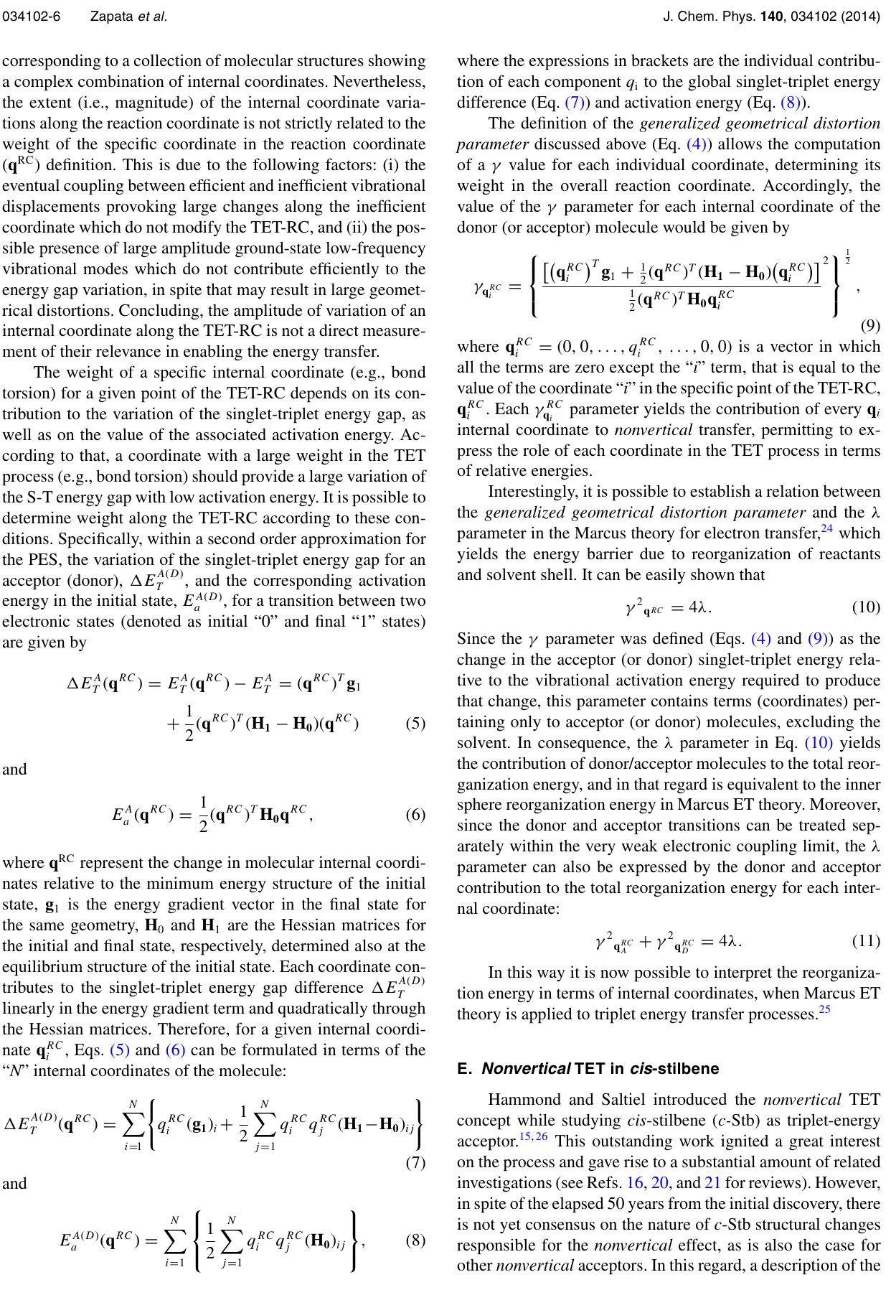

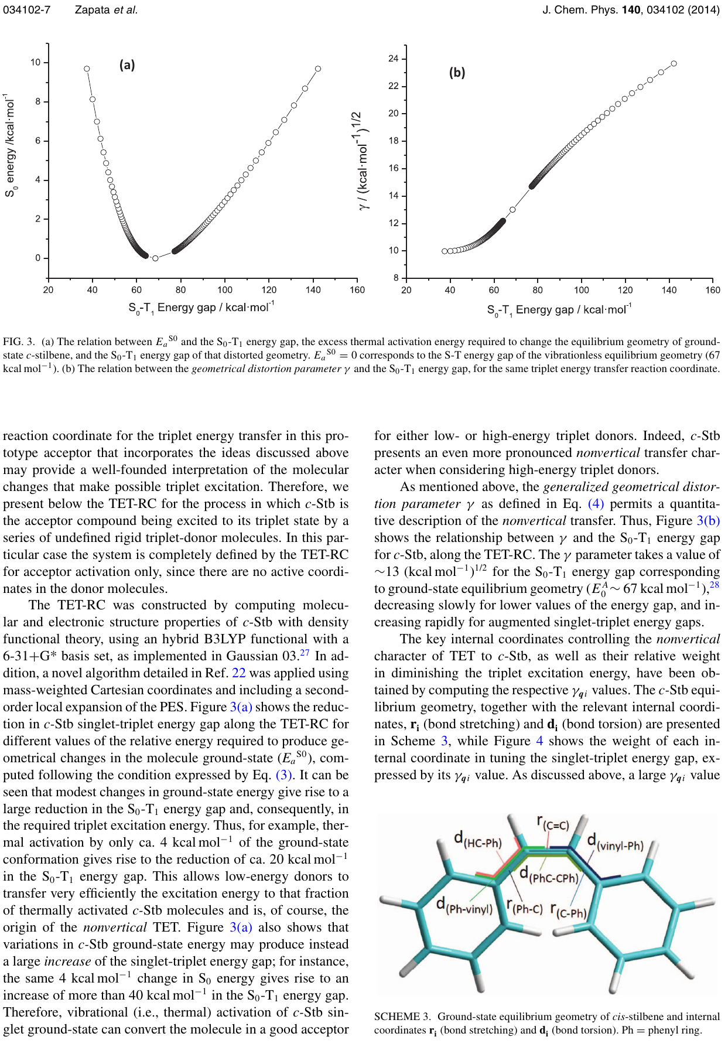

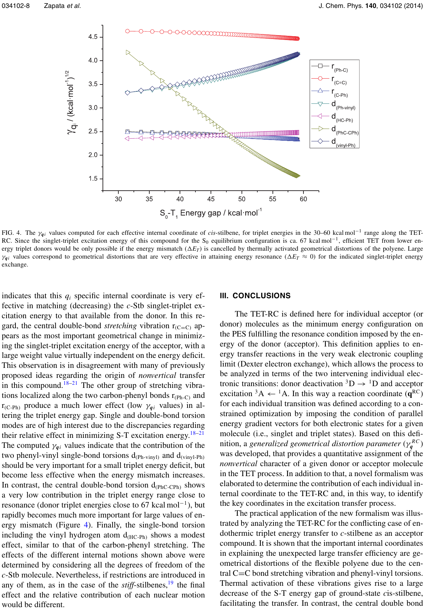

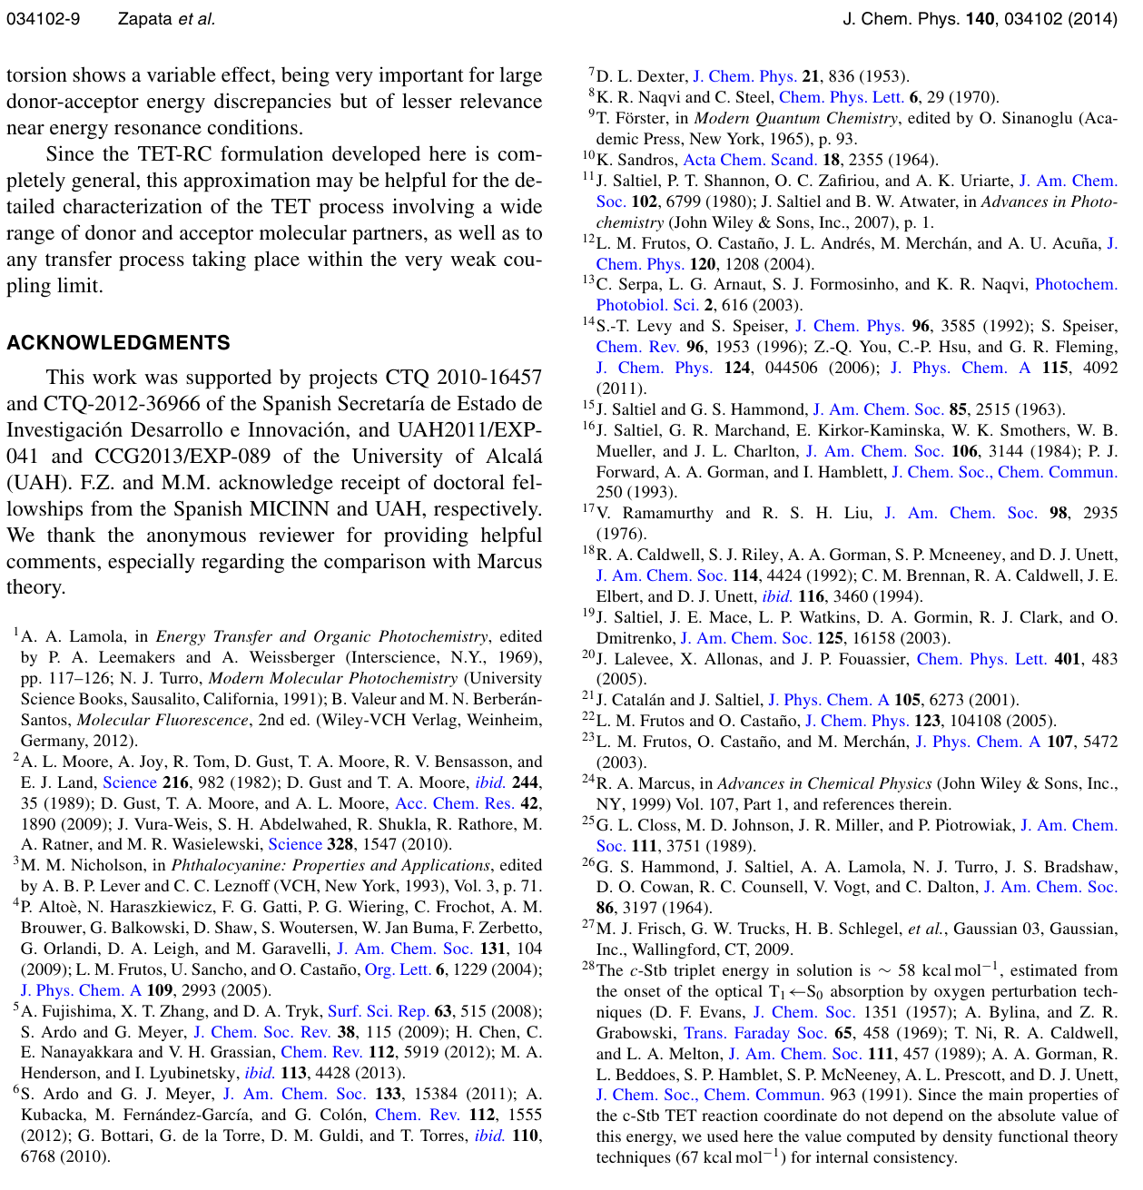

* + 1. **A Dynamical approach to the triplet-triplet energy transfer reaction coordinate**

In section 4.2 we explored a static version of the process of triplet energy transfer and even though the geometrical distortion parameter can effectively characterized the relevant coordinates of the TET process, it does not tell us how the system behaves in solution where there is a significant amount of energy constantly interchange between the solute and the dissolvent and there is a physical limit of the available thermic energy that can be used to module the singlet-triplet energy gap. Therefore in this section a dynamical approach is presented.

* + 1. **Triplet energy transfer space**

As has been discussed in the introduction (see section 4.1), triplet energy transfer required that the singlet-triplet energy gap of both donor and acceptor become equal. For a given donor (or acceptor) there is associated a singlet-triplet energy gap, therefore the acceptor (or donor) moiety must carried out some geometrical distortions in order to modify its own singlet-triplet energy, gap maximizing the reaction efficiency.

* + - 1. **TET-ACC algorithm**

In order to calculate the set of geometrical configuration with a given singlet-triplet energy gap, which can be reached with the minimal energy distortion, it was developed an algorithm called triplet energy transfer–activated complex coordinate (TET-ACC) (Frutos and Castano 2005). In this development, the equilibrium geometry in S0 belongs to the TET–ACC curve, therefore this point can be used as center of a hypersphere, containing at least two points on the surface, which fulfil that the gradient in both S0 and T1 states are parallel, one correspond to gradient vectors oriented in the same direction while the other case correspond to opposed directions. The TET-ACC localized both of these points and base on them, it is build a couple of new hyperspheres, where new points fulfilling the parallel condition are localized and the procedure continuous iteratively. This procedure is schematically represented in Figure 3.

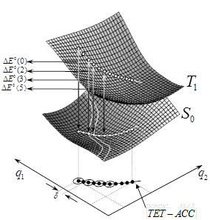

Figure 3 Beginning from the minimal point in the S0 state, it is iteratively build a set of hyperspheres containing the optimized points which are the tangent point between the hyperspheres, creating a TET-ACC curve. Each point corresponds with a different singlet-triplet energy gap .

The optimization process on the hypersphere surface is based on the gradient difference (GD) or force difference vector  between both electronic states (S0 and T1). defines the direction which keeps constant the singlet-triplet energy gap, assuming that the singlet-triplet energy gap can be linearly approximated. The optimization is carried out taking a given displacement in the direction of the projection of S0 force vector onto the subspace which is orthogonal to  and minimized S0 while keeping constant the difference S0-T1, finally the displacement is projected onto the hypersphere surface, as shown on Figure 4. In the new optimized point it is again calculated the gradient vector both on S0 and T1, if both vectors are not parallel (optimization condition) the previous optimization algorithm is repeated until the convergence criteria are fulfilled.

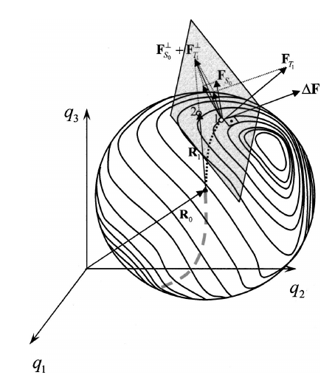

Figure 4. Schematic representation of the first step of the TET-ACC algorithm. The geometrical displacement from the point “1” to point “2” through the projection of the vector onto the hypersphere of center  and radius equal to  is represented. Likewise, the way that this vector is obtained as a sum of the projections of the force vectors on S0 and T1 ( andvectors) onto the plane perpendicular to.

The TET-ACC algorithm even though is accurate can be extremely inefficient, since it is on the energy gradients of both states, while the aim of the algorithm is to minimize (or maximize), the angle formed by these gradients, being most appropriate to analyse the gradient direction apart from its magnitude. Therefore it is important to include the Hessians for both states, improving the algorithm efficiency as will be described in the following section.

#### Quadratic approximation

Potential energy on both triplet and singlet states can be represented as a series expansion up to second order, allowing to follow the angular variation between the energy gradient vectors as function of the internal coordinates. It is important to bear in mind, that this variation is unknown in the TET-ACC algorithm since the gradient difference is constant.

Quadratic energy expansions on both electronic states, can tackle the two main drawback of the TET-ACC algorithm which are: a) slow convergence b) breaking symmetry description (which is impossible in a linear approximation). Both problems are closely related to optimization methods based on the gradient, for which it is impossible to break the system symmetry to identify a more stable minimum. Besides, algorithms like steepest descent also suffer from a poor convergence nearby a stationary point.

The quadratic expansion for the energy in both singlet and triplet states are given by:







where is the Franck-Condon point around which the expansion is center,a given configuration around the Franck-Condon point. andare the gradient and hessian computed at the expansion point, respectively. Accordingly the gradient at some point q for both states are:





Since we want to calculate the angle formed by the two gradient vectors, we can calculate firstly the dot product and use it to compute the angle between the two gradients as follows (omitting the  subscript):



then



or equivalently



Derivation of , which is the angle variation as function of the coordinates is expressed as:



The gradients of  and  are given by:





Replacing and into is obtained the rate of change of the angle between the gradients in both states as function of the molecular coordinates.



A first approximation to , is to evaluate it in the initial geometry, obtaining:



The approximation will be used in the improvement of the TET-ACC algorithm as is shown in the following section.

* + - 1. **TET-ACC improvement**

Since our primary objective is found those points for which the singlet and triplet energy gradients are parallel, equation must fulfill that:



And simultaneously:



It was not found an analytical solution to the set of equation and for the molecular position; therefore a numerical approximation was developed.

A schematic representation of the new optimization step is shown Figure 5. Beginning at new structure with coordinates  and imposing the optimization on the hypersphere surface of radius, it is calculated the vector evaluated at, according to . Then, a displacement in the direction or is carry out, depending if the aims is to minimize or maximize the singlet-triplet energy gap, restrained to a minimal activation energy. In this point it is newly calculated the gradient vector of the angle between both singlet and triplet states, if the convergence criteria is not achieved a new iteration is carry out until numerical convergence.

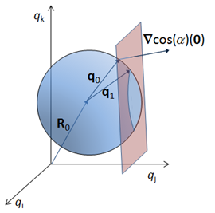

Figure 5. Schematic representation of an optimization step of the TET-ACC improved. Beginning at initial structure and calculating in that point it is determined the displacement which minimize or maximize, obtaining a new structure. Where are internal coordinates of the system.

#### Convergence criteria and optimization parameters

There are several control parameters in the optimization process. The first of them is the hypersphere radius, which can be chosen only inside the boundaries of the quadratic approximation. Therefore, radiuses between 0.01-0.05 Angstroms were taken which are inside the quadratic approximation.

In order to avoid rotations of the pivot vector , it was imposed a maximum rotation of 0.5 degrees. This constrains results in an increased in the number of iterations per optimization step, but poses no computational cost, since the gradients and hessians energies are the always the same independently of the position vector .

A point is considered to be optimized when it fulfil that the module of  is smaller than radians/Bohr and simultaneously  must be greater than 0.998. This last criterion guarantees that both gradient vectors in the singlet and triplet states are parallel.

Chapter Bibliography

Brasseur, N., Sensitizers for PDT: phthalocyanines. In *Photodynamics Therapy*, Häder, D.-P.; Jori, G., Eds. Royal Society of Chemistry: Cambridge, UK, 2003.

Brennan, C. M.; Caldwell, R. A.; Elbert, J. E.; Unett, D. J., Nonvertical Triplet Excitation Transfer to Arylalkene Acceptors: Further Evidence That Double Bond Torsion Is Unimportant. *J. Am. Chem. Soc.* **1994,** *116*, 3460-3464.

Caldwell, R. A.; Riley, S. J.; Gorman, A. A.; McNeeney, S. P.; Unett, D. J., Relaxed triplet energies of phenylnorbornenes. The role of phenyl-vinyl torsions. Origin of nonvertical triplet excitation transfer. *J. Am. Chem. Soc.* **1992,** *114*, 4424-4426.

Catalán, J.; Saltiel, J., On the Origin of Nonvertical Triplet Excitation Transfer:  The Relative Role of Double-Bond and Phenyl-Vinyl Torsions in the Stilbenes. *The Journal of Physical Chemistry A* **2001,** *105*, 6273-6276.

Dexter, D. L., A Theory of Sensitized Luminescence in Solids. *The Journal of Chemical Physics* **1953,** *21*, 836-850.

Ethirajan, M.; Chen, Y.; Joshi, P.; Pandey, R. K., The role of porphyrin chemistry in tumor imaging and photodynamic therapy. *Chem. Soc. Rev.* **2011,** *40*, 340-362.

Frutos, L. M.; Castano, O., A new algorithm for predicting triplet-triplet energy-transfer activated complex coordinate in terms of accurate potential-energy surfaces *J. Chem. Phys.* **2005,** *123*, 104108-104111.

Lalevee, J.; Allonas, X.; Fouassier, J. P., Triplet–triplet energy transfer reaction to cis-stilbene: a dual thermal bond activation mechanism. *Chem. Phys. Lett.* **2005,** *401*, 483-486.

Langhals, H.; Esterbauer, A. J.; Walter, A.; Riedle, E.; Pugliesi, I., Foerster Resonant Energy Transfer in Orthogonally Arranged Chromophores. *J. Am. Chem. Soc.* **2010,** *132*, 16777-16782.

Monguzzi, A.; Mezyk, J.; Scotognella, F.; Tubino, R.; Meinardi, F., Upconversion-induced fluorescence in multicomponent systems: Steady-state excitation power threshold. *Physical Review B* **2008,** *78*, 195112(1)– 195112(5).

Muñoz-Losa, A.; Curutchet, C.; Krueger, B. P.; Hartsell, L. R.; Mennucci, B., Fretting about FRET: failure of the ideal dipole approximation." Biophys. J. 96: 8. *Biophys. J.* **2009,** *96*, 4779-4788.

Ramamurthy, V.; Liu, R. S. H., Photochemistry of polyenes. IX. Excitation, relaxation, and deactivation of dienes, trienes, and higher polyenes in the vitamin A series in the sensitized isomerization reaction. *J. Am. Chem. Soc.* **1976,** *98*, 2935-2942.

Redmond, R. W.; Kochevar, I. E., Symposium-in-Print: Singlet Oxygen Invited Review. *Photochem. Photobiol.* **2006,** *82*, 1178-1186.

Reineke, S.; Lindner, F.; Schwartz, G.; Seidler, N.; Walzer, K.; Luessem, B.; Leo, K., White organic light-emitting diodes with fluorescent tube efficiency. *Nature* **2009,** *459*, 234-238.

Saltiel, J.; Hammond, G. S., Mechanisms of Photochemical Reactions in Solution. XVII. cis-trans Isomerization of the Stilbenes by Excitation Transfer from Low Energy Sensitizers. *J. Am. Chem. Soc.* **1963,** *85*, 2515-2516.

Saltiel, J.; Mace, J. E.; Watkins, L. P.; Gormin, D. A.; Clark, R. J.; Dmitrenko, O., Biindanylidenes:  Role of Central Bond Torsion in Nonvertical Triplet Excitation Transfer to the Stilbenes. *J. Am. Chem. Soc.* **2003,** *125*, 16158-16159.

Saltiel, J.; Marchand, G. R.; Kirkor-Kaminska, E.; Smothers, W. K.; Mueller, W. B.; Charlton, J. L., Nonvertical triplet excitation transfer to cis- and trans-stilbene. *J. Am. Chem. Soc.* **1984,** *106*, 3144-3151.

Serpa, C.; Arnaut, L. G.; Formosinho, S. J.; Naqvi, K. R., Calculation of triplet-triplet energy transfer rates from emission and absorption spectra. The quenching of hemicarcerated triplet biacetyl by aromatic hydrocarbons. *Photochemical & Photobiological Sciences* **2003,** *2*, 616-623.

Speiser, S., Photophysics and Mechanisms of Intramolecular Electronic Energy Transfer in Bichromophoric Molecular Systems:  Solution and Supersonic Jet Studies. *Chem. Rev.* **1996,** *96*, 1953-1976.

You, Z.-Q.; Hsu, C.-P., The fragment spin difference scheme for triplet-triplet energy transfer coupling. *The Journal of Chemical Physics* **2010,** *133*, 074105.

# Optomechanical Control of Spectroscopy Molecular Properties and Photoinduced Mechanical Work

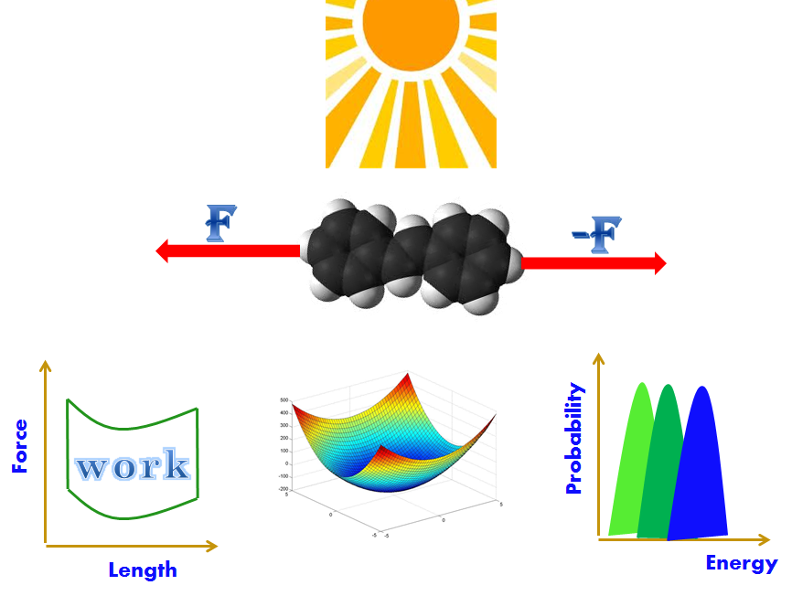

*The most exciting phrase to hear in science, the one that heralds new discoveries, is not 'Eureka!' but 'That's funny...'*

*Isaac Asimov*

## Introduction

The modulation of spectroscopical properties can be accomplished based on different approaches, which seek to induce a bathochromic or hypsochromic shift in the spectra. Some of those experimental methods are: chemical modification of the chromophore, application of an external force, change of solvent, adjustment in the pH conditions or mutation in the gen which expressed a protein, changing the chemical surrounding. Nevertheless, since those modifications, in general does not follow a well-defined methodology, but rather are random modifications of countless possibilities it will be desirable to establish a procedure in order to accurately determine which kind of modifications produces the desired effect.

In this Ph.D. thesis we have focused on developed a set of methodologies which provides guidelines on the prediction and if possible the modulation of wavelength absorbed for a general chromophore under the effect of an external force. Firstly, in section 5.2.1 we have tackled the problem of the influence of a substituent on the excitation energy of a chromophore and subsequently in section 5.2.2 we have engaged in a dynamical study of the application of a mechanical external force to a chromophore.

On the other hand, the accomplishment of a molecular device which uses geometrical transformations, as the driving force to generate a periodic motion which result in an autonomous power generation at molecular scale, has been a major goal in molecular engineering. The design of such devices requires a careful consideration of the many physical details involved in such devices, as the nature of the energy required to carry out the geometrical transformation, the automation of the cyclic power generation, as well as the requirements in terms of structure and chemical reactivity that the candidates molecules should have, etc. The development of a methodology which serves as a guideline in the building of such molecular devices will deeply discussed on section 5.2.4.

### Mechanochemistry

Even though the application of external mechanical forces has been linked to the chemistry since its beginning as science (e.g. maceration and grinding of raw materials), it has been only in the last years that it has received attention as a possibility to induce chemical reactions or change physical chemistry properties. Since the introduction of the surface force apparatus in the early 1970’s, a new and proliferous experimental field in the researching of the interaction of external forces with molecular systems has bloom. The capacity to measure not only the macroscopic properties of some bulk material under stress, but the ability to follow the breaking of a covalent bond into single molecules, has endowed us with chemical information that was not possible to obtain before, clearing the way to design new simulations. For an extended discussion of the state of the art in Mechanochemistry see: (Balaz, et al. 2013, Beyer and Clausen-Schaumann 2005).

Experimental Methodologies as single-molecule force spectroscopy (SMFS) and scanning tunneling microscopy (STM) alongside with theoretical methodologies have allowed us to follow different phenomena in a very atomistic detail as: polymeric properties (Caruso, et al. 2009, Holland, et al. 2003, Wiggins, et al. 2012) , optomechanics (Bléger, et al. 2011), peptides conformation (Blanco-Lomas, et al. 2012), bond stability (Helgaker, et al. 2000), switchable conductivity (Wang, et al. 2009) among others.

In this thesis the simulation of applied mechanical forces in molecules is used on the modulation of the energetic gap between the fundamental and the optical brilliant states of some relevant molecules. Of special interest in this thesis is the work generated by molecular motors under the influence of mechanical forces (Hugel, et al. 2002, McCullagh, et al. 2011). Specially we focus on the control of the spectroscopical properties once the molecular switch is subject to external forces transmitted through the linker (*e.g.* covalently bound to a protein or peptide (Blanco-Lomas, et al. 2012, Schierling, et al. 2010), or introduced in the main chain of a polymer systems (Ercole, et al. 2010, Sapich, et al. 2005). More generally, in this thesis we present a new and efficient method to simulate single molecule force spectroscopy of whatever chromophore.

### Molecular Switches and Motors

On the other hand, photoswitches are bi-stable (state A and B) chromophores of special interest in the design and fabrication of optomechanical devices, since the absorption of light at a certain wavelength by state A is usually followed by a large structural change, which makes possible to reach state B. Then a second pulse of light (or thermal relaxation step), commonly at a different wavelength, reverse the process defining a pathway from state B back to state A (Balzani, et al. 2008, Feringa and Browneed 2011). Especially, switches based on photoisomerization are commonly applied to solve a variety of scientific and engineering problems, ranging from protein conformation control to photocatalysis, from molecular data storage to foldamers. In all these cases, photoisomerization provides an efficient (*i.e.* ultrafast time scale) way to switch a process ON and OFF (Garcia-Iriepa, et al. 2013). Moreover, we can take advantage of the photoswitching property of a chromophore by generating optomechanical work in a single molecule device, operating switching cycles in a periodic mode, and therefore leading to the eventual design and fabrication of optomechanical motors (Holland, et al. 2003).

Of particular interest are the optomechanical materials, which are based on direct conversion of light (applied as input), into macroscopic motion. This behaviour depends on the molecular structure of the material itself. Especially, soft organic materials were successfully designed as optomechanical responsive systems (*e.g.* oligomers and polymers) where the presence of one or more chromophore units is essential to ensure light absorption, which constitutes the first necessary event to promote the subsequent conformational and/or chemical modification underlying mechanical motion (Bleger, et al. 2011, Hosono, et al. 2010).

In this thesis it is presented a theoretical methodology to develop molecular switches and motors based on the protonated Schiff base chromophores of rhodopsins, remarking the use of hydrogen bonds in the unidirectional rotation.

## Results

### Structural Substituent Effect

The relation between structure and reactivity which has been in vogue for many years in chemistry since the initial Linear Free Energy Relationship (LFER) of Hammett (Hammett 1937) to the series of improvements and modification to interpret the mechanism of organic reaction in the ground state (Swain and Lupton 1968, Taft 1952) , has been extensively studied and successfully applied to the study of mechanism and catalysis. On the other hand, the substituent effect on the excited states was attempted to rationalize by the Woodward’s rules which relates empirically the wavelength of the absorption maximum in UV spectra and the extent of carbon-carbon double bond substitution in conjugated systems (Woodward 1941), but still there is not a clear methodology to predict the excitation energy of substituted chromophores. Therefore, in this Ph.D. thesis it is presented a methodology which predicts the excitation energy of a substituted chromophore based on the structural modifications induces by the substituent on the reference chromophore.

In the case of an organic chomophores, if the substituent does not play an import role in the nature of the excitation state, meaning that the substituent does not have a lone pair of electrons or π orbitals which can resonate with the chromophore, it is possible to analyse the effect substituent on the alteration of the energy absorbed by the chromophore, regarding the substituent as an external force which disrupts the equilibrium of an unsubstituted molecule.

In the work presented in section 0 it is shown how can be expressed the excitation energy as function of the some intrinsic parameters of the unsubstituted chromophore, assuming that a quadratic interpolation spanned around the equilibrium geometry of the unsubstituted chromophore can accurately described the structural modifications induces by the substituent. It is then shown that the excitation energy is given by the following expression,



Where *R* stands for properties of the substituted chromophore, is the equilibrium structure of the unsubstituted chromophore,  is the structural distortion caused by the substituent,  is the gradient of the unsubstituted chromophore in the excited state, and ,are the Hessian matrices for the unsubstituted chromophore for the gradient and excited state, respectively.

According to equation the geometrical the change in the excitation energy resulting from the modification of the equilibrium geometry caused by the disruption of the substituent, can be divided in two factors: the distortion along the gradient and perpendicular to it. Subsequently is developed a method to identify the most relevant internal coordinates, being associated directly to the gradient or perpendicular to it.

Following, the method is tested on the family of S-nitrosothiols RSNO which has been shown to store, transport and release nitric oxide (NO) within the mammalian body (Stamler, et al. 1997). Considering the previous results of the mechanism of the photocleavage of the family of S-nitrosothiols, calculated at the CASPT2 level of theory (Marazzi, et al. 2012), it was obtained accurate geometrical structures which together with the methyl nitrosothiol as reference structure , were used to tested the foregoing methodology. Obtaining both excitation energies and the set of internal coordinates most relevant in the modulation of the absorption wavelength. Finally, it is shown the comparison of the results given by the presented method with respect to *ab initio* calculations, showing the accuracy of the method and the interpretation of the error.

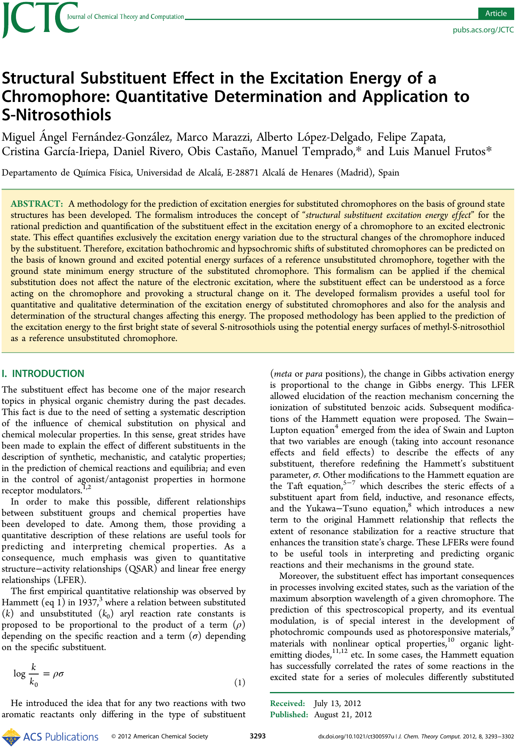

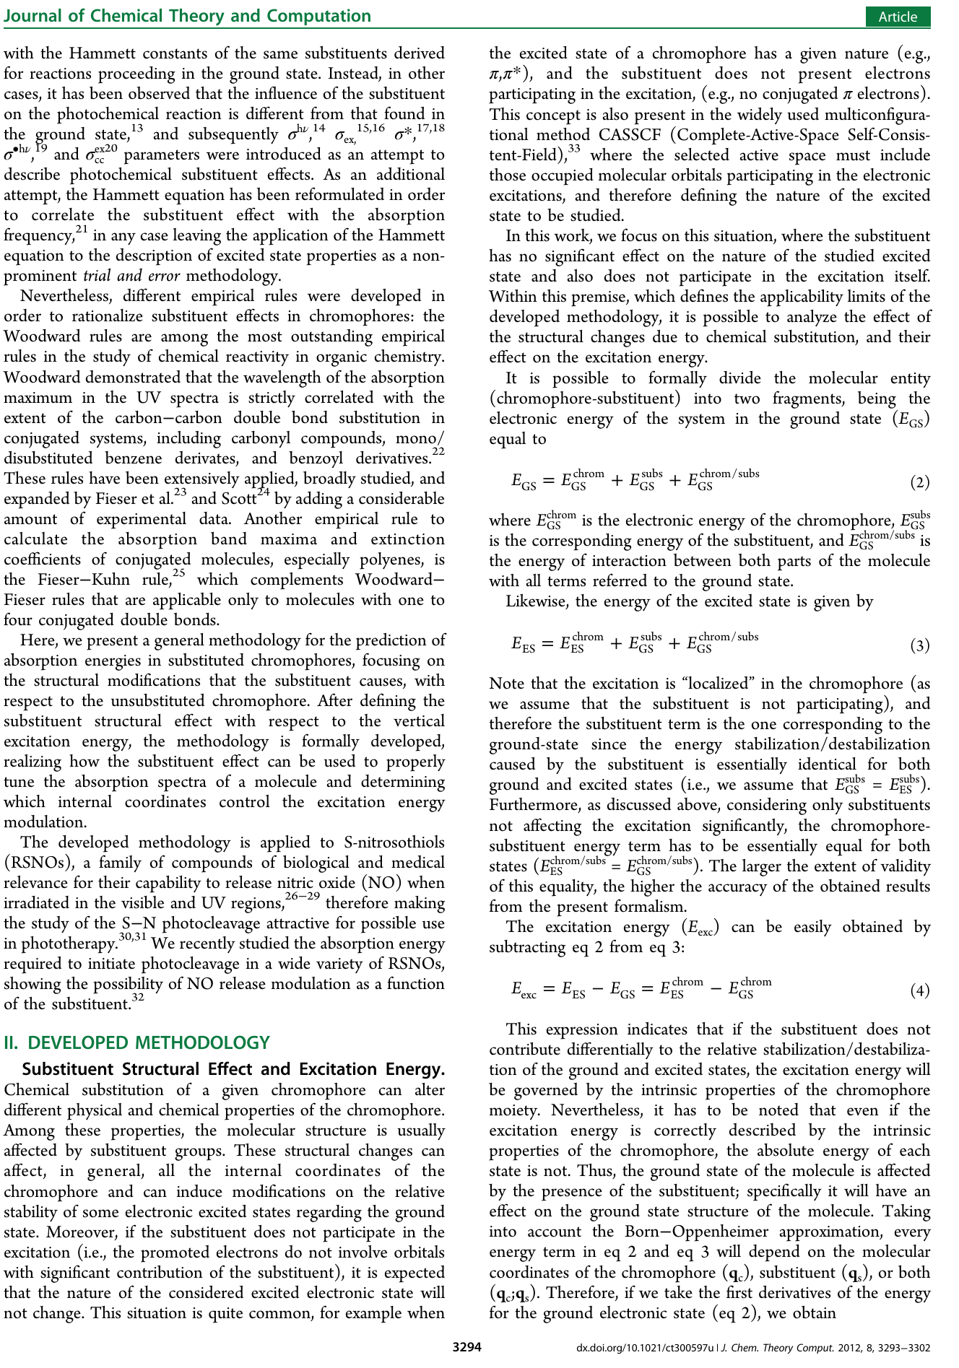

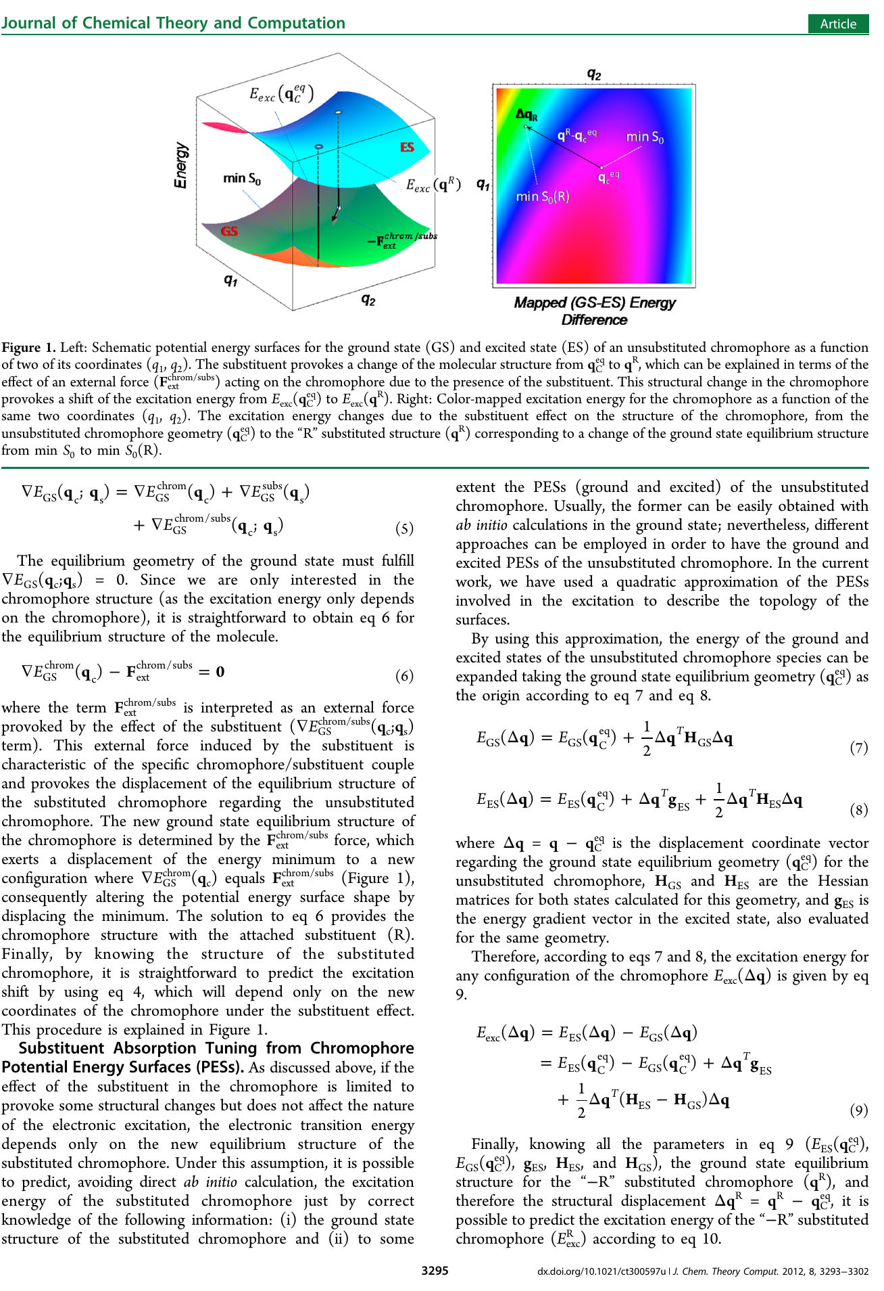

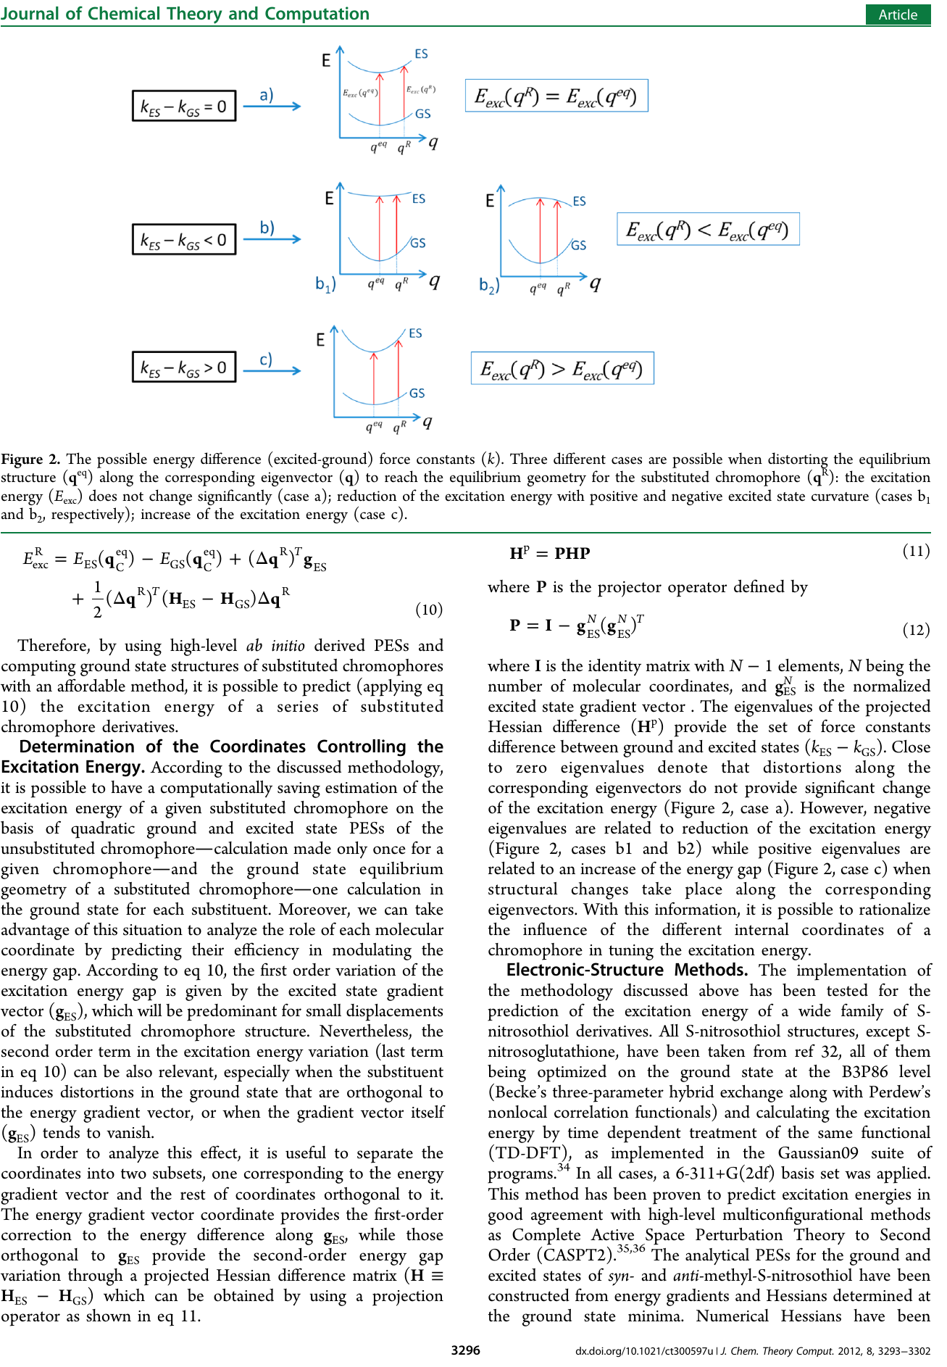

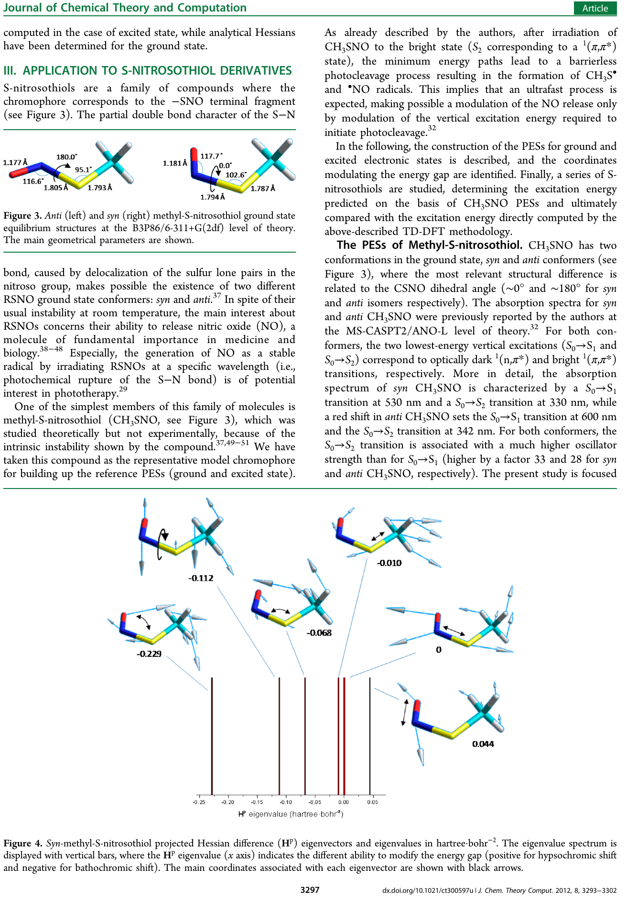

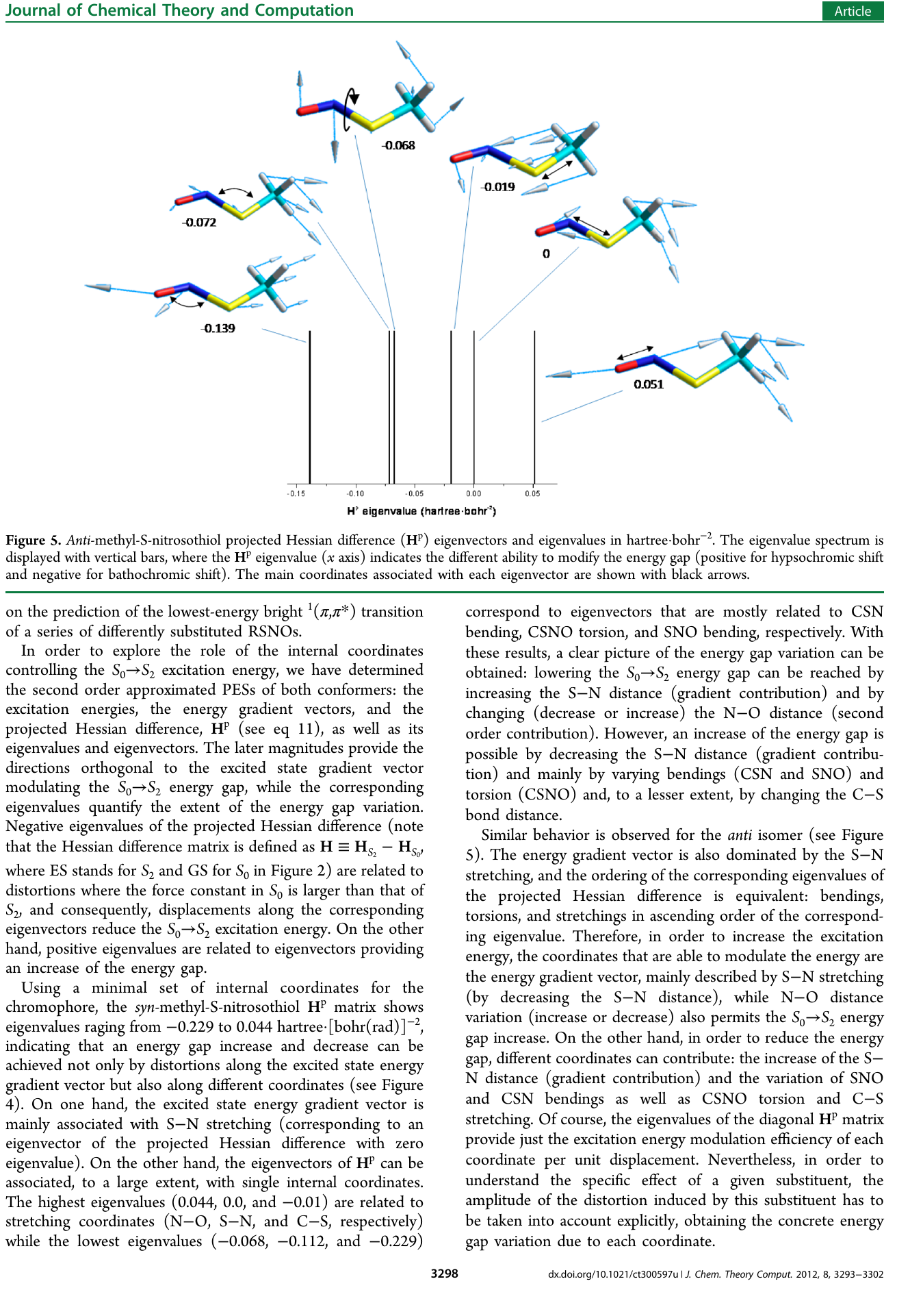

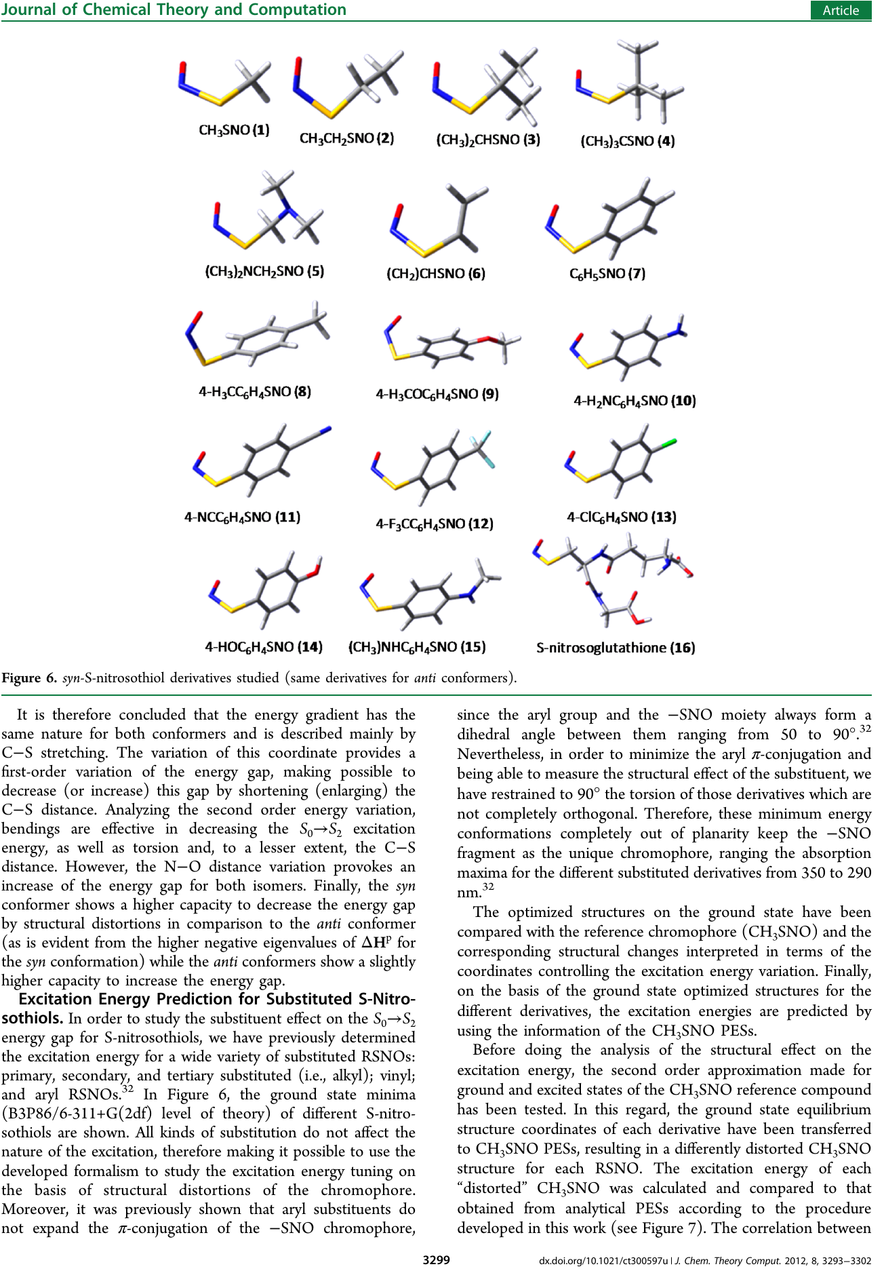

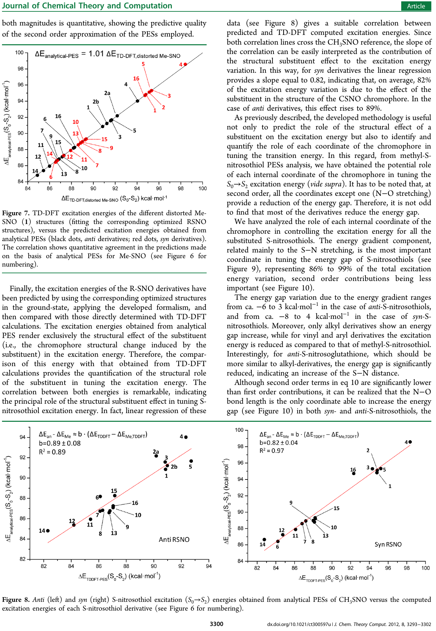

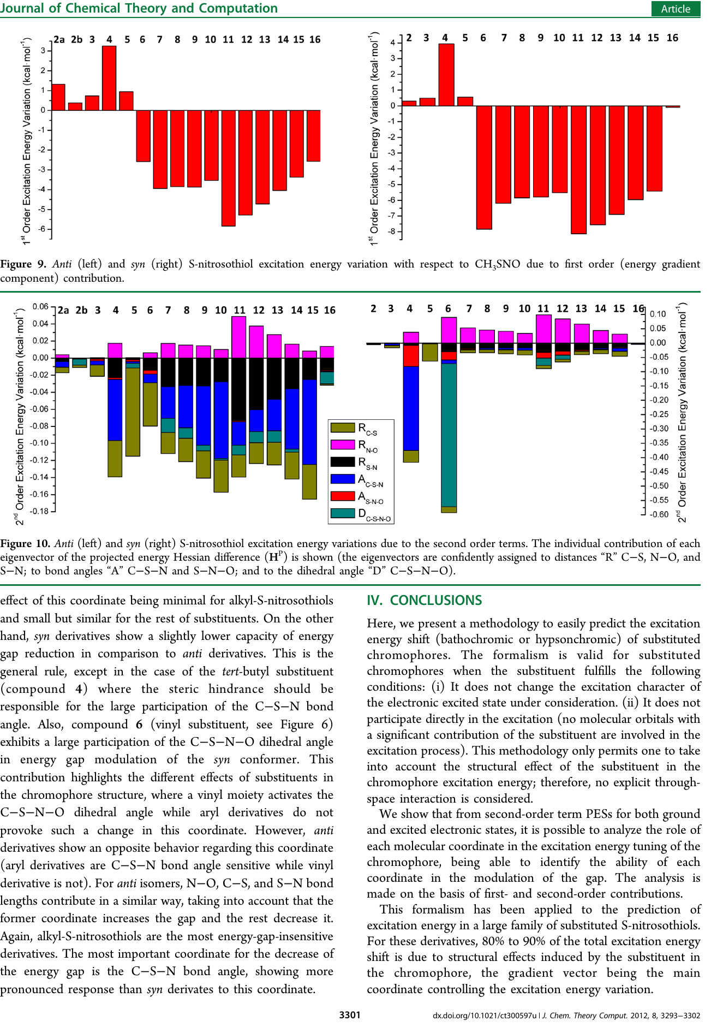



### Towards an Optomechanical Control of Photoswitches by Tuning the Spectroscopical Properties

As has been discussed in the foregoing section it is important to notice, that an external force can be regarded as an agent which can induce structural changes in the conformation of the molecule, being it a substituent or a direct applied mechanical force. Once we have tackled the “structural substituent excitation energy effect” we focus on a dynamical and static approach to the tuning of Spectroscopical properties.

Therefore in the contribution presented in this section, we have chosen a well study system regarding application of external mechanical forces as it is the azobenzene, in order to have an experimental framework for comparison. Then a careful study of the ground state topology was carried out, aiming to identify the mechanical limits of molecule and set the maximum external force which can be applied.

Subsequently using the methodology described on section 2.4, we carried out molecular dynamics at constant temperature on both minima for the cis and trans conformation of the azobenzene, using a quadratic interpolation around the both cis and trans minima. The external forces is represented as pair of forces (same magnitude and oppose direction) applied in the para position of both phenyl substituents. Using also a quadratic interpolation it was possible to obtain an analytical PES representation for the S1 and S2 excited states around the Franck-Condon point with respect to the ground states, being possible to compute in each step of the molecular dynamics the energy gap, for the lowest energy transitions S0→S1 and S0→S2, which correspond to optically dark (n,π*) and bright (n,π*) transitions, respectively. Allowing to simulate the absorption spectra for different magnitudes of external forces, for both the cis and trans configurations.

The simulated spectrum is obtained as an histogram which consist of a collection of evenly distributed deltas of excitation energy, where it is counted how many conformations of the (cis or trans) azobenzene sampled during the molecular dynamic simulation, have excitation energy inside one of those deltas, which after normalization provides the probability to have a given excitation energy. But in order to calculate the spectrum it is necessary to multiple those probabilities for the oscillator strength. With regard to the oscillator strength for the given range of excitation energies, it was calculated the oscillator strength using and electronic structure package, for a set of 100 random geometries taken from the trajectories of the molecular dynamics. If there is no correlation between the excitation energy and the oscillator strength, the oscillator strength is given as the mean arithmetic value. Otherwise, an adjusted function is used to described the correlation, being finally possible to obtain spectra for both cis and trans conformation, for both excitations (S0 →S1 or S0 →S2) using different magnitudes of external forces.

It was found that compression forces for both cis and trans conformations barely affects the absorption spectra, while stretching forces alter significantly the spectral shape as well as the wavelength absorbed. The shifting in the absorption spectra was rationalized in terms of the differences between the forces constants on the ground and excited states, identifying the most import internal coordinates in the modulation of the energy gap. Also it was proposed a set of force-pairs on different positions which can promote the red or blue shifting depending on the desired functionality.

Finally, based on given results, it was proposed a linear polymeric photoswitch device, which operates in two possible kinds of four steps cycles. The first operation mode consist in the application of an external force at para position to the trans conformation, follow by irradiation to allow the trans-cis isomerization then the external force is disengage of the cis isomer and finally a photoinduced cis-trans isomerization results in the original molecule. The other cycle involves the same steps, but swapping the cis and trans isomers. It is proposed the amount of work generated by both cycles and also it is analyse the feasible work as function of the polymerization degree.

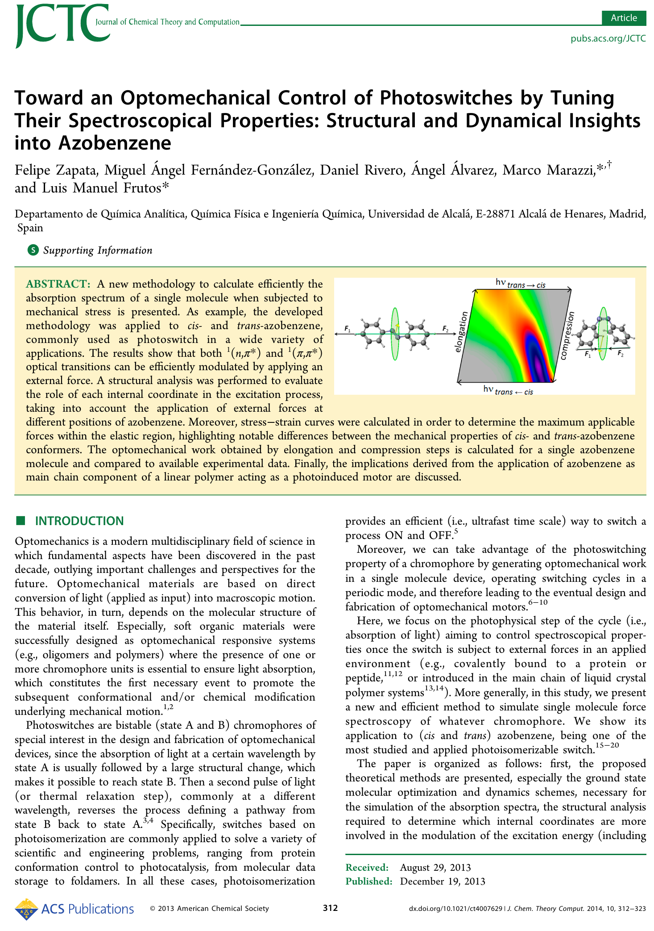 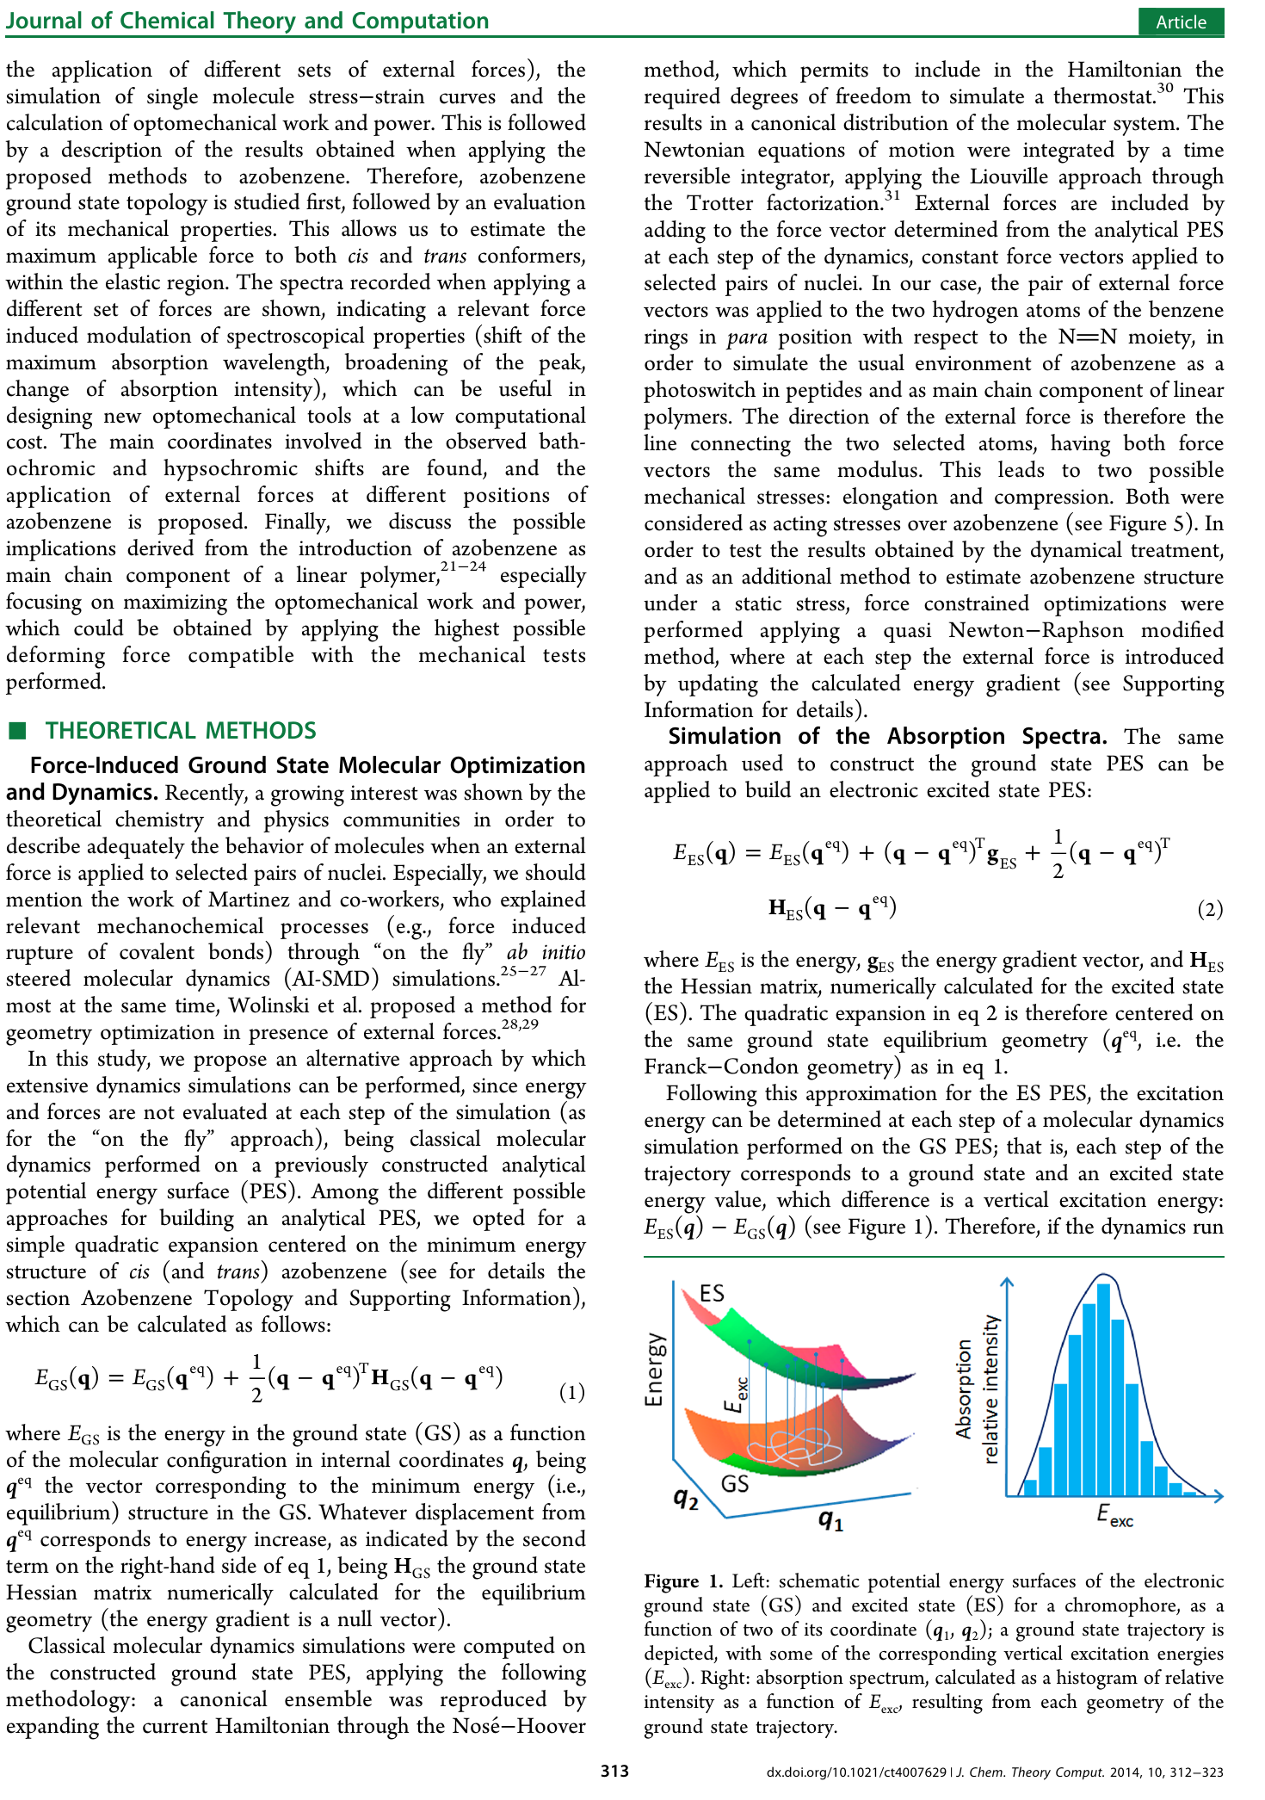

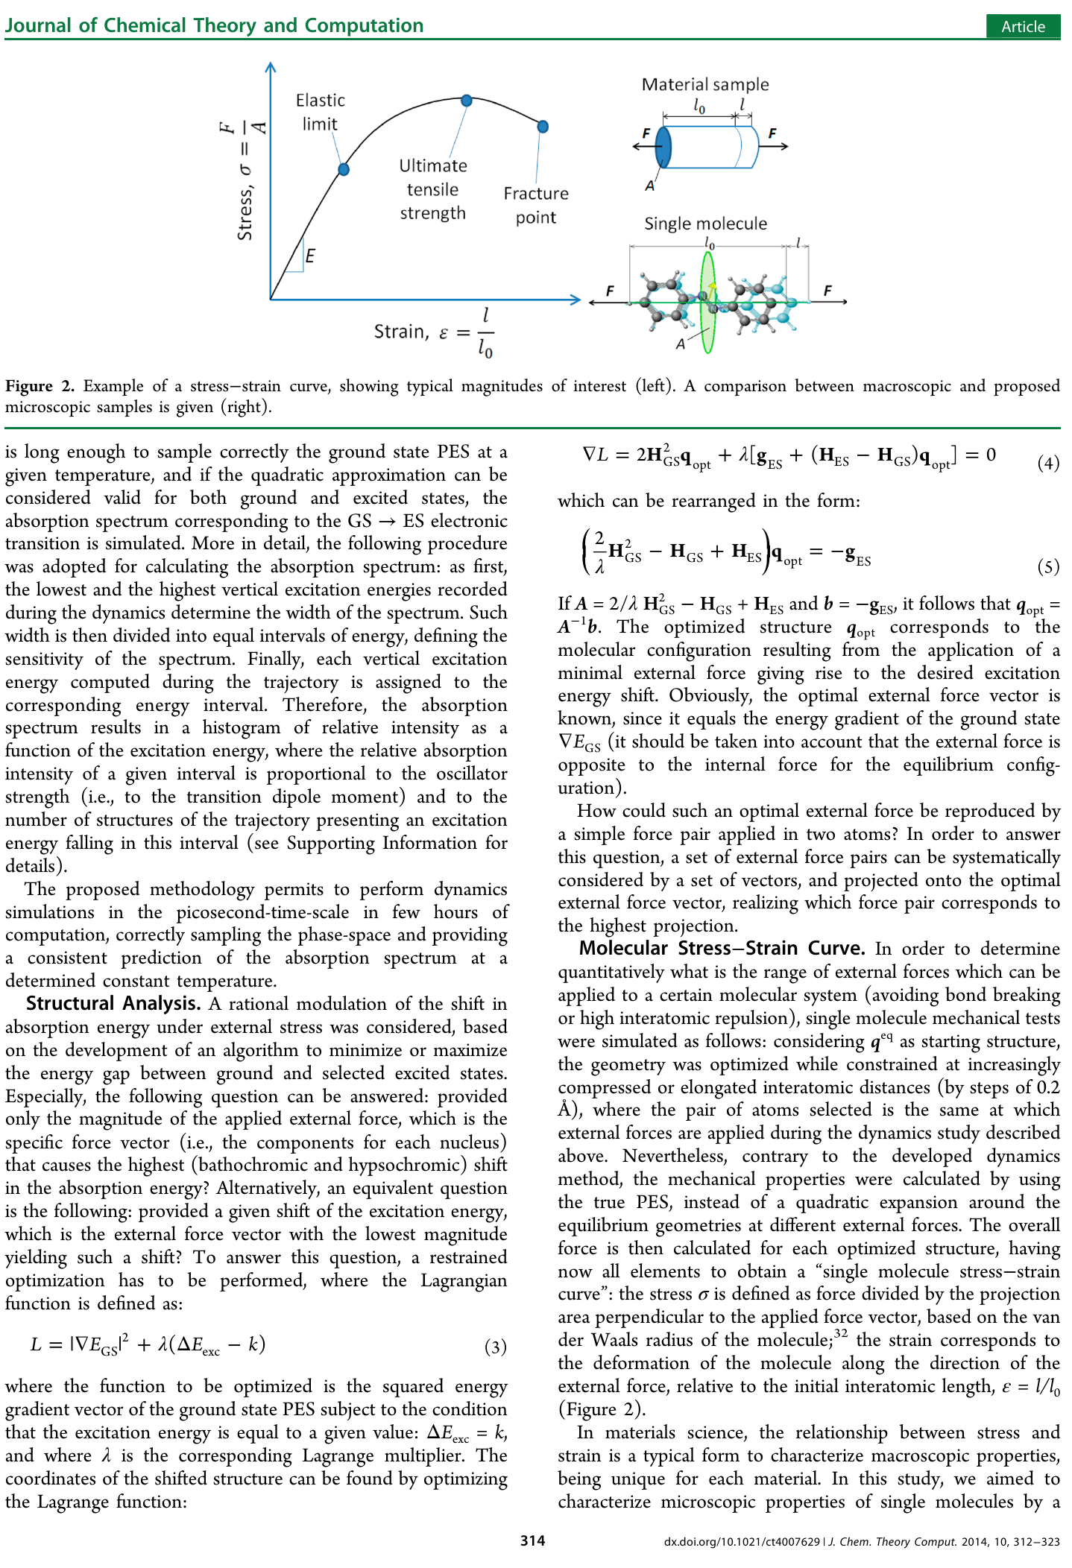

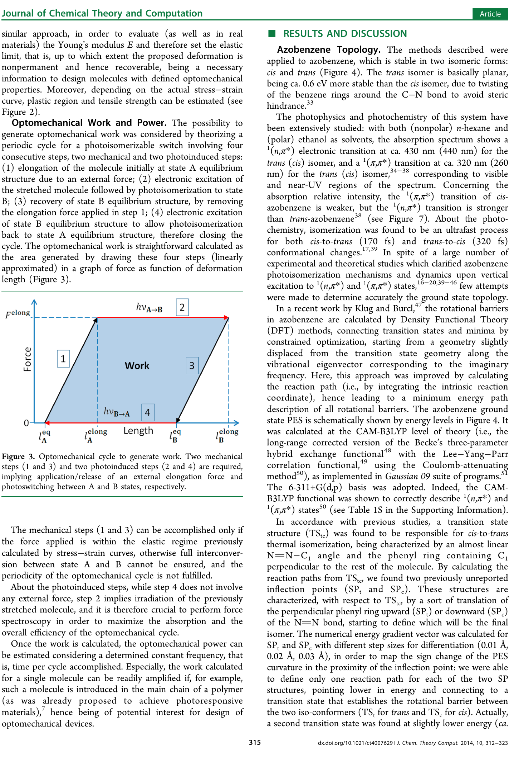

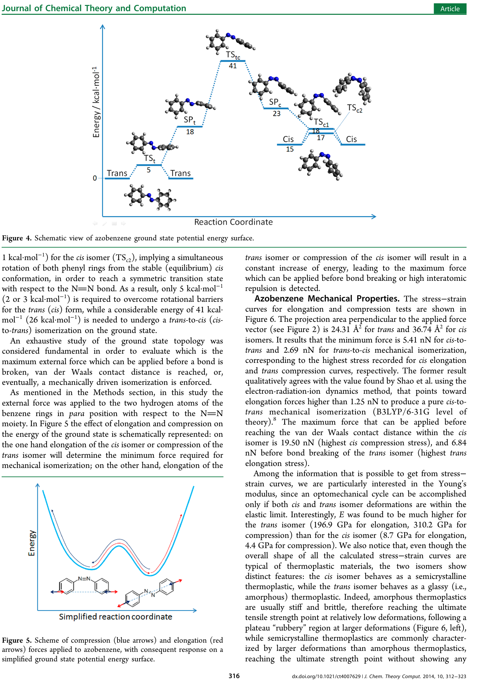

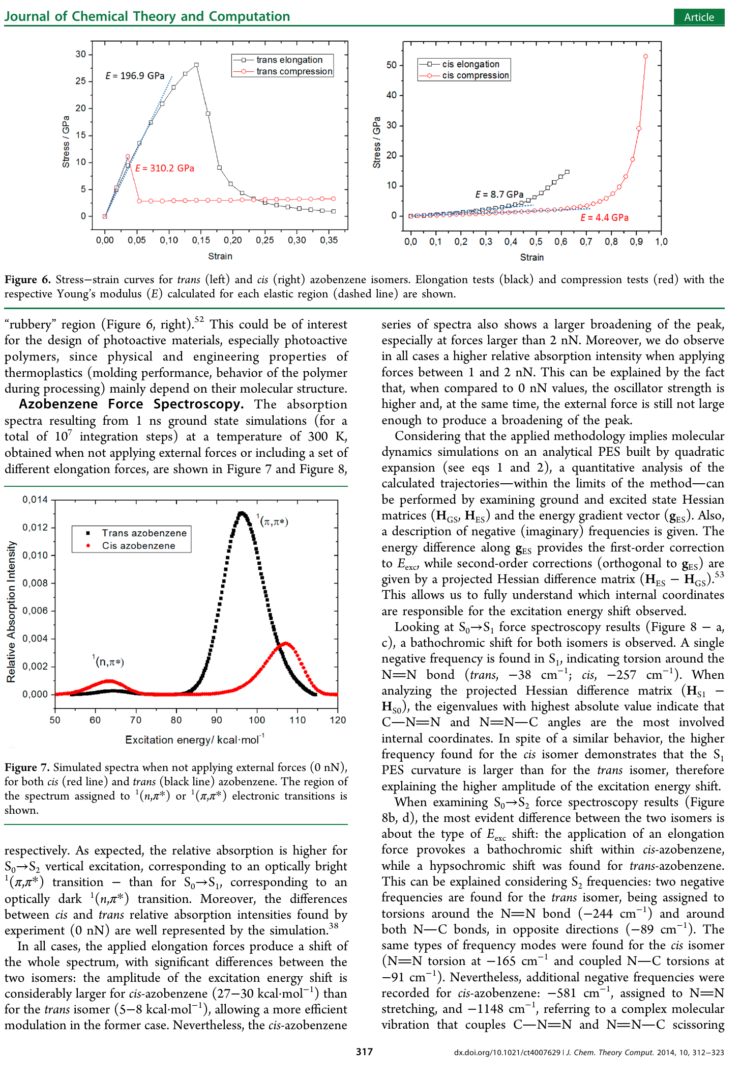

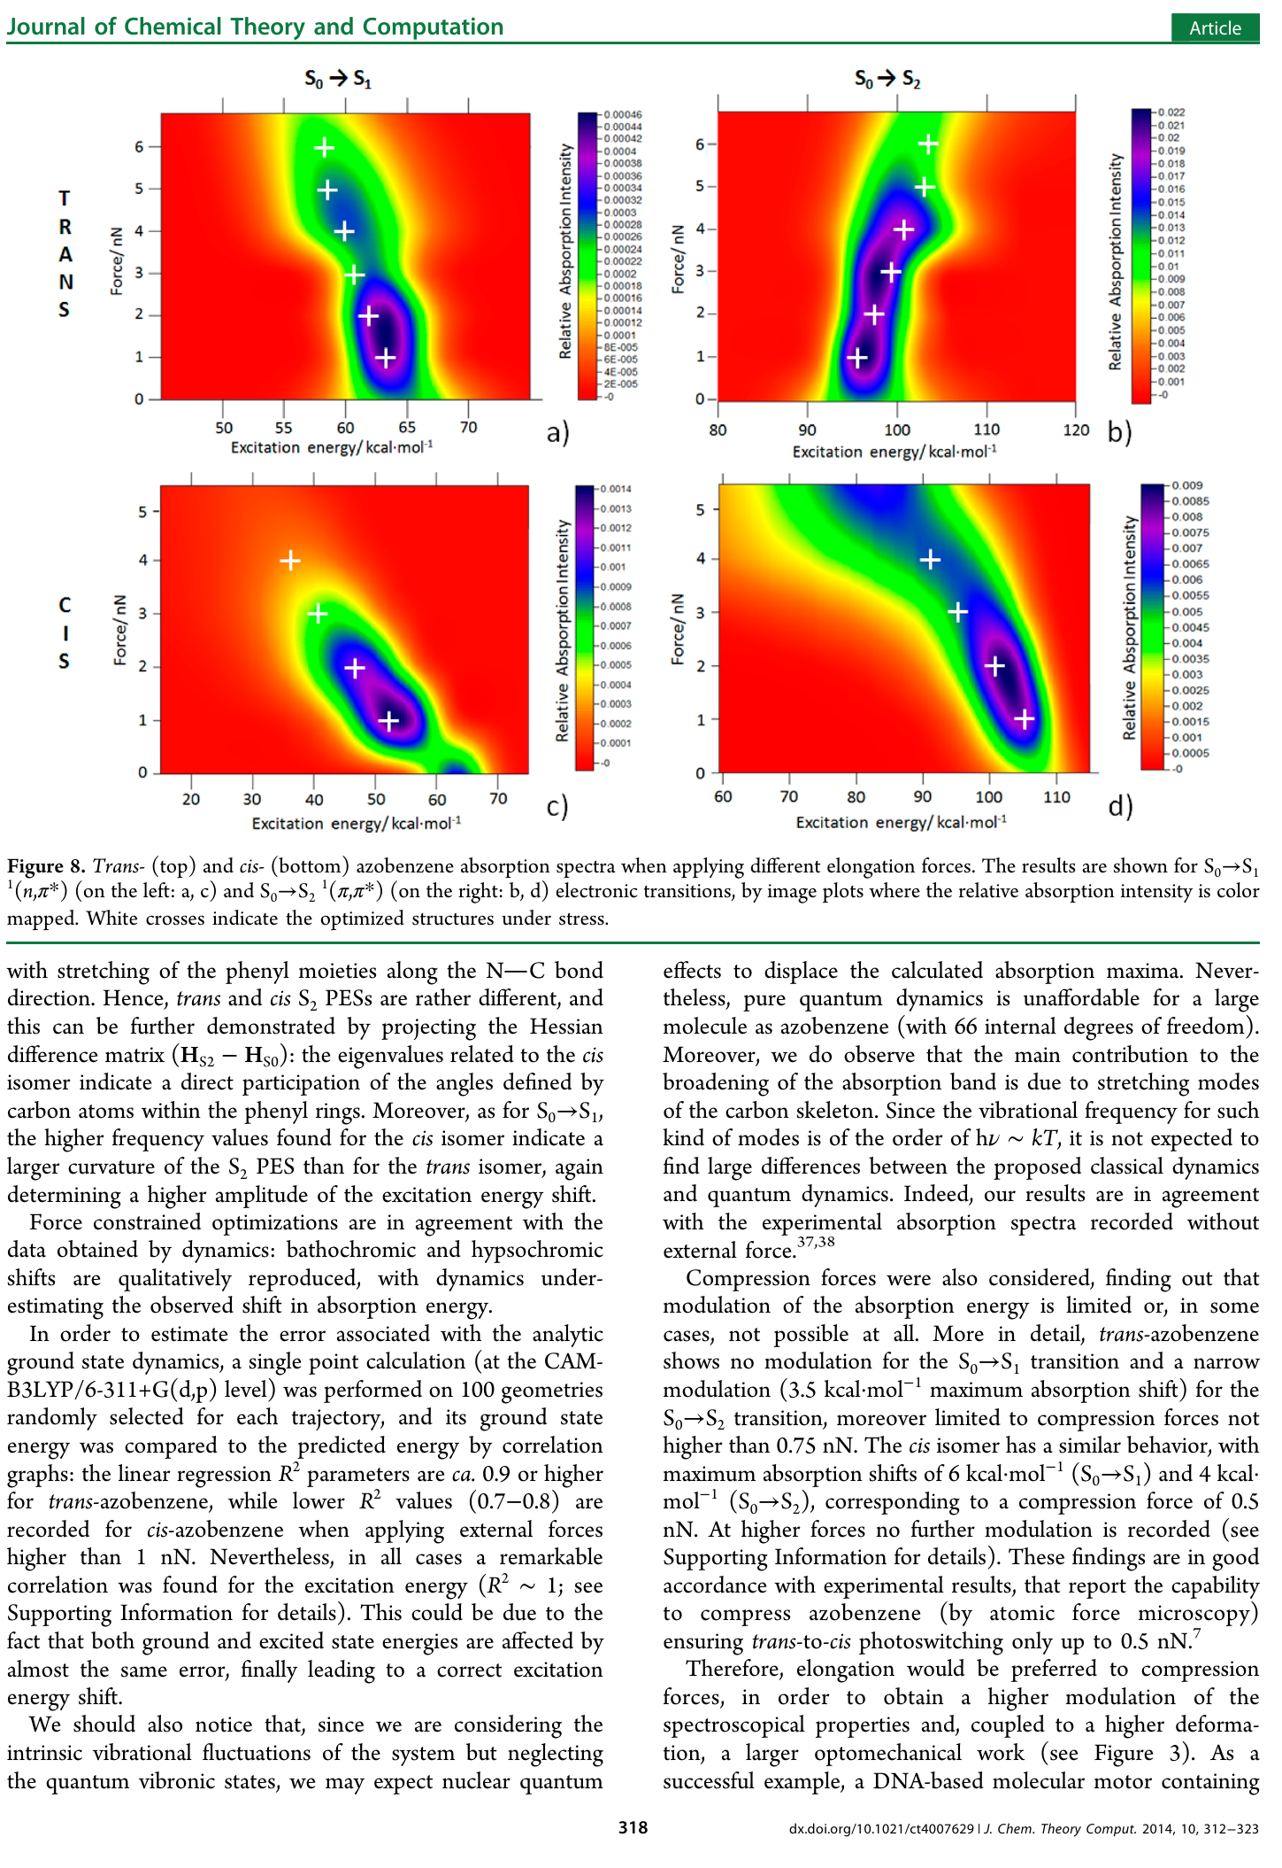

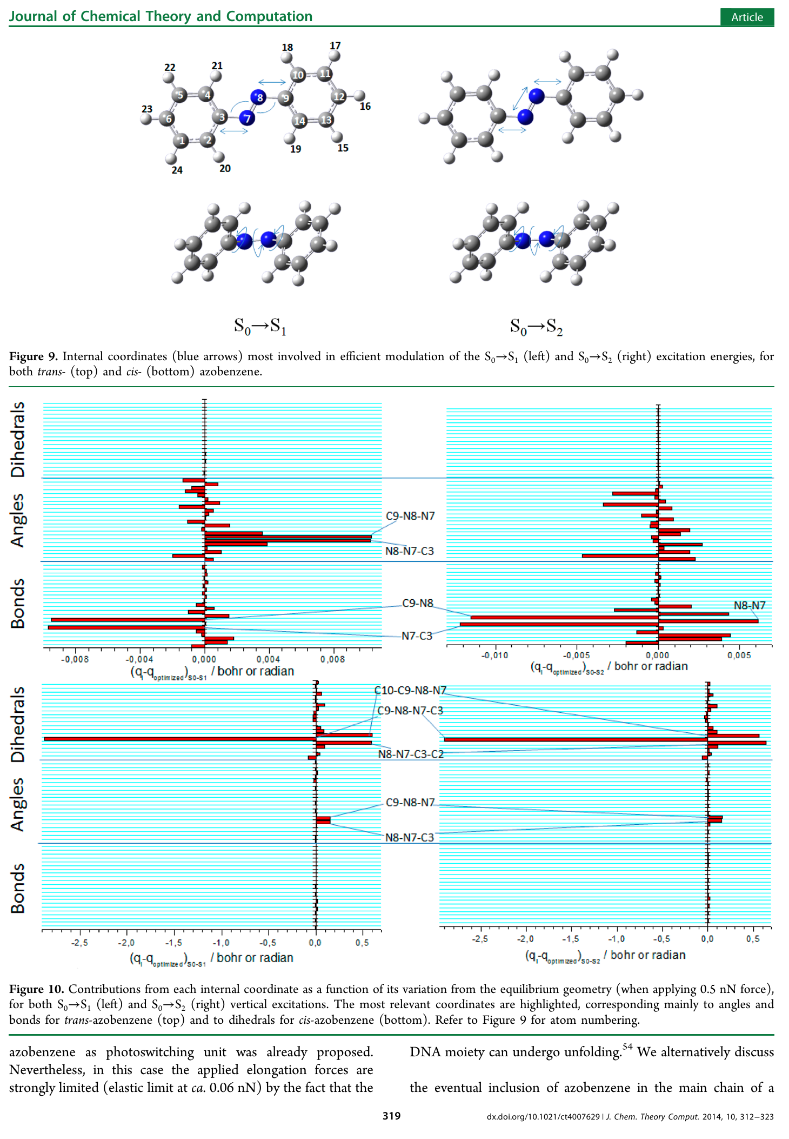

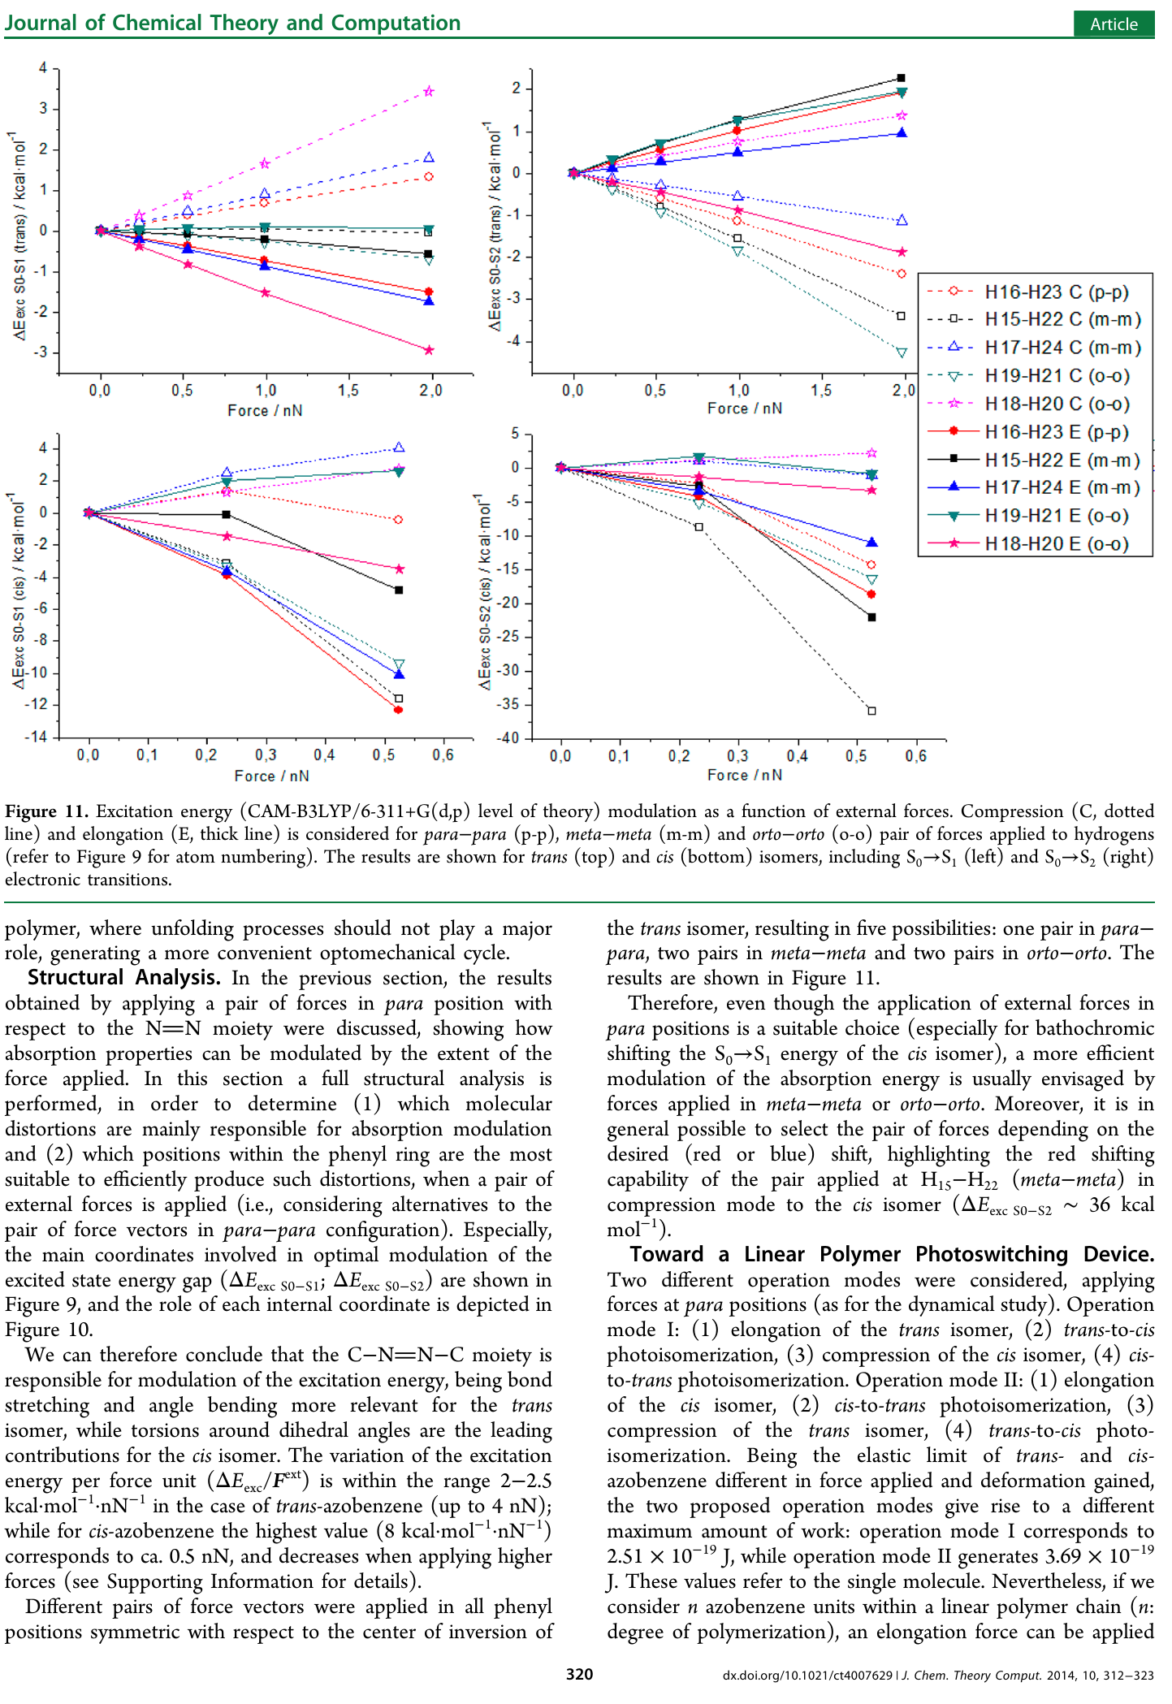

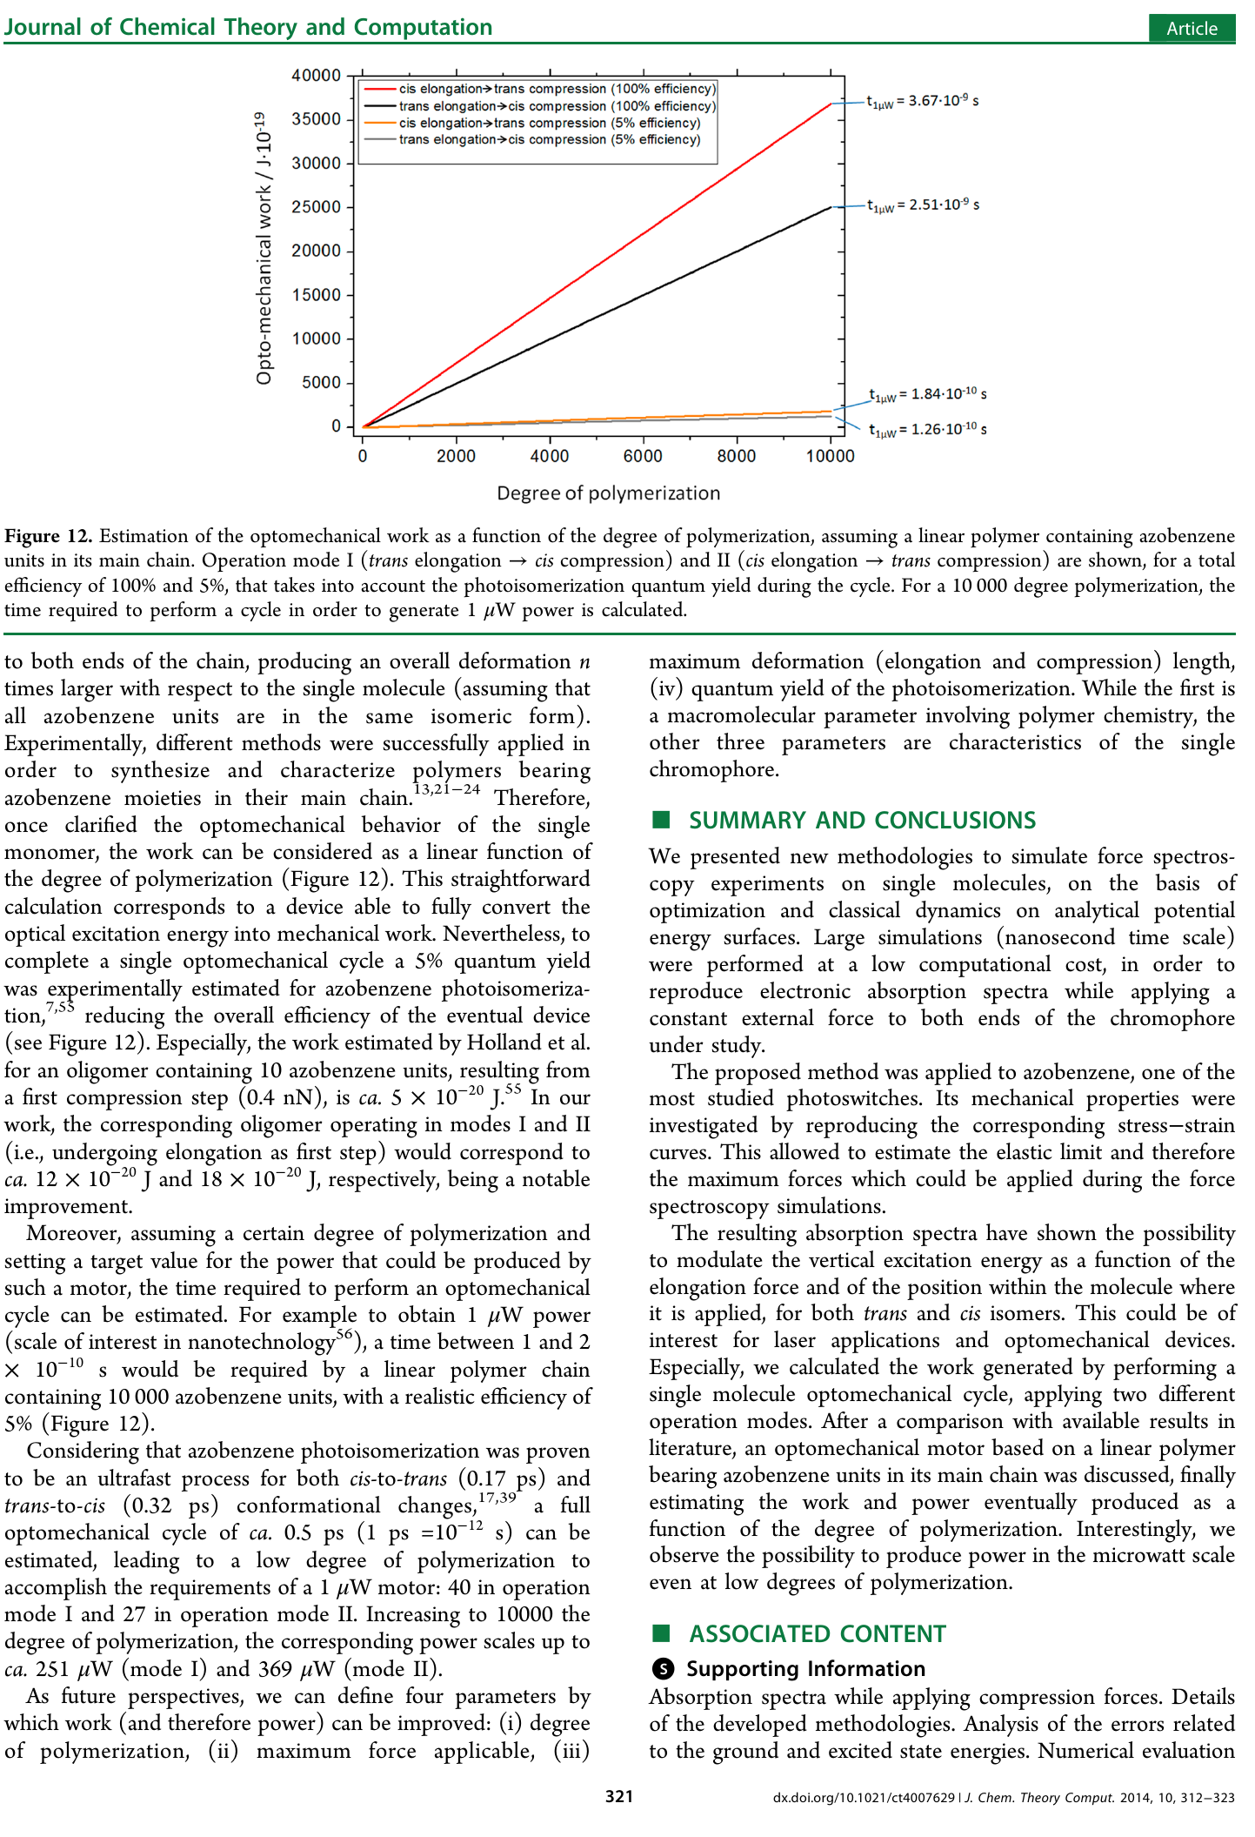

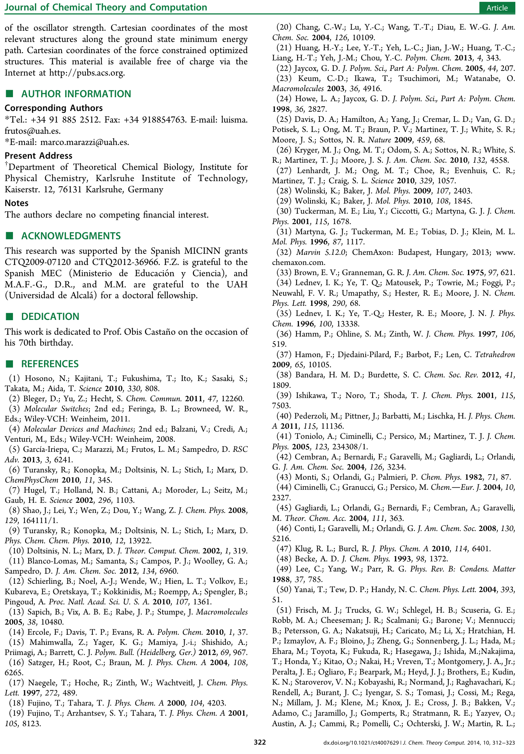



### External forces effect on the photochemical reactions

### Design of molecular devices

The design and construction of molecular device by the bottom-up strategy (i.e. from atoms to molecular devices) is a major goal of nanotechnology. Molecular switches and motors are essential parts of molecular machines, and full understanding of its mechanisms and dynamical properties is of fundamental importance. These devices convert energy supply into mechanical energy, leading to a controlled motion (Feringa 2007). Photoinduced processes are well suited to use as input energy for molecular devices, because it does not produce waste products and the devices can operate in autonomous fashion (Balzani, et al. 2009, Cnossen, et al. 2012).

On the other hand, the mechanism of photoswitches is the interconversion between the two possible states, on/off, while the performance of molecular motors involves a continuous, repetitive and unidirectional rotary movement of 360 degrees. Therefore, in the design of molecular motors is crucial to promote the unidirectional rotation of the device, and among the possible effect which can induce unidirectional rotations, it has been found that a chiral environment induce an asymmetric gradient which induces a unidirectional rotation (Albu, et al. 2009, Liu and Morokuma 2012, Yamaki, et al. 2005).

In the contributions presented in section there was explored a set of efficient photoswitches, based on the retinal chromophore, which are then taken as framework on the design of novel molecular motors, where the unidirectional rotation is caused by an initial torsion induced by hydrogen-bonds with chiral properties. It is important to emphasise that while molecular motors based on helical structured like diarylethenes (ter Wiel, et al. 2003), need four steps to complete a cycle (two photochemical and two thermal steps), we propose molecular motors performing a cycle in two identical photochemical steps.

Firstly a detailed description of the nature of the excited state electronic structure is provided. Subsequently non-adiabatic molecular dynamics (NAMD) were performed to provide a dynamical picture of the molecular motor behaviour.

#### Chiral hydrogen bond environment providing unidirectional rotation in photoactive molecular motors

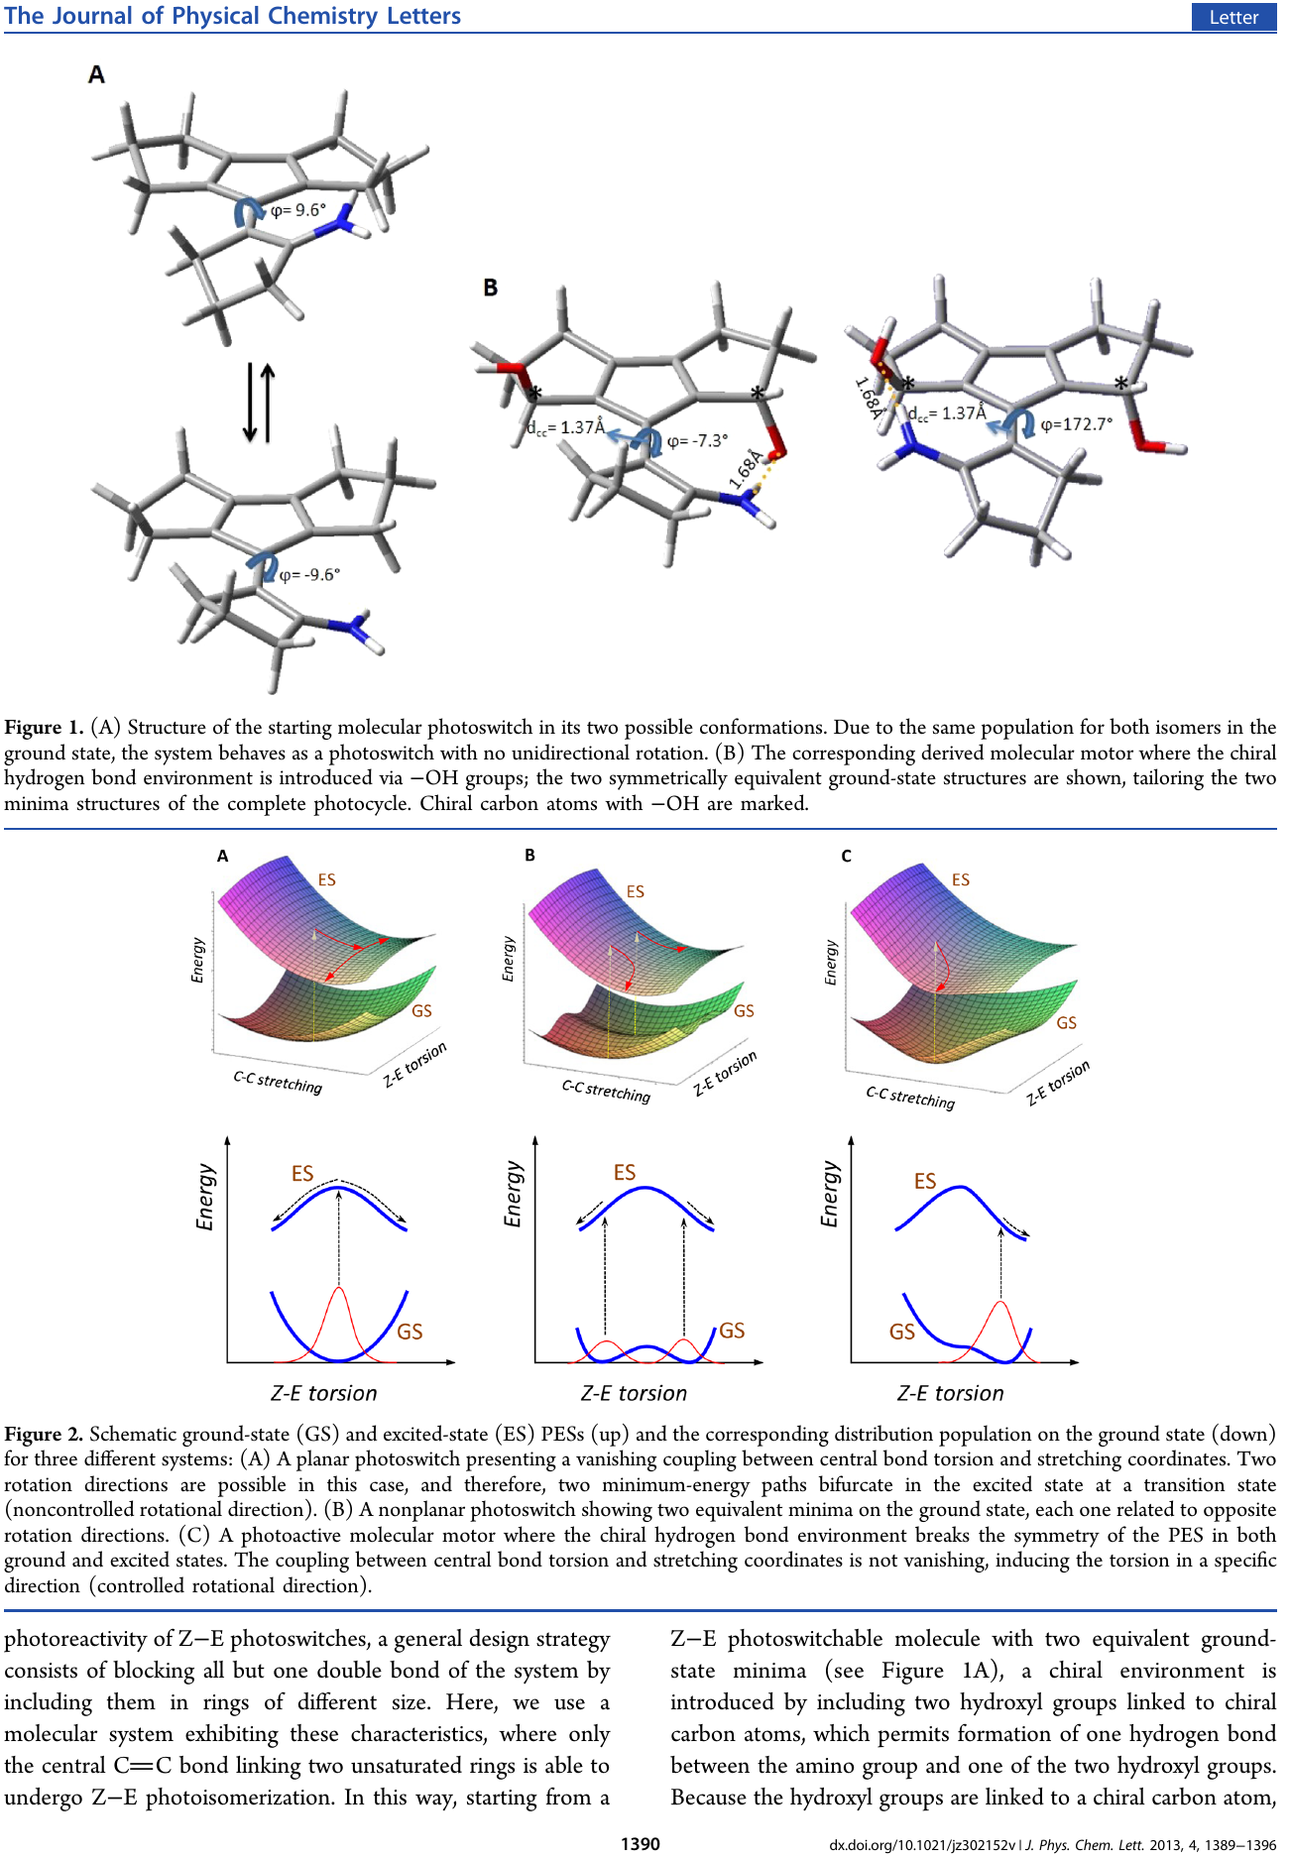

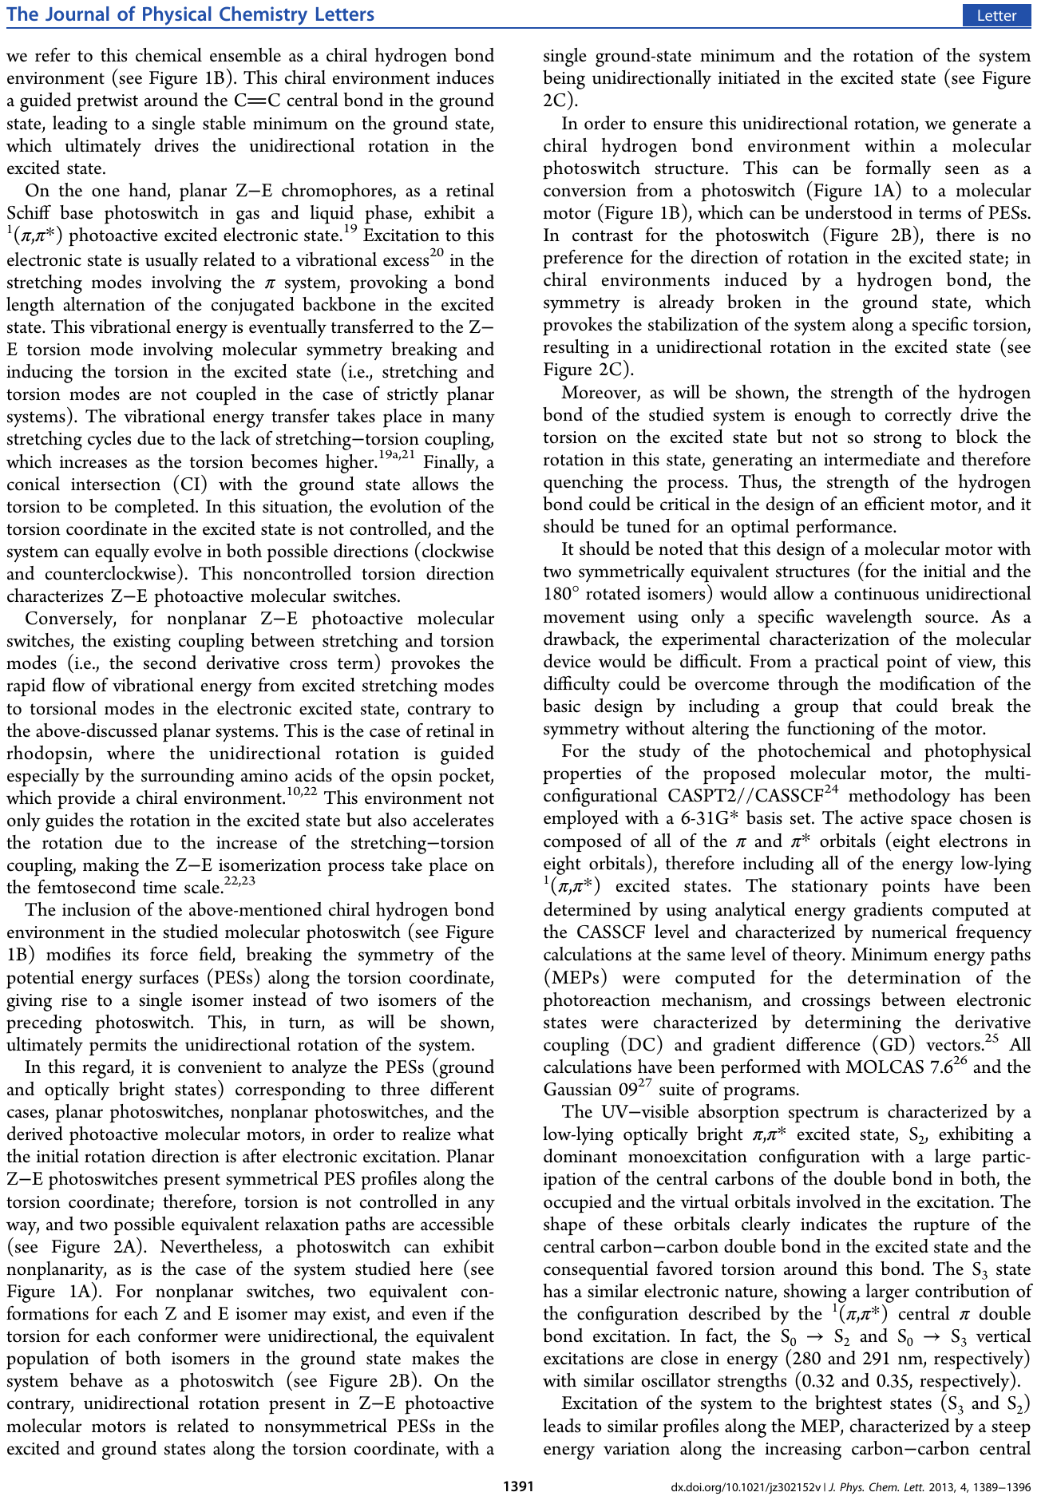

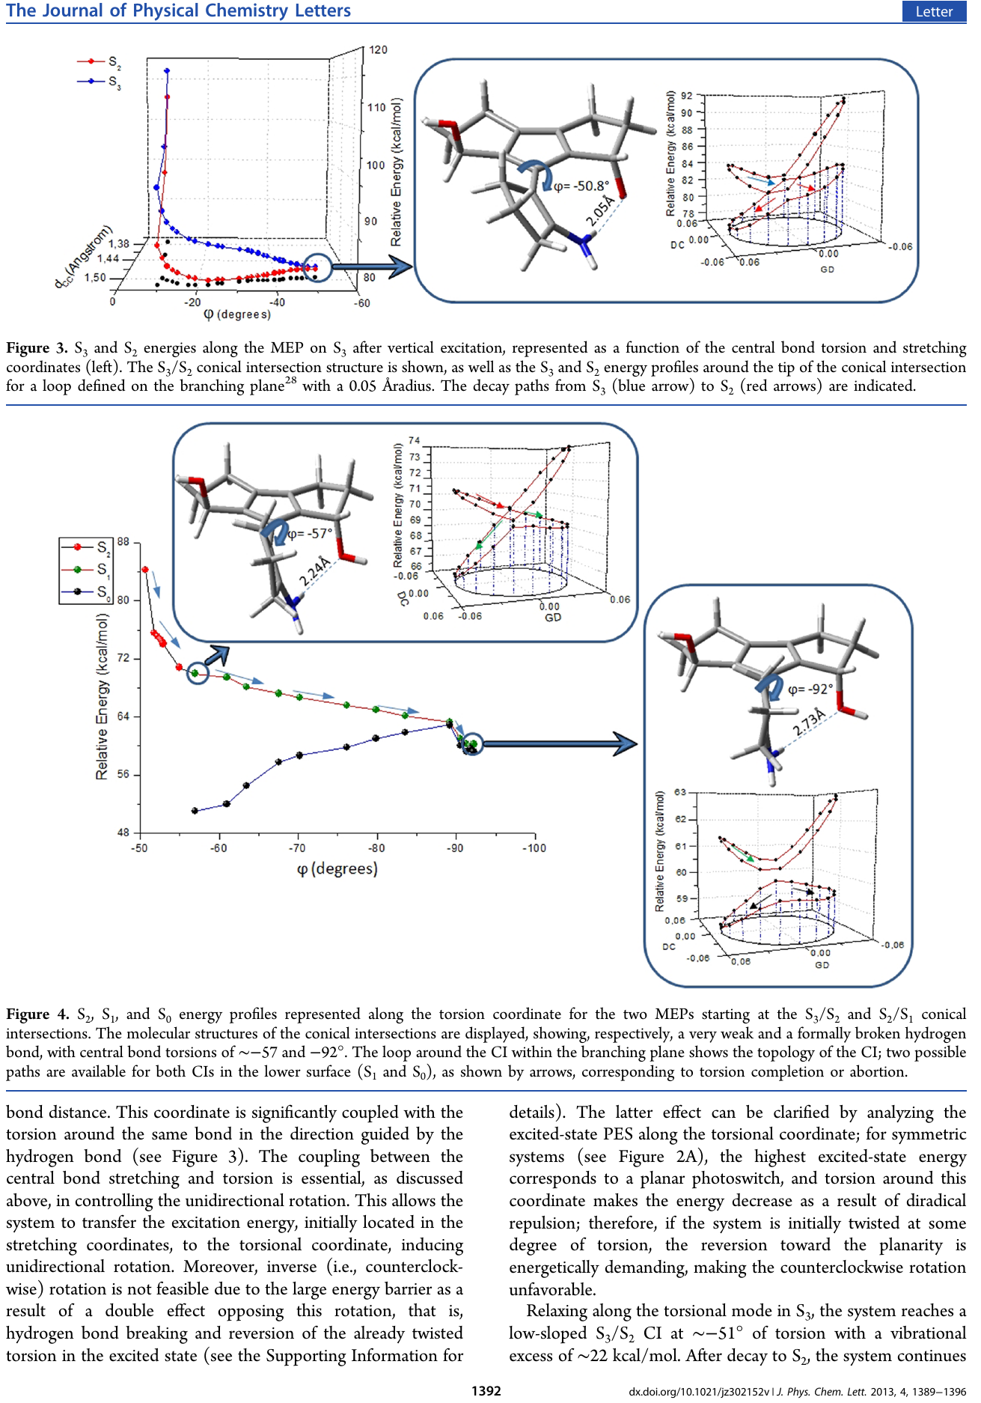

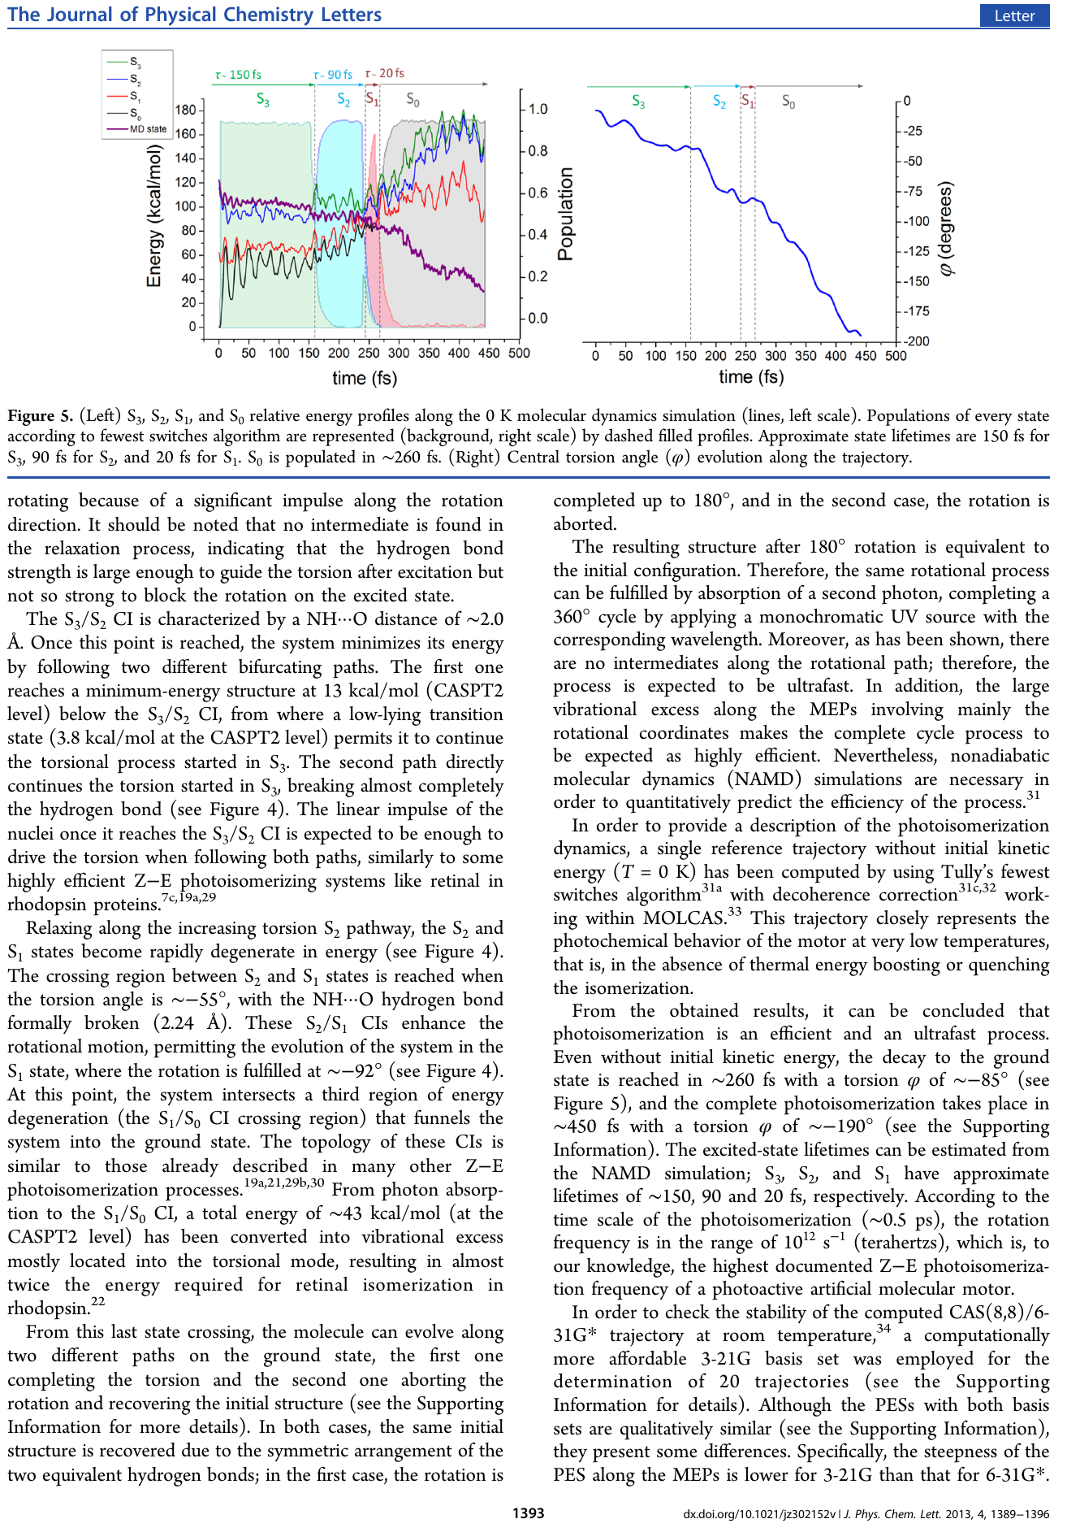



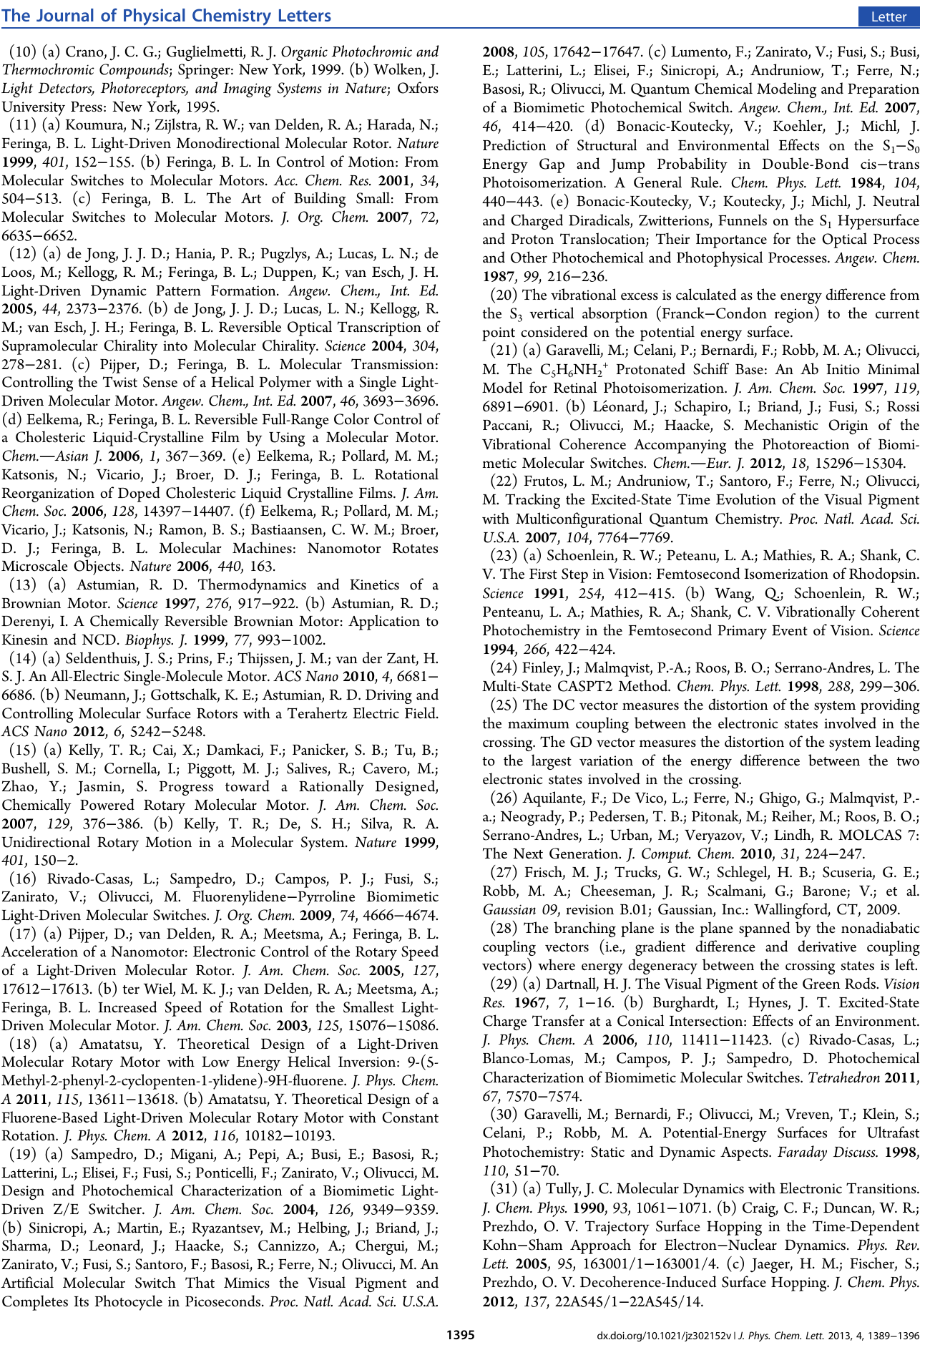

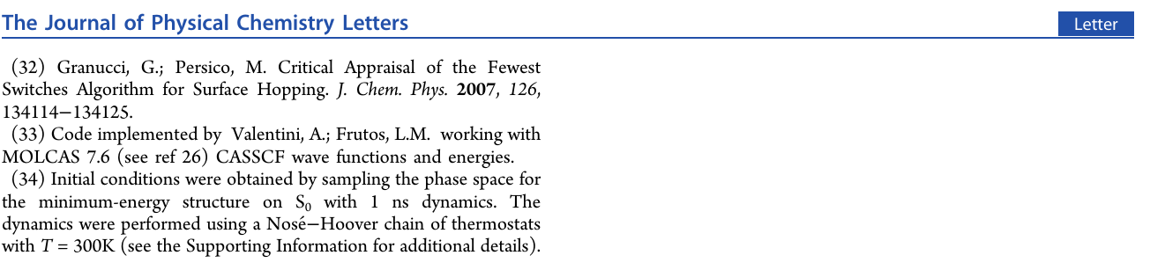

#### Molecular design concepts: towards highly efficient photoactive molecular motors

Chapter Bibliography

Albu, N. M.; Bergin, E.; Yaron, D. J., Computational Design of a Light-Driven Molecular Motor. *The Journal of Physical Chemistry A* **2009,** *113*, 7090-7096.

Balaz, P.; Achimovicova, M.; Balaz, M.; Billik, P.; Cherkezova-Zheleva, Z.; Criado, J. M.; Delogu, F.; Dutkova, E.; Gaffet, E.; Gotor, F. J.; Kumar, R.; Mitov, I.; Rojac, T.; Senna, M.; Streletskii, A.; Wieczorek-Ciurowa, K., Hallmarks of mechanochemistry: from nanoparticles to technology. *Chem. Soc. Rev.* **2013**.

Balzani, V.; Credi, A.; Venturi, M., *Molecular Devices and Machines*. 2nd ed.; Wiley-VCH: Weinheim, 2008.

Balzani, V.; Credi, A.; Venturi, M., Light powered molecular machines. *Chem. Soc. Rev.* **2009,** *38*, 1542-1550.

Beyer, M. K.; Clausen-Schaumann, H., Mechanochemistry:  The Mechanical Activation of Covalent Bonds. *Chem. Rev.* **2005,** *105*, 2921-2948.

Blanco-Lomas, M.; Samanta, S.; Campos, P. J.; Woolley, G. A.; Sampedro, D., Reversible Photocontrol of Peptide Conformation with a Rhodopsin-like Photoswitch. *J. Am. Chem. Soc.* **2012,** *134*, 6960-6963.

Bleger, D.; Yu, Z.; Hecht, S., Toward optomechanics: Maximizing the photodeformation of individual molecules. *Chem. Commun.* **2011,** *47*, 12260-12266.

Bléger, D.; Yu, Z.; Hecht, S., Toward optomechanics: Maximizing the photodeformation of individual molecules. *Chem. Commun.* **2011,** *47*, 12260–12266.

Caruso, M. M.; Davis, D. A.; Shen, Q.; Odom, S. A.; Sottos, N. R.; White, S. R.; Moore, J. S., Mechanically-Induced Chemical Changes in Polymeric Materials. *Chem. Rev.* **2009,** *109*, 5755-5798.

Cnossen, A.; Hou, L.; Pollard, M. M.; Wesenhagen, P. V.; Browne, W. R.; Feringa, B. L., Driving Unidirectional Molecular Rotary Motors with Visible Light by Intra- And Intermolecular Energy Transfer from Palladium Porphyrin. *J. Am. Chem. Soc.* **2012,** *134*, 17613-17619.

Ercole, F.; Davis, T. P.; Evans, R. A., Photo-responsive systems and biomaterials: photochromic polymers, light-triggered self-assembly, surface modification, fluorescence modulation and beyond. *Polym. Chem.* **2010,** *1*, 37-54.

Feringa, B. L., The Art of Building Small:  From Molecular Switches to Molecular Motors. *The Journal of Organic Chemistry* **2007,** *72*, 6635-6652.

Feringa, B. L.; Browneed, W. R., *Molecular Switches*. 2nd ed.; Wiley-VCH: Weinheim, 2011.

Garcia-Iriepa, C.; Marazzi, M.; Frutos, L. M.; Sampedro, D., E/Z Photochemical switches: syntheses, properties and applications. *RSC Advances* **2013,** *3*, 6241-6266.

Hammett, L. P., The Effect of Structure upon the Reactions of Organic Compounds. Benzene Derivatives. *J. Am. Chem. Soc.* **1937,** *59*, 96-103.

Helgaker, T.; Jorgensen, P.; Olsen, J., *Moleculat Electronic-Structure Theory*. JHON WILEY & SONS Great Britain, 2000.

Holland, N. B.; hugel, T.; Neuert, G.; Cattani-Scholz, A.; Renner, C.; Oesterhelt, D.; moroder, L.; Seitz, M.; Gaub, H. E., Single Molecule Force Spectroscopy of Azobenzene Polymers: Switching Elasticity of Single Photochromic Macromolecules. *Macromolecules* **2003,** *36*, 2015-2023.

Hosono, N.; Kajitani, T.; Fukushima, T.; Ito, K.; Sasaki, S.; Takata, M.; Aida, T., Large-Area Three-Dimensional Molecular Ordering of a Polymer Brush by One-Step Processing. *Science* **2010,** *330*, 808-811.

Hugel, T.; Holland, N. B.; Cattani, A.; Moroder, L.; Seitz, M.; Gaub, H. E., Single-Molecule Optomechanical Cycle. *Science* **2002,** *296*, 1103-1106.

Liu, F.; Morokuma, K., Computational Study on the Working Mechanism of a Stilbene Light-Driven Molecular Rotary Motor: Sloped Minimal Energy Path and Unidirectional Nonadiabatic Photoisomerization. *J. Am. Chem. Soc.* **2012,** *134*, 4864-4876.

Marazzi, M.; López-Delgado, A.; Fernández-González, M. A.; Castaño, O.; Frutos, L. M.; Temprado, M., Modulating Nitric Oxide Release by S-Nitrosothiol Photocleavage: Mechanism and Substituent Effects. *The Journal of Physical Chemistry A* **2012,** *116*, 7039-7049.

McCullagh, M.; Franco, I.; Ratner, M. A.; Schatz, G. C., DNA-Based Optomechanical Molecular Motor. *J. Am. Chem. Soc.* **2011,** *133*, 3452-3459.

Sapich, B.; Vix, A. B. E.; Rabe, J. P.; Stumpe, J., Photoinduced Self-Organization and Photoorientation of a LC Main-Chain Polyester Containing Azobenzene Moieties. *Macromolecules* **2005,** *38*, 10480-10486.

Schierling, B.; Noel, A.-J.; Wende, W.; Hien, L. T.; Volkov, E.; Kubareva, E.; Oretskaya, T.; Kokkinidis, M.; Roempp, A.; Spengler, B.; Pingoud, A., Controlling the enzymatic activity of a restriction enzyme by light. *Proc. Natl. Acad. Sci. U. S. A.* **2010,** *107*, 1361-1366, S1361/1-S1361/4.

Stamler, J. S.; Jia, L.; Eu, J. P.; McMahon, T. J.; Demchenko, I. T.; Bonaventura, J.; Gernert, K.; Piantadosi, C. A., Blood Flow Regulation by S-Nitrosohemoglobin in the Physiological Oxygen Gradient. *Science* **1997,** *276*, 2034-2037.

Swain, C. G.; Lupton, E. C., Field and resonance components of substituent effects. *J. Am. Chem. Soc.* **1968,** *90*, 4328-4337.

Taft, R. W., Polar and Steric Substituent Constants for Aliphatic and o-Benzoate Groups from Rates of Esterification and Hydrolysis of Esters1. *J. Am. Chem. Soc.* **1952,** *74*, 3120-3128.

ter Wiel, M. K. J.; van Delden, R. A.; Meetsma, A.; Feringa, B. L., Increased Speed of Rotation for the Smallest Light-Driven Molecular Motor. *J. Am. Chem. Soc.* **2003,** *125*, 15076-15086.

Wang, K.; Rangel, N. L.; Kundu, S.; Sotelo, J. C.; Tovar, R. M.; Seminario, J. M.; Liang, H., Switchable Molecular Conductivity. *J. Am. Chem. Soc.* **2009,** *131*, 10447-10451.

Wiggins, K. M.; Brantley, J. N.; Bielawski, C. W., Polymer Mechanochemistry: Force Enabled Transformations. *ACS Macro Letters* **2012,** *1*, 623-626.

Woodward, R. B., Structure and the Absorption Spectra of α,β-Unsaturated Ketones. *J. Am. Chem. Soc.* **1941,** *63*, 1123-1126.

Yamaki, M.; Hoki, K.; Ohtsuki, Y.; Kono, H.; Fujimura, Y., Quantum Control of a Chiral Molecular Motor Driven by Laser Pulses. *J. Am. Chem. Soc.* **2005,** *127*, 7300-7301.

1. **PhotoChemical Dynamics**

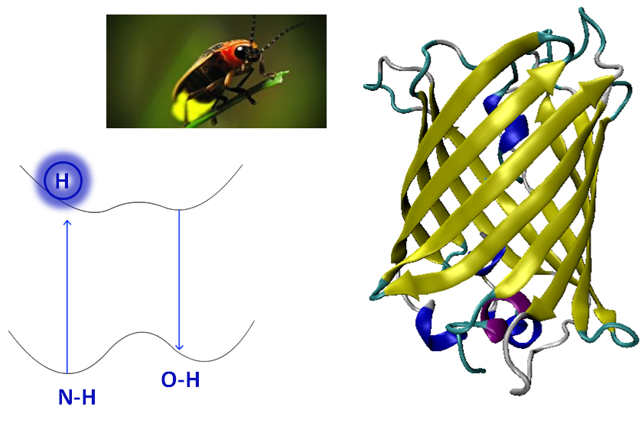

*Anybody who has been seriously engaged in scientific work of any kind realizes that over the entrance to the gates of the temple of science are written the words: 'Ye must have faith.'*

Max Planck

* 1. **Introduction**

Photoinduced chemical processes are interesting both from academic point of view as well as its potential technological application. In this section we have approach two problems directly linked with biological related application, which offer many technological application.

In section 6.2.1, we have focused on the study of a molecular model to account for several unanswered experimental question about bioluminescence, using the multi-reference perturbation theory CASPT2 and CASSCF “on the fly” molecular dynamics.

While in section 6.2.2, we present our first approach to the study of the relation between environment and spectroscopical properties trough the QM/MM methodology.

* + 1. **Chemiluminescence**

Chemiluminescence refers to the phenomenon of light emission by an excited product resulting from a chemical reaction, when the same phenomenon is produced in living beings is called bioluminescence. The exoergic reaction induces the promotion of an electron from its ground state to an excited electronic state, usually through a transition from a p bonding to a p* anti-bonding orbital (p→p*) or from a non-bonding to an anti-bonding orbital (n→p*), in organic molecules. Both chemiluminescence and bioluminescence phenomena, have attracted considerable attention not only because its role in nature (Fraga 2008, Zimmer 2009) as well as theoretical interest(Carpenter 2006), but also because is application in analytical chemistry (Lippert, et al. 2011, Paley and Prescher 2014, Razgulin, et al. 2011).

In general quantum efficiencies are greater in case of bioluminescence thanchemiluminescence in solution. The high quantum yield and the presence of oxygen has suggested that that the family 1,2-dioxetanes are key intermediates for the highly efficient bioluminescent phenomena in nature (Matsumoto 2004).

* + 1. **Modulation of Excited-State Properties of Fluorescent Proteins**

In the past years, fluorescent proteins (FPs) derived from the green fluorescent protein (GFP) family were successfully applied as biological markers, allowing the visualization of a wide type of processes, ranging from gene expression to cell development and protein movements within live cells (Konstantin, et al. 2005, Shaner, et al. 2007, Wiedenmann and Nienhaus 2006). Moreover, other technological areas as optical microscopy and photonics took advantage of the particular characteristics offered by FPs, leading to the development of optical nanoscopy (Betzig, et al. 2006, Hess, et al. 2006) and promising advances in data-storage devices (Sauer 2005).

These achievements were possible because of the high spatial and time resolution offered by FPs, which multiple variants can emit different colors and intensities, depending on the wavelength required for irradiation. Indeed, starting from the original green fluorescence, blue (higher energy) and red (lower energy) shifted emission FPs are nowadays available (Kredel, et al. 2008, Merzlyak, et al. 2007, Shaner, et al. 2004)

Experimental studies are pointing towards genetic engineering (through site-directed mutagenesis) and structural characterization (through spectroscopic and X-ray crystallographic techniques), which are powerful tools to investigate systematically the effect of amino acid replacement on the stability of the protein itself and on the absorption and emission energy shifts, compared to their predecessor FPs. Nevertheless, most of the attempts revealed the difficulty of guessing which specific mutation can lead to a certain change in biophysical properties, being the chromophore pocket highly sensitive to the chemical environment (hydrogen bonding, proton transfer, π-π stacking). In some cases a single amino acid replacement is enough to observe the expected spectroscopic variation, as the introduction of the Asn143Ser substitution into d2eqFP611 to generate d2RFP630, and the additional Ser158Cys mutation to generate RFP639, involving the weakening of hydrogen bonding interactions between side chains and the chromophore (Nienhaus, et al. 2008). In other cases amino acids replacements lead to unexpected nearly complete loss of fluorescence, which could be recovered after completion of several rounds of random mutagenesis and multi-site directed mutagenesis, as is the case of mRuby which required altogether 28 amino acid replacements, compared to wild-type eqFP611 (Kredel, et al. 2009).

On the other hand, theoretical and computational studies were performed to elucidate the underlying mechanisms suggested or indicated by experiments, by which we can currently divide FPs in three groups:

a) Reversibly photoswitchable FPs, characterized by a fluorescent on state and a non-fluorescent off state, connected by cis-trans photoisomerization (Ando, et al. 2004);

b) Irreversibly photoconvertible FPs, leading to transformation from a non-fluorescent state to a fluorescent state (Patterson and Lippincott-Schwartz 2002), or between differently emitting states, involving extension of the conjugate  system by rupture of a covalent bond (Tsutsui, et al. 2005);

c) FPs showing both irreversible photoconversion and reversible photoswitching of the two photoconvertible states, resulting in a four-states FP (Fuchs, et al. 2010).

Computational studies are focusing on understanding how photoinduced isomerization and protonation are coupled, being the first ultrafast steps which the chromophore undergoes. This constitutes a topic still under debate, also considering the variety of possible chromophores, post-translationally formed by autocatalytic cyclization and oxidation. As an example, we should mention the results obtained on asFP595 (a prototype for photoswitchable proteins) by quantum mechanics-coupled-molecular mechanics (QM/MM) techniques, by which different processes were suggested or validated (Schäfer, et al. 2007).

Nevertheless, the task to obtain a FP variant absorbing in the red region (630-750 nm) remains difficult, being currently far-red PSmOrange-like the only monomeric form with a near-red excitation wavelength (636) (Subach, et al. 2011). Moreover, the excitation maximum of most of the other available FPs is set in the range 400-588 nm (Kredel, et al. 2009), therefore requiring costly lasers to be used for photoactivation, while above 640 nm a common laser pointer could be employed, determining important budget reduction, always desired especially for technological applications. Nevertheless a rational design of the fluorescence properties of FPs was still not attempted.

* 1. **Results**
     1. **Revisiting the Non-Adiabatic process in 1,2-dioexetane**

A common feature in the reactions involved in the phenomenon of bioluminescence, is the formation of a peroxo intermediate ring 1,2-dioxetane ( or 1,2-dioxetanone), which is pointed as the responsible of producing the excited state intermediate, which subsequently carry out the light emission process (Fraga 2008).

There has been much discussion regarding the mechanism of decomposition of the 1,2-dioxetanes (De Vico, et al. 2007), being three the mechanism proposed: the biradical, concerted and merged mechanism. The biradical mechanism is characterized by the initial formation of a biradical after the O-O bonds cleavage through a transition state, follows by breaking of the C-C bond, which bring the system to the excited stated responsible for the light emission. On the other hand the merged mechanism implies the staring of the cleavage of the C-C bond, before the O-O bond is completed broken. Finally the concerted mechanism, involves the simultaneous cleave of both C-C and O-O bonds.

Even though there is experimental and theoretical evidence which support the biradical mechanism, there is not an agreement about the nature of the mechanism. Besides, some other facts as the large ratio phosphorescence/ﬂuorescence of the chemiluminescence emission are still unanswered. In the following subsection it is presented a work which provides further inside into the biradical mechanism of the decomposition of the 1,2-dioxetane, and simultaneously address the phosphorescence/ﬂuorescence ratio problem. The methodology employed to explore the aforementioned problematic, was multistate multiconﬁgurational reference second-order perturbation theory (MS-CASPT2) calculations and ab initio molecular dynamics.

It was previously reported that a entropic trap region plays a crucial role in the dynamics of the decomposition of the 1,2-dioxdetane (De Vico, et al. 2007). The entropic trap is the situation when the entire four singlet and four triplet states manifold becomes degenerate, when the molecule is in the vicinity of the transition state corresponding to the O-O bond rupture. This situation becomes more complicated because in order to properly describe the interaction between the states is important to introduce the spin coupling of the two radical electrons. A First dynamical approach to this entropic trap is to consider only the singlet states and carrying out molecular dynamics without taking into account the spin coupling.

Of special interest in this thesis is the used of the so called “on the fly” molecular dynamics using CASSCF/ANO-RCC-VDZP theory Level. The idea is to provide a statistical relevant sampling of the ground state on the entropic trap, because the phosphorescence process requires a population transfer from the ground state S0 to the triplet state T1, therefore a preliminary dynamics can describes the kind of geometrical configurations available for a future intersystem crossing study. Besides, molecular dynamic simulation also provides time spent in the entropic trap by the molecule on the ground state.

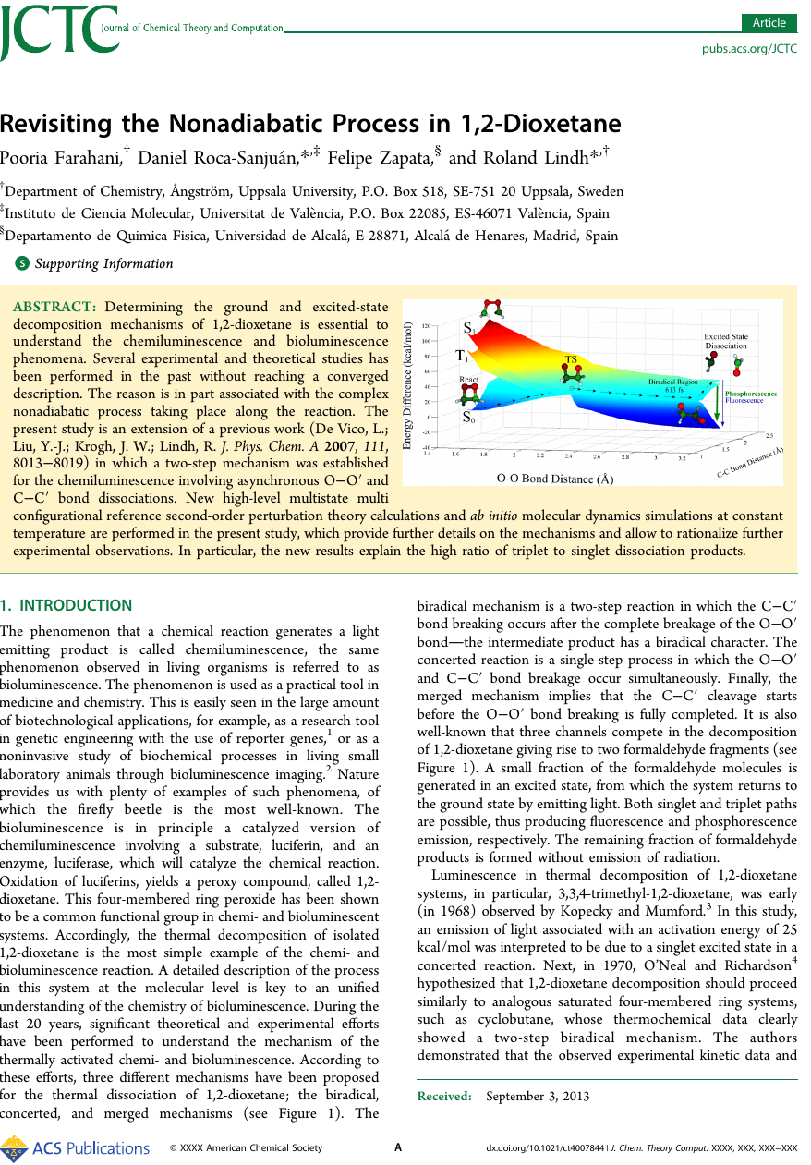

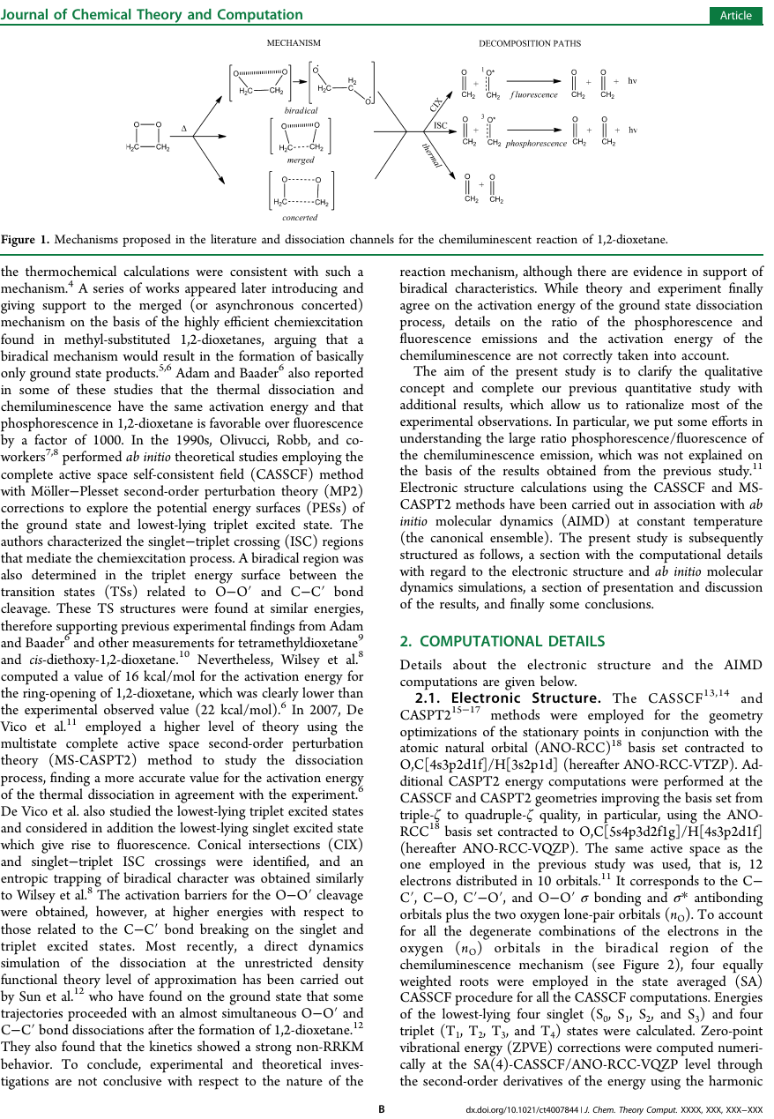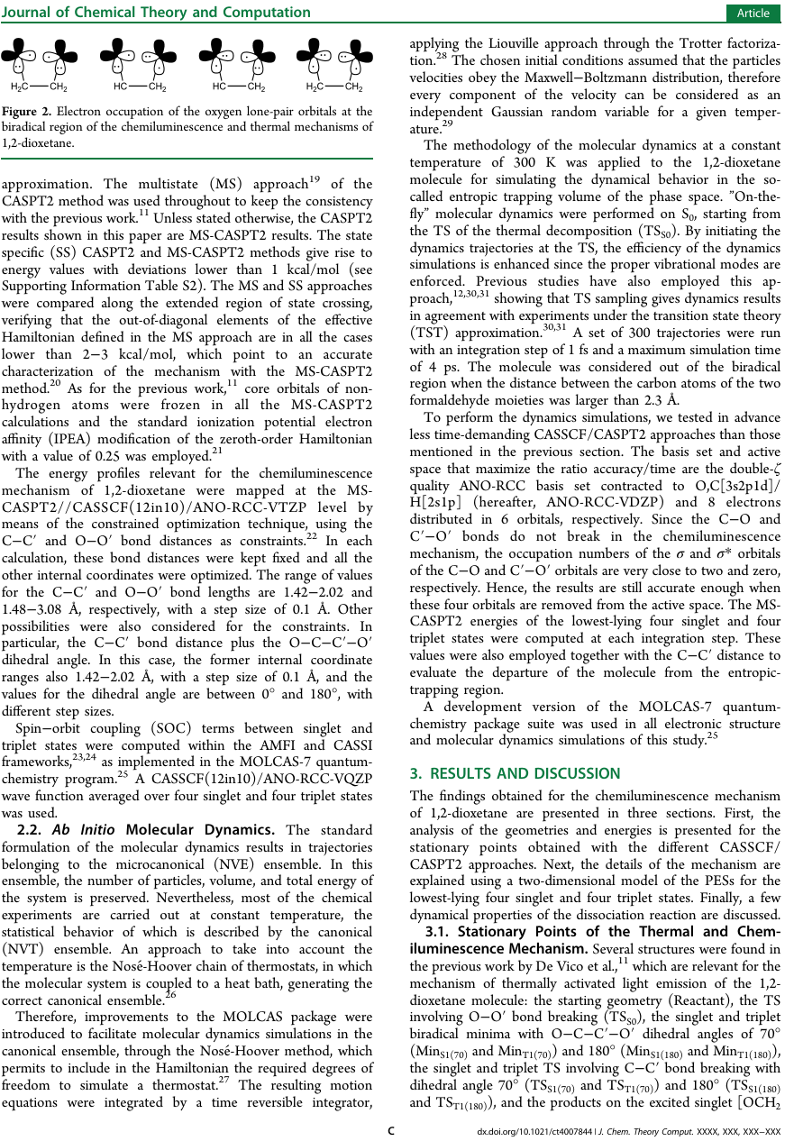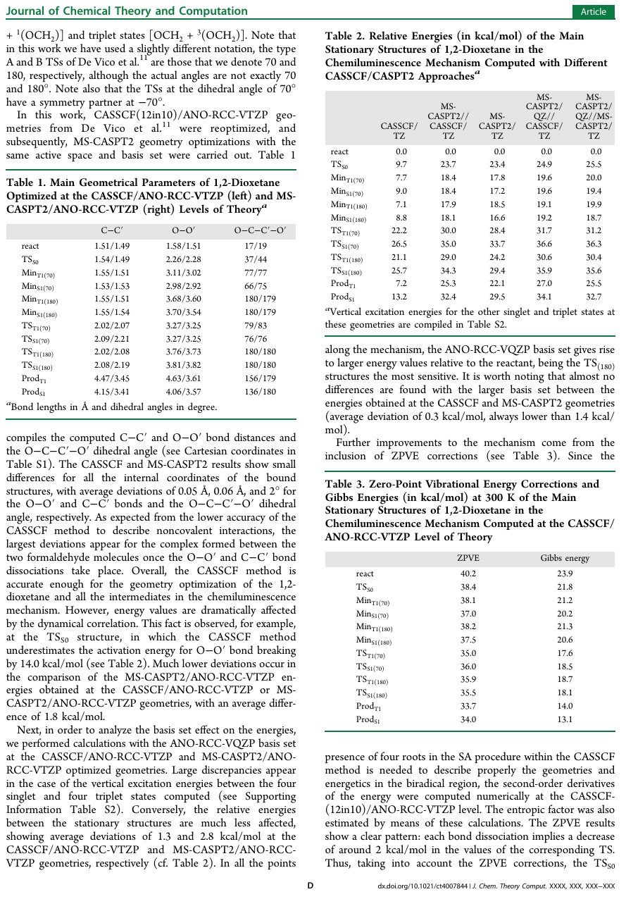

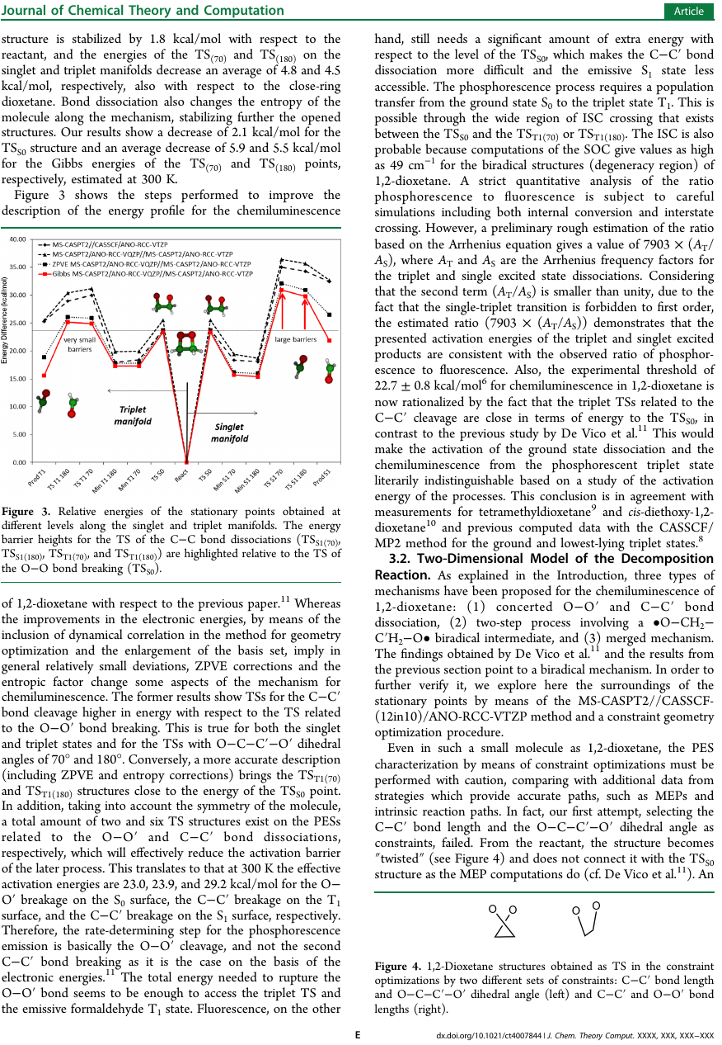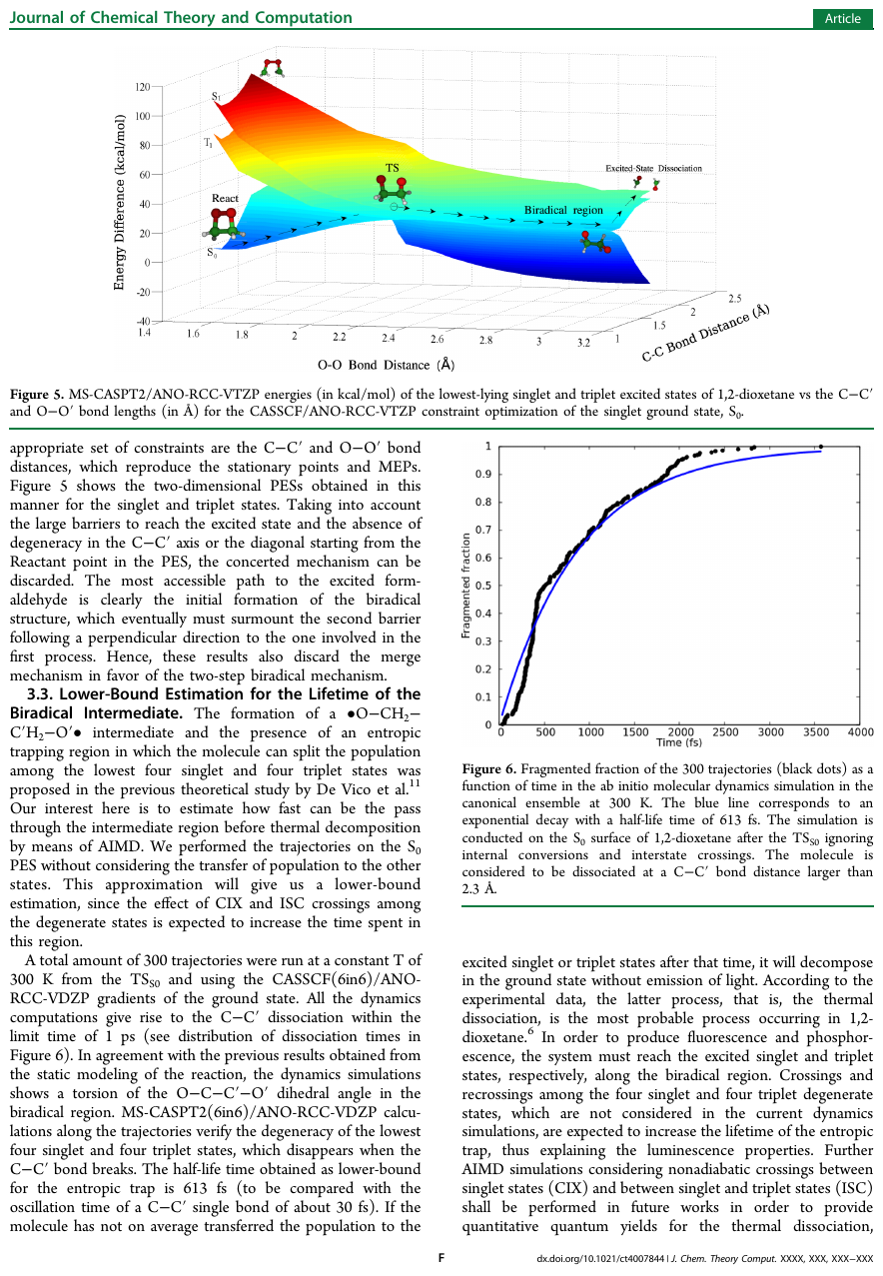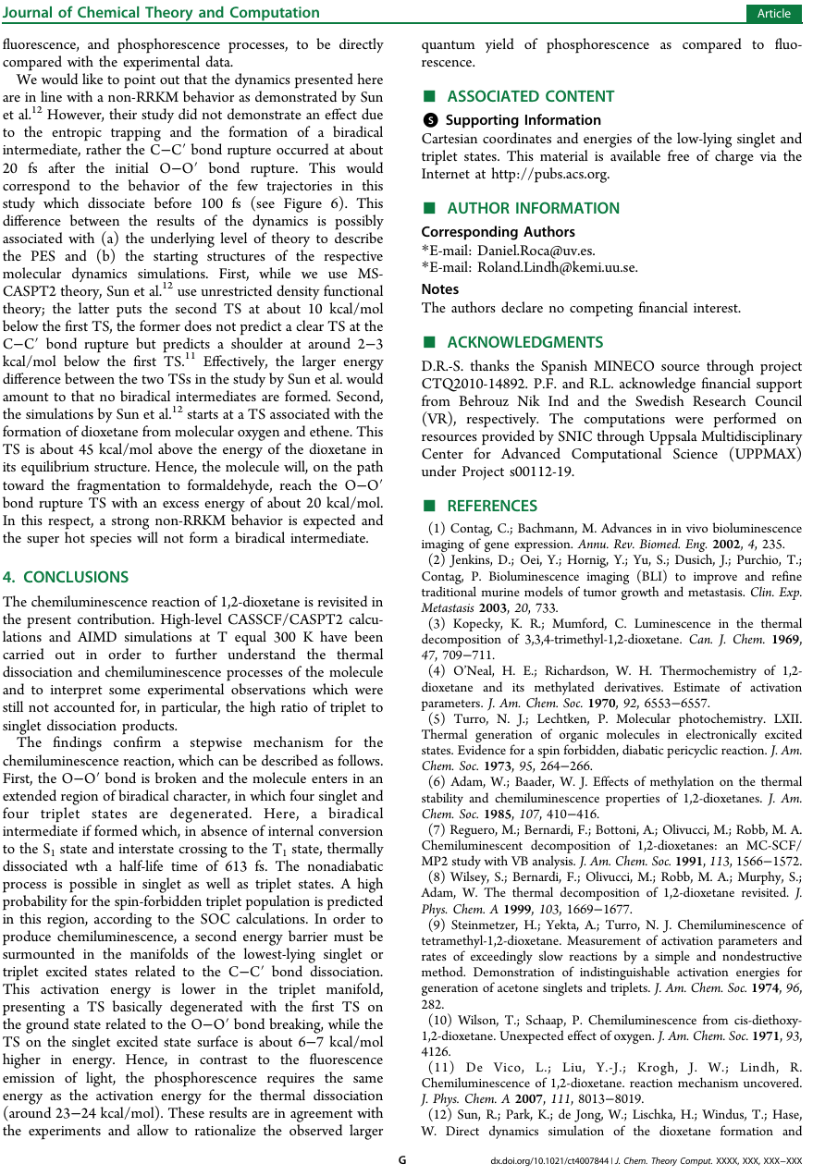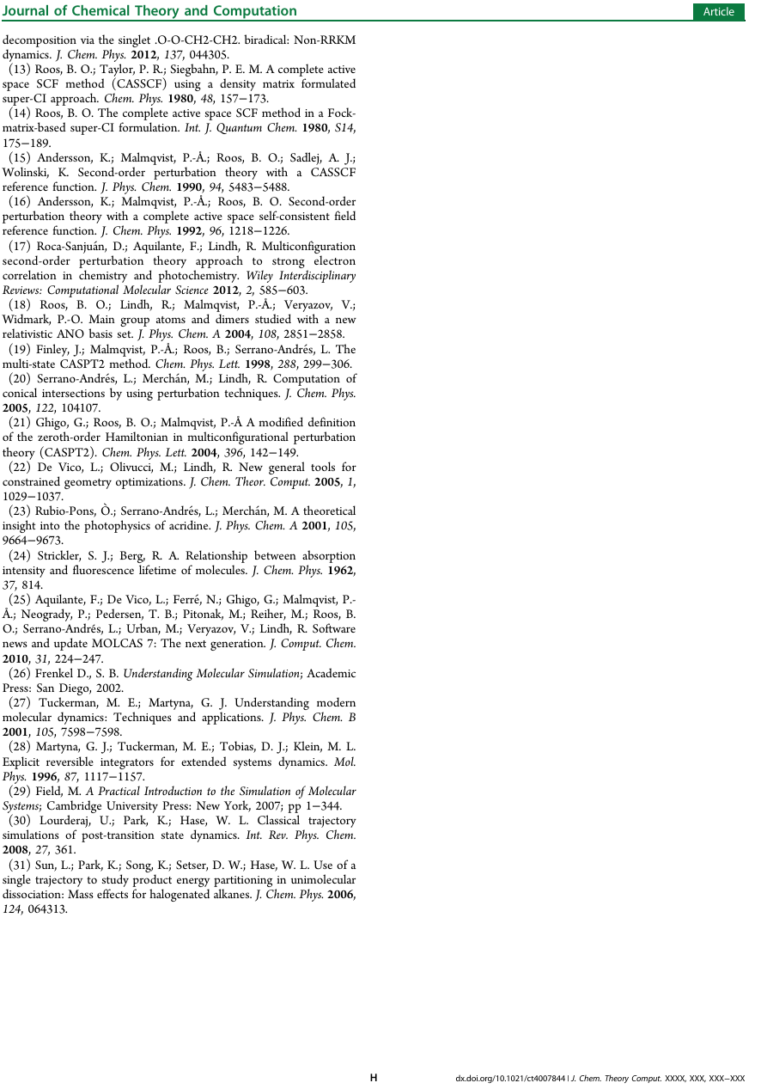

* + 1. **QM/MM Simulations of IrisFP**

In this thesis we focus on the IrisFP which presents both a reversible photoswitching between fluorescent and nonfluorescent states, and irreversible photoconversion (Adam, et al. 2008). In figure k, it is presented a scheme showing the possible states of the IrisFP chromophore and its comparison with the well-studied Dronpa fluorescent protein (Andresen, et al. 2007).

In order to establish the basis for a future study on the spectroscopical properties of the FP, it was initially considered the fluorescent emission of the irisFP as first step towards the development of a computational method to design FP variants with a defined absorption energy and as large as possible Stokes shift for emission.

Previous calculations have shown that the PES of the green fluorescent protein chromophore (green shaded structure in figure k), presents a ultra-fast deactivation due to the lack of some minimum on S1, being then presumed that the protein pocket stabilized the charged chromophore, in such a way that the chromophore is driven towards a minimum, where the fluorescent emission is carried out (Martin, et al. 2004).

In order to take into account the effect of the environment, the QM/MM methodology using the Molcas/tinker interface (Aquilante, et al. 2010), was applied to the whole protein. Our molecular dynamics package has a module to communicate with the Molcas/Tinker interface aiming to read the gradient calculated by such package, and introduce it in the thermostat integration routine, resulting in constant temperature molecular simulation.

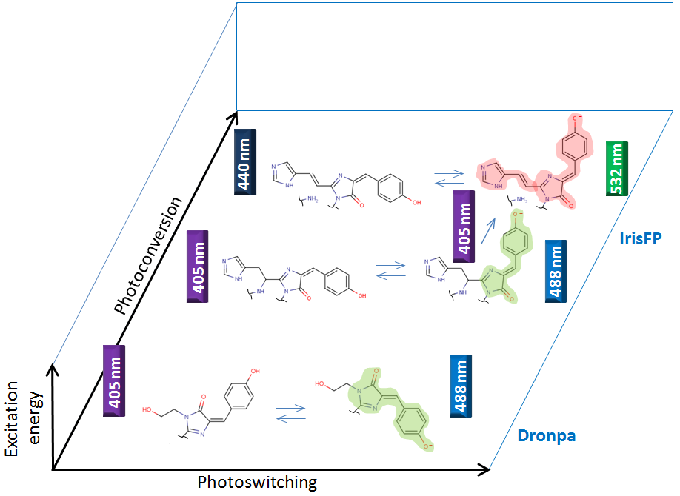

Figure 6. (Top) β-barrel overall structure of fluorescent proteins, with chromophore location and main dimensions (related to nano-technological applications) highlighted. (Bottom) Two examples of photoactivatable FPs: photoswitchable Dronpa, interconverting trans-dim and cis-green state, by irradiating with violet and blue light; photoswitchable and photoconvertible IrisFP, interconverting trans-dim and cis-green/red states, by multiple irradiation channels.

In Figure L it is shown

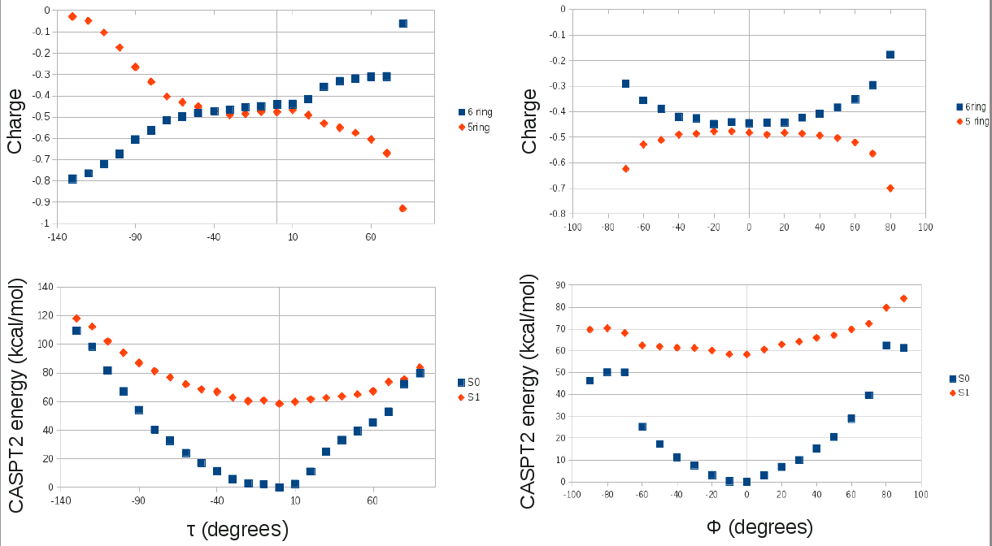

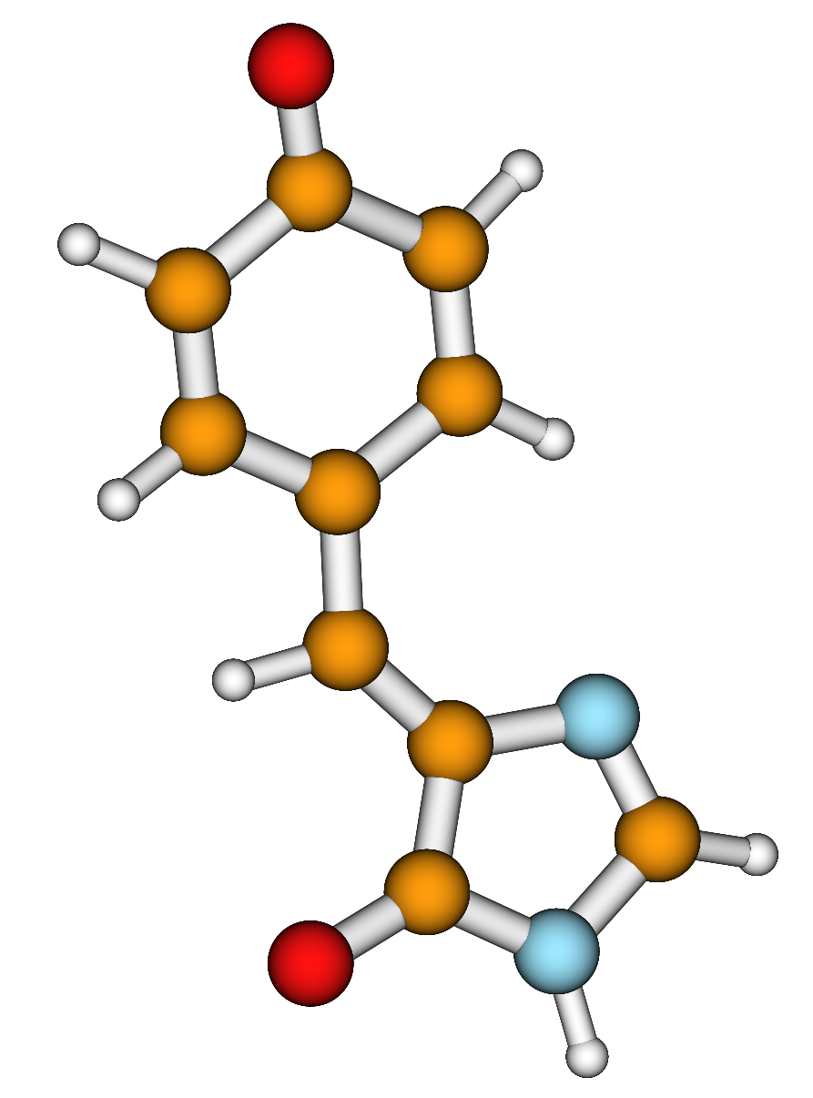

τ

ϕ

Figure L. (Top) scans

. (Bottom) schematic representation of the τ and ϕ dihedral angles in the IrisFP chromophore.

* + 1. **Excited State Intramolecular Proton Transfer**

Adam, V.; Lelimousin, M.; Boehme, S.; Desfonds, G.; Nienhaus, K.; Field, M. J.; Wiedenmann, J.; McSweeney, S.; Nienhaus, G. U.; Bourgeois, D., Structural characterization of IrisFP, an optical highlighter undergoing multiple photo-induced transformations. *Proceedings of the National Academy of Sciences* **2008,** *105*, 18343-18348.

Ando, R.; Mizuno, H.; Miyawaki, A., Regulated Fast Nucleocytoplasmic Shuttling Observed by Reversible Protein Highlighting. *Science* **2004,** *306*, 1370-1373.

Andresen, M.; Stiel, A. C.; Trowitzsch, S.; Weber, G.; Eggeling, C.; Wahl, M. C.; Hell, S. W.; Jakobs, S., Structural basis for reversible photoswitching in Dronpa. *Proceedings of the National Academy of Sciences* **2007,** *104*, 13005-13009.

Aquilante, F.; De Vico, L.; Ferré, N.; Ghigo, G.; Malmqvist, P.-å.; Neogrády, P.; Pedersen, T. B.; Pitoňák, M.; Reiher, M.; Roos, B. O.; Serrano-Andrés, L.; Urban, M.; Veryazov, V.; Lindh, R., MOLCAS 7: The Next Generation. *J. Comput. Chem.* **2010,** *31*, 224-247.

Betzig, E.; Patterson, G. H.; Sougrat, R.; Lindwasser, O. W.; Olenych, S.; Bonifacino, J. S.; Davidson, M. W.; Lippincott-Schwartz, J.; Hess, H. F., Imaging Intracellular Fluorescent Proteins at Nanometer Resolution. *Science* **2006,** *313*, 1642-1645.

Carpenter, B. K., Electronically nonadiabatic thermal reactions of organic molecules. *Chem. Soc. Rev.* **2006,** *35*, 736-747.

De Vico, L.; Liu, Y.-J.; Krogh, J. W.; Lindh, R., Chemiluminescence of 1,2-Dioxetane. Reaction Mechanism Uncovered. *The Journal of Physical Chemistry A* **2007,** *111*, 8013-8019.

Fraga, H., Firefly luminescence: A historical perspective and recent developments. *Photochemical & Photobiological Sciences* **2008,** *7*, 146-158.

Fuchs, J.; Bohme, S.; Oswald, F.; Hedde, P. N.; Krause, M.; Wiedenmann, J.; Nienhaus, G. U., A photoactivatable marker protein for pulse-chase imaging with superresolution. *Nat Meth* **2010,** *7*, 627-630.

Hess, S. T.; Girirajan, T. P. K.; Mason, M. D., Ultra-High Resolution Imaging by Fluorescence Photoactivation Localization Microscopy. *Biophys. J.* **2006,** *91*, 4258-4272.

Konstantin, A.; Lukyanov, D. M.; Chudakov, S. L.; Verkhusha, V. V., Photoactivatable fluorescent proteins. *Nature Reviews Molecular Cell Biology* **2005,** *6*, 885.

Kredel, S.; Nienhaus, K.; Oswald, F.; Wolff, M.; Ivanchenko, S.; Cymer, F.; Jeromin, A.; Michel, F. J.; Spindler, K.-D.; Heilker, R.; Nienhaus, G. U.; Wiedenmann, J., Optimized and Far-Red-Emitting Variants of Fluorescent Protein eqFP611. *Chemistry & biology* **2008,** *15*, 224-233.

Kredel, S.; Oswald, F.; Nienhaus, K.; Deuschle, K.; Röcker, C.; Wolff, M.; Heilker, R.; Nienhaus, G. U.; Wiedenmann, J., mRuby, a Bright Monomeric Red Fluorescent Protein for Labeling of Subcellular Structures. *PLoS ONE* **2009,** *4*, e4391.

Lippert, A. R.; Van de Bittner, G. C.; Chang, C. J., Boronate Oxidation as a Bioorthogonal Reaction Approach for Studying the Chemistry of Hydrogen Peroxide in Living Systems. *Acc. Chem. Res.* **2011,** *44*, 793-804.

Martin, M. E.; Negri, F.; Olivucci, M., Origin, Nature, and Fate of the Fluorescent State of the Green Fluorescent Protein Chromophore at the CASPT2//CASSCF Resolution. *J. Am. Chem. Soc.* **2004,** *126*, 5452-5464.

Matsumoto, M., Advanced chemistry of dioxetane-based chemiluminescent substrates originating from bioluminescence. *Journal of Photochemistry and Photobiology C: Photochemistry Reviews* **2004,** *5*, 27-53.

Merzlyak, E. M.; Goedhart, J.; Shcherbo, D.; Bulina, M. E.; Shcheglov, A. S.; Fradkov, A. F.; Gaintzeva, A.; Lukyanov, K. A.; Lukyanov, S.; Gadella, T. W. J.; Chudakov, D. M., Bright monomeric red fluorescent protein with an extended fluorescence lifetime. *Nat Meth* **2007,** *4*, 555-557.

Nienhaus, K.; Nar, H.; Heilker, R.; Wiedenmann, J. r.; Nienhaus, G. U., Trans−Cis Isomerization is Responsible for the Red-Shifted Fluorescence in Variants of the Red Fluorescent Protein eqFP611. *J. Am. Chem. Soc.* **2008,** *130*, 12578-12579.

Paley, M. A.; Prescher, J. A., Bioluminescence: a versatile technique for imaging cellular and molecular features. *MedChemComm* **2014**.

Patterson, G. H.; Lippincott-Schwartz, J., A Photoactivatable GFP for Selective Photolabeling of Proteins and Cells. *Science* **2002,** *297*, 1873-1877.

Razgulin, A.; Ma, N.; Rao, J., Strategies for in vivo imaging of enzyme activity: an overview and recent advances. *Chem. Soc. Rev.* **2011,** *40*, 4186-4216.

Sauer, M., Reversible molecular photoswitches: A key technology for nanoscience and fluorescence imaging. *Proceedings of the National Academy of Sciences of the United States of America* **2005,** *102*, 9433-9434.

Schäfer, L. V.; Groenhof, G.; Klingen, A. R.; Ullmann, G. M.; Boggio-Pasqua, M.; Robb, M. A.; Grubmüller, H., Photoswitching of the Fluorescent Protein asFP595: Mechanism, Proton Pathways, and Absorption Spectra. *Angew. Chem. Int. Ed.* **2007,** *46*, 530-536.

Shaner, N. C.; Campbell, R. E.; Steinbach, P. A.; Giepmans, B. N. G.; Palmer, A. E.; Tsien, R. Y., Improved monomeric red, orange and yellow fluorescent proteins derived from Discosoma sp. red fluorescent protein. *Nat Biotech* **2004,** *22*, 1567-1572.

Shaner, N. C.; Patterson, G. H.; Davidson, M. W., Advances in fluorescent protein technology. *J. Cell Sci.* **2007,** *120*, 4247-4260.

Subach, F. V.; Piatkevich, K. D.; Verkhusha, V. V., Directed molecular evolution to design advanced red fluorescent proteins. *Nat Meth* **2011,** *8*, 1019-1026.

Tsutsui, H.; Karasawa, S.; Shimizu, H.; Nukina, N.; Miyawaki, A., Semi-rational engineering of a coral fluorescent protein into an efficient highlighter. *EMBO Rep* **2005,** *6*, 233-238.

Wiedenmann, J.; Nienhaus, G. U., Live-cell imaging with EosFP and other photoactivatable marker proteins of the GFP family. *Expert Review of Proteomics* **2006,** *3*, 361-374.

Zimmer, M., GFP: from jellyfish to the Nobel prize and beyond. *Chem. Soc. Rev.* **2009,** *38*, 2823-2832.

# Summary and Conclusions

"Seven and a half million years our race has waited for this Great and Hopefully Enlightening Day!" cried the cheer leader. "The Day of the Answer!" Hurrahs burst from the ecstatic crowd. "Never again," cried the man, "never again will we wake up in the morning and think Who am I? What is my purpose in life? Does it really, cosmically speaking, matter if I don't get up and go to work? For today we will finally learn once and for all the plain and simple answer to all these nagging little problems of Life, the Universe and Everything!".

…There was a moment's expectant pause whilst panels slowly came to life on the front of the console. Lights flashed on and off experimentally and settled down into a businesslike pattern. A soft low hum came from the communication channel. "Good morning," said Deep Thought at last. "Er ... Good morning, O Deep Thought," said Loonquawl nervously, "do you have ... er, that is ..." "An answer for you?" interrupted Deep Thought majestically. "Yes. I have."... "There really is one?" breathed Phouchg. "There really is one," confirmed Deep Thought. "To Everything? To the great Question of Life, the Universe and Everything?" "Yes."

... "And you're ready to give it to us?" urged Loonquawl. "I am." "Now?" "Now," said Deep Thought. "Though I don't think," added Deep Thought, "that you're going to like it." "Doesn't matter!" said Phouchg. "We must know it! Now!" "Now?" inquired Deep Thought. "Yes! Now.

..." "Alright," said the computer and settled into silence again. "The Answer to the Great Question...""Yes ...!" "Of Life, the Universe and Everything ..." said Deep Thought. "Yes ...!" "Is ..." said Deep Thought, and paused. "Yes ...!" "Is ..." "Yes ...!!!...?"

"Forty-two," said Deep Thought, with infinite majesty and calm.

*The Hitchhiker’s Guide to the Galaxy,* Douglas Adams

In this thesis we have developed a series of theoretical and computational methodologies, which were subsequently applied to a set of chemical and biological relevant systems in the field of photochemistry. The phenomena considered in this thesis, can be described as follows:

* Dexter-type energy transfer mechanisms between a donor and an acceptor molecule have been studied with the aim of defining an energy transfer reaction coordinate. Special attention has been focused on nonvertical excitation processes studying, as example, triplet-triplet energy transfer (TET).
* Effect of external forces over the spectroscopical properties of molecular systems was studied. Understanding the force as an agent which can induce structural changes in the conformation of the molecule, being it a substituent or a direct applied mechanical force.
* Design of molecular devices using a bottom-up methodology, which operates in an autonomous fashion and in the case of molecular motor induces a unidirectional rotation, driven by hydrogen bonds.
* Chemiluminescence and bioluminescence phenomena were studied, using a minimal model of the 1,2-dioxetane family of composes, which are the intermediates responsible for the light emission after its decomposition.
* Fluorescent emission of the irisFP, was studied in order to identify the main structural factors which mainly influence the fluorescent emission at a given temperature.

The aforementioned phenomena were addressed using a set of developed methodologies which implies the use of standard *ab initio* methods as density functional theory (DFT), time dependent density functional theory (TD-DFT) and multiconfigurational methods (CASSCF, CASPT2).

Accordingly, it were developed the following methodologies:

* An algorithm to define an energy transfer reaction coordinate, which can assign a quantitative weight to the contribution of each internal coordinate to the global transfer process.
* A software for molecular dynamic simulation was developed, providing the following features: a Nosé-Hoover chain of thermostat to control the temperature, a fewest switches algorithm for non-adiabatic surfaces hopping, several interfaces to perform “on the fly” molecular dynamics using Gaussian or Molcas, an interface to perform molecular dynamics using analytical PESs and finally a QM/MM interface which is currently under development.
* A guideline to design molecular switches and motors, which operates in a cycle driven by photochemical excitations of the same wavelength.

# Resumen y Conclusiones (Spanish Version)

“José Arcadio Buendía pasó los largos meses de lluvia encerrado en un cuartito que construyó en el fondo de la casa para que nadie perturbara sus experimentos. Habiendo abandonado por completo las obligaciones domésticas, permaneció noches enteras en el patio vigilando el curso de los astros, y estuvo a punto de contraer una insolación por tratar de establecer un método exacto para encontrar el mediodía. Cuando se hizo experto en el uso y manejo de sus instrumentos, tuvo una noción del espacio que le permitió navegar por mares incógnitos, visitar territorios deshabitados y trabar relación con seres espléndidos, sin necesidad de abandonar su gabinete. Fue ésa la época en que adquirió el hábito de hablar a solas, paseándose por la casa sin hacer caso de nadie, mientras Úrsula y los niños se partían el espinazo en la huerta cuidando el plátano y la malanga, la yuca y el ñame, la ahuyama y la berenjena. De pronto, sin ningún anuncio, su actividad febril se interrumpió y fue sustituida por una especie de fascinación. Estuvo varios días como hechizado, repitiéndose a sí mismo en voz baja un sartal de asombrosas conjeturas, sin dar crédito a su propio entendimiento. Por fin, un martes de diciembre, a la hora del almuerzo, soltó de un golpe toda la carga de su tormento. Los niños habían de recordar por el resto de su vida la augusta solemnidad con que su padre se sentó a la cabecera de la mesa, temblando de fiebre, devastado por la prolongada vigilia y por el encono de su imaginación, y les reveló su descubrimiento.

-La tierra es redonda como una naranja”

*Cien años de Soledad,* Gabriel García Márquez

El proyecto realizado en esta Tesis consiste en el desarrollo y aplicación de metodologías teóricas y computaciones, usadas en la descripción estática y dinámica de procesos fotofísicos y fotoquímicos de compuestos químicos y de interés biológico. Estas metodologías computacionales fueron implementadas aplicando técnicas punteras usadas en el campo de la ciencia de la computación.

La presente Tesis se compone de 3 bloques principales. El primero de estos bloques se centra en el proceso de transferencia de energía intermolecular, especialmente transferencia de energía triplete. El segundo bloque consiste en el estudio del efecto de fuerzas externas sobre las propiedades espectroscópicas de los sistemas moleculares y en el diseño de dispositivos moleculares que usan cambios conformacionales foto-inducidos en la generación de trabajo. Finalmente, el último bloque consiste en conjunto de aplicaciones fotoquímicas utilizando herramientas desarrolladas para la simulación de dinámicas moleculares.

## Transferencia de Energía Triplete

Terenin y Ermolaev fueron los primeros en observar que una molécula que absorbe luz a cierta longitud de onda puede inducir emisión de fosforescencia en otra que se encuentra en la misma solución, pero que sin la presencia de la primera especie, este evento no se presentaría (Terenin and Ermolaev 1956). Este fenómeno es denominado transferencia de energía triplete (TET).

El mecanismo de la TET consiste en un intercambio electrónico entre las dos moléculas implicadas (förster 1965), suponiendo que existe una interacción electrostática entre el dador en estado excitado (D*) y el aceptor (A), esta interacción acopla la energía liberada por D* para excitar simultáneamente el aceptor, proceso que resulta en la formación de las especies D y A*, conservándose el momento de spin total. Este proceso ocurre con una velocidad que puede ser medida experimentalmente. Además, Para que la TET ocurra, es necesario que las moléculas estén a una distancia cercana para que ocurra el intercambio electrónico. Esta distancia en general es menor de un nanómetro.

Como ha sido señalado en un estudio teórico (Frutos, Castaño et al. 2004), para una distancia dador-aceptor determinada, la diferencia de energía entre los estados triplete del dador y aceptor (suponiendo un acoplamiento débil) esta modulada por activación térmica de determinadas coordenadas moleculares de los reactivos, lo que permite que ambas energías sean iguales, permitiendo el proceso de transferencia de energía. Si se considera una energía constante para el dador (lo cual ocurre con un dador rígido por ejemplo), es posible determinar las coordenadas que regulan o modulan la activación térmica para un determinado aceptor (dador).

En la presenta tesis se ha desarrollado un algoritmo que permite identificar las principales coordenadas en el proceso de TET, además establece un formalismo para asignar valores numéricos a la aportación de cada coordenada interna del sistema, a la coordenada de reacción del sistema. Además, este desarrollo demuestra la posibilidad de separar las contribuciones del dador tanto como el aceptor, a la coordenada de reacción, cuantificando efectivamente el aporte de cada molécula en el proceso de TET (Zapata, et al. 2014).

El mentado formalismo fue aplicado al paradigmático caso del cis-estilbeno, que fue la primera molécula en la que se estudió el proceso de TET no vertical. El termino de transferencia no vertical surge de la hipótesis usada para explicar el hecho que la velocidad de transferencia de energía para varios dadores son significativamente más altas en comparación con las cinéticas predichas por Sandros (Saltiel, et al. 1984, sandros 1964) .

El mentado algoritmo permitió la identificación de las principales coordenadas involucradas en el proceso de transferencia de energía del cis-estilbeno. Donde se ha encontrado que el enlace central C1=C2, es quien en mayor medida regula la diferencia de energía singlete-triplete, en la zona de déficits energético (Energía Aceptor > Energía dador). Esta observación está en desacuerdo con hipótesis previas acerca de la naturaleza del comportamiento no vertical (Brennan, et al. 1994, Catalán and Saltiel 2001).

Por otra parte, tanto el enlace C1-C3 como C2-C4 producen un efecto significativamente menos importante, en cambiar la diferencia de Energía singlete-triplete. Resulta importante anotar que la torsión associada al enlace central C3C1=C2C4, juega un papel poco importante cuando la energía disponible para la transferencia está cerca al punto de resonancia (~ 67 kcal/mol) y su importancia aumenta a medida que disminuye la energía del dador. Por el contrario, las contribuciones de las dos torsiones asociadas a los enlaces fenil-vinil C5C3-C1C2 y C1C2-C4C6, son importantes en la región de energía cercana a la resoncia y su importancia disminuye a medida que disminuye la energía aportada por el dador.

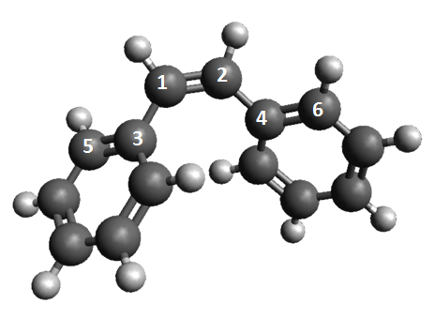

Figura m. Representación esquemática del cis-estibelno y numeración de los principales átomos involucrados en modular la diferencia de energía singlete-triplete.

Tras desarrollar el mentado formalismo y corroborar su fiabilidad, es necesario ampliar el enfoque del problema de transferencia de energía puesto que la orientación dada hasta el momento corresponde a un análisis estático, sin embargo los procesos de transferencia de energía ocurren en fase condensada a una determinada temperatura. Es preciso entonces introducir los efectos dinámicos e investigar sus implicaciones en el proceso de transferencia de energía, y posteriormente su comparación con respecto a los análisis estático.

Para llevar a cabo un estudio dinámico fue desarrollada e implementada una metodología de simulación de dinámicas moleculares. La metodología se basa en la aproximación de Born-Oppenheimer, la cual supone que los núcleos atómicos se mueven en el campo electrostático medio causado por los electrones, desacoplando formalmente el moviente de núcleos y electrones. Además de ello esta metodología conlleva a una representación clásica de los átomos cuya dinámica está gobernada por las leyes de Newton. De tal forma que el potencial necesario para integrar las ecuaciones de Newton, debe dar cuenta de las interacciones entre los átomos que conforman el sistema molecular.

Para obtener el potencial necesario para integrar las ecuaciones clásicas de movimiento, se ha utilizado una aproximación cuadrática de segundo orden alrededor del punto Franck-Condon (utilizando el gradiente y Hessiano). Esta extrapolación como fue demostrado, describe de forma realista el potencial en los entornos del punto de equilibrio, al mismo tiempo que permite un cálculo sencillo y rápido del gradiente molecular. Además de ello fue utilizado el algoritmo simplectico Velociy-Verlet para integrar las ecuaciones de movimiento. Donde simplectico se refiere a la propiedad de conservar el espacio de fases accesible a una determinada energía, sin perder o ganar energía por cuenta de errores numéricos acumulativos (Frenkel and smit 2002).

Por otra parte, el proceso de transferencia de energía en solución se lleva a cabo a una temperatura determinada, de manera que el dador y aceptor estas en equilibrio térmico con el solvente. Por tanto para simular efectivamente estas condiciones es necesario introducir un termostato que intercambie constantemente energía con el sistema molecular. Para ello fueron implementadas las ecuaciones de la cadena de termostatos de Nosé-Hoover (Martyna, et al. 1992). Estos termostatos intercambian energía con el sistema molecular, de tal forma que las estadísticas resultantes de estas simulaciones pertenecen a las descritas por un ensamble canónico NVT, que describen correctamente el comportamiento de los sistemas moleculares a temperatura constante.

Esta metodología de dinámicas moleculares fue aplicada al estudio de uno de los pasos claves de la terapia fotodinámica, la transferencia de energía. En esta terapia usa algún tipo de sensibilizador, generalmente un derivado de la porfirina que tiene un tiempo de vida media grande, para transferir la energía de excitación al oxígeno en estado fundamental triplete. El resultado de la transferencia es la formación de oxígeno singlete quien es el agente citotóxico responsable de la muerte celular (DeRosa and Crutchley 2002, Ethirajan, et al. 2011).

## Control Opto-Mecánico de Propiedades Espectroscópicas y Generación de Trabajo foto-Inducido

### Control opto-mecánico

El desarrollo de materiales a escala nanoscópica es uno de los retos actuales más abordados. De especial importancia son los materiales foto activos cuya configuración cambia al ser expuesto a radiación electromagnética, convirtiendo la luz en movimiento microscópico. Dentro de estos materiales se encuentran los interruptores fotosensibles, que están compuestos de cromóforos con dos estados estables, que pueden ser interconvertidos entre sí al absorber luz. Dado que el azobenceno presenta dos isómeros, cis y trans que pueden ser interconvertido entre sí a través de radiación electromagnética de diferentes longitudes de onda, resulta en el candidato ideal para el desarrollo de dispositivos moleculares fotoactivos.

En la presente tesis se ha presentado un estudio teórico del efecto de fuerzas externas sobre las propiedades espectroscópicas con el objetivo de modular la absorción en función de la fuerza externa aplicada (Zapata, et al. 2013). Inicialmente un estudio estático de la topología del azobenceno en estado fundamental fue llevado a cabo, pudiéndose determinar los valores extremos de fuerza a los que puede ser sometida sin que ocurre una disrupción irreversible en el sistema. Seguidamente una optimización a fuerzas externas constantes fue llevada a cabo; este procedimiento permitió identificar las geometrías moleculares más estables bajo una fuerza externa. Estas fuerzas son aplicadas como pares en las posiciones para de los anillos aromáticos.

Subsecuente se llevaron a cabo dinámicas moleculares a fuerza externa constante, utilizando una aproximación cuadrática para calcular el gradiente como ha sido descrito en la sección anterior. Dado que la representación cuadrática permite calcular el potencial de forma rápida, fue posible calcular en cada paso de integración, la energía para el estado fundamental y los dos estados excitados más bajos en energía S1 y S2, respectivamente. Con estos datos fue posible simular el espectro de absorción, construido como un histograma resultante de contar el número de energías de excitación (S0→S1 y S0→S2) que ocurren en un intervalo determinado durante las dinámicas. Al multiplicar cada entrada de este histograma por la fuerza del oscilador es posible obtener un espectro. Es importante notar que, un estudio estadístico (i.e. un muestreo aleatorio de geometrías tomadas de las dinámicas) fue llevado a cabo para identificar si existía una relación entra la energía de excitación para cada estado y la fuerza del oscilador, en el caso de existir tal relación fue ajustada una función para describir tal relación; mientras en el caso de no existir alguna relación, la fuerza del oscilador utilizada corresponde a la media aritmética de los valores muestreados.

Los estudios dinámicos mostraron que no existe una modulación aparente cuando se aplican fuerzas de compresión para ambos isómeros. Sin embargo en el caso de fuerzas de extensión se ha encontrado que en el trans-azobenceno las fuerzas externas producen un desplazamiento batocrómico para la transición S0→S1, por el contrario para la transición S0→S2 la aplicación de fuerza externa resulta en un desplazamiento hipsocrómico. Mientras que para el cis-azobenceno isómero, las fuerzas externas producen un desplazamiento batocrómico para ambas transiciones. Seguidamente fueron identificadas las coordenadas internas mayormente responsables en la modulación de la diferencia de energía para ambas transiciones, haciendo uso de las constantes de fuerza (i.e. Hessianos) obtenidas de las geometrías optimizadas a fuerza constate.

En este estudio también fueron estudiado posibles alternativas a la aplicación de fuerzas en posiciones diferente a posiciones para, encontrándose que las fuerzas aplicadas en posición meta podrían modular más eficientemente la diferencia de energía entre S0→S1 y S0→S2.

Finalmente, basado en los resultados previos es propuesto un polímero lineal que actúa como un interruptor fotosensible. Basados en los dos posibles modos de operación del polímero y en el grado de polimerización del mismo son propuestos valores teóricos para la cantidad de trabajo producido por unidad de tiempo.

### Interruptores y motores moleculares

Los motores moleculares fotoactivos son dispositivos que tras la excitación a un estado electrónico excitado llevan a cabo un movimiento rotacional unidireccional, generalmente basado en una isomerización cis-trans de un doble enlace presente en la molécula (Garcia-Iriepa, et al. 2013). Este carácter unidireccional del movimiento rotatorio hace únicos a este tipo de dispositivos para distintas aplicaciones como el plegamiento de una macromolécula (Pijper and Feringa 2007), la generación de movimiento microscópico(Balzani, et al. 2009), etc.

Los motores moleculares propuestos hasta el momento (Feringa 2007), operan en ciclos de cuatros etapas dos fotoquímicas (utilizando radiación electromagnética de dos diferentes frecuencias) y dos térmicas, siendo las etapas térmicas la limitación en la velocidad de rotación del motor. Además estos motores moleculares emplean estructurales helicoidales para asegurar la rotación unidireccional.

Una alternativa para mejorar el rendimiento de los motores moleculares ha sido propuesta por García-Iriepa y colaboradores (García-Iriepa, et al. 2013), en el cual se plantea una nueva estrategia para el diseño de motores moleculares con una alta velocidad de rotación, dado que dichos motores operan a través de solo dos etapas fotoquímicas (sin ninguna etapa térmica), las cuales son iniciadas con radiación electromagnética de la misma longitud de onda.

Estos nuevos motores moleculares deben presentar las siguientes características: a) su naturaleza electrónica deber ser tal que contenga un estado electrónico permitido que involucre la excitación de un enlace C=C; b) presencia de un enlace de hidrógeno quiral que sea lo suficientemente fuerte para producir la rotación unidireccional pero suficientemente débil para permitir la rotación en el estado excitado; c) la ausencia de mínimos de energía accesibles a la temperatura de reacción que permitan la formación de intermedios. En la Figura n, se presenta un esquema de un posible motor molecular que cumple las mentadas condiciones.

Con el objetivo de corroborar la naturaleza unidireccional del motor molecular propuesto, fueron llevadas a cabo simulaciones de dinámicas moleculares no adiabáticas a cero Kelvin. Estas simulaciones utilizan trayectorias clásicas para describir las regiones del espacio de fase donde el acoplamiento entre diferentes estados electrónicos es despreciable, mientras que el algoritmo de Tully (Tully 1990) es usado en las regiones donde el acoplamiento entre dos estados electrónicos es significativo. Este algoritmo fue implementado por Valentini y Frutos (Valentini and Frutos 2012).

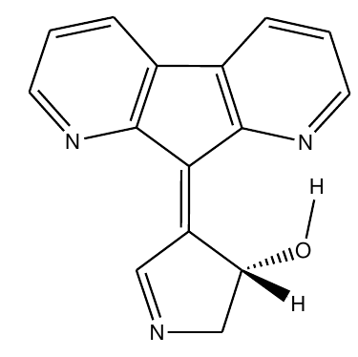

Figure n. Posible motor molecular fotoactivo cuya rotación esta inducida por un enlace de hidrógeno que genera un entorno quiral.

## Dinámica de Procesos Fotoinducidos

Durante el transcurso de esta tesis doctoral fue desarrollado un software para realizar simulaciones de dinámicas moleculares, bajo diferentes condiciones como: energía constante, temperatura constante y aplicación de fuerzas externas. Además de ello fue implementado un algoritmo para dar cuenta de del comportamiento no adiabático dentro de las dinámicas moleculares, como ha sido descrito en la sección previa.

Este conjunto de herramientas fue utilizado en el estudio dinámico de varios procesos fotoquímicos en sistemas modelo de interés biológico. A continuación se describe brevemente los resultados obtenidos.

### Quimioluminiscencia y bioluminiscencia

El fenómeno de la quimioluminiscencia se refiere a la emisión de luz como resultado de la desactivación fluorescente de molécula en estado excitado, la cual es producto resultante de una reacción química. Cuando este fenómeno se presenta en los seres vivos es llamado bioluminiscencia.

Para el proceso de bioluminiscencia ha sido encontrado que existe una familia de intermedios de reacción cíclicos, 1,2-dioxoetanos, que han sido señalados como los responsable de producir el fragmento en estado excitado responsable de la fotoemisión (Fraga 2008). Sin embargo, no existe aún un conceso sobre el mecanismo de formación del mismo. Además de ello, algunos hechos como la relación fosforescencia/fluorescencia en la quimioluminiscencia todavía no ha sido explicada satisfactoriamente.

Uno de los aspectos más interesantes en la descomposición del 1,2-dioxentane, es la aparición de una región dentro del espacio de fases denominada trampa entrópica (De Vico, et al. 2007). Este término se refiere a la situación donde los primeros cuatro estados singletes más bajos en energía e igualmente los primero cuatro estados tripletes están degenerados en energía, en la región entorno al estado de transición que conlleva al rompimiento del enlace O-O.

Basados en la discusión anterior, en la presente tesis se he presentado un conjunto de cálculos usando el nivel de teoría de múltiples configuraciones y estados con correcciones perturbativas de segundo orden (MS-CASPT2), con el objetivo de proveer resultados claves que soporten en mecanismo biradicalario y su evolución en la trampa entrópica.

Además, dinámicas moleculares calculando el potencial “al vuelo” y usando el nivel de teoría CASSCF/ANO-RCC-VDZP, fueron llevadas a cabo para calcular el tiempo de vida medio de la molécula en la trampa entrópica en el estado fundamental. Además de ello, dado que el proceso de fosforescencia requiere una transferencia de población del estado fundamental al estado triplete, es necesario muestrear el espacio de fases en el estado fundamental con el objetivo de tener geometrías de referencia para futuros estudio de cruces entre sistemas.

### Estudios QM/MM de la irisFP

Las proteínas fluorescentes fotoactivas

Balzani, V.; Credi, A.; Venturi, M., Light powered molecular machines. *Chem. Soc. Rev.* **2009,** *38*, 1542-1550.

Brennan, C. M.; Caldwell, R. A.; Elbert, J. E.; Unett, D. J., Nonvertical Triplet Excitation Transfer to Arylalkene Acceptors: Further Evidence That Double Bond Torsion Is Unimportant. *J. Am. Chem. Soc.* **1994,** *116*, 3460-3464.

Catalán, J.; Saltiel, J., On the Origin of Nonvertical Triplet Excitation Transfer:  The Relative Role of Double-Bond and Phenyl-Vinyl Torsions in the Stilbenes. *The Journal of Physical Chemistry A* **2001,** *105*, 6273-6276.

De Vico, L.; Liu, Y.-J.; Krogh, J. W.; Lindh, R., Chemiluminescence of 1,2-Dioxetane. Reaction Mechanism Uncovered. *The Journal of Physical Chemistry A* **2007,** *111*, 8013-8019.

DeRosa, M. C.; Crutchley, R. J., Photosensitized singlet oxygen and its applications. *Coord. Chem. Rev.* **2002,** *233-234*, 351-371.

Ethirajan, M.; Chen, Y.; Joshi, P.; Pandey, R. K., The role of porphyrin chemistry in tumor imaging and photodynamic therapy. *Chem. Soc. Rev.* **2011,** *40*, 340-362.

Feringa, B. L., The Art of Building Small:  From Molecular Switches to Molecular Motors. *The Journal of Organic Chemistry* **2007,** *72*, 6635-6652.

förster, T., Delocalized excitation and excitation transfer. In *Modern Quantum Chemistry*, Sinanoglu, O., Ed. Academic Press: New York, 1965; pp 93-137.

Fraga, H., Firefly luminescence: A historical perspective and recent developments. *Photochemical & Photobiological Sciences* **2008,** *7*, 146-158.

Frenkel, D.; smit, B., *Understanding Molecular Simulation*. second ed.; Academic Press: San Diego, 2002; Vol. 1.

Garcia-Iriepa, C.; Marazzi, M.; Frutos, L. M.; Sampedro, D., E/Z Photochemical switches: syntheses, properties and applications. *RSC Advances* **2013,** *3*, 6241-6266.

García-Iriepa, C.; Marazzi, M.; Zapata, F.; Valentini, A.; Sampedro, D.; Frutos, L. M., Chiral Hydrogen Bond Environment Providing Unidirectional Rotation in Photoactive Molecular Motors. *Journal of Physical Chemistry Letters* **2013,** *4*, 1389-1396.

Martyna, G. J.; Klein, M. L.; Tuckerman, M., Nosé-Hoover chains: The canonical ensemble via continuous dynamics. *The Journal of Chemical Physics* **1992,** *97*, 2635-2643.

Pijper, D.; Feringa, B. L., Molecular Transmission: Controlling the Twist Sense of a Helical Polymer with a Single Light-Driven Molecular Motor. *Angew. Chem. Int. Ed.* **2007,** *46*, 3693-3696.

Saltiel, J.; Marchand, G. R.; Kirkor-Kaminska, E.; Smothers, W. K.; Mueller, W. B.; Charlton, J. L., Nonvertical triplet excitation transfer to cis- and trans-stilbene. *J. Am. Chem. Soc.* **1984,** *106*, 3144-3151.

sandros, K., Transfer of Triplet State Energy in Fluid Solutions. III. Reversible Energy Transfer. *Acta Chem. Scand.* **1964,** *18*, 2355.

Terenin, A.; Ermolaev, V., Sensitized phosphorescence in organic solutions at low temperature. Energy transfer between triplet states. *Transactions of the Faraday Society* **1956,** *52*, 1042-1052.

Tully, J. C., Molecular dynamics with electronic transitions. *The Journal of Chemical Physics* **1990,** *93*, 1061-1071.

Valentini, A.; Frutos, L. M., Tully’s fewest switches algorithm with decoherence correction for the surface hop implemented in Molcas 7.6. 2012.

Zapata, F.; Fernández-González, M. Á.; Rivero, D.; Álvarez, Á.; Marazzi, M.; Frutos, L. M., Toward an Optomechanical Control of Photoswitches by Tuning Their Spectroscopical Properties: Structural and Dynamical Insights into Azobenzene. *Journal of Chemical Theory and Computation* **2013,** *10*, 312-323.

Zapata, F.; Marazzi, M.; Castaño, O.; Acuña, A. U.; Frutos, L. M., Definition and determination of the triplet-triplet energy transfer reaction coordinate. *The Journal of Chemical Physics* **2014,** *140*, -.

# Appendices

## A General Molecular dynamics interface program: HsDynamics

During this Ph.D. Thesis it was gradually developed a set of tools to carry out molecular dynamics and also some utilities to manage several important tasks as are: file parsing, calling of external electronic structure packages (Molcas, Gaussian, etc.), Input/Output processes and miscellaneous functions. Therefore it was developed a package called Hsdynamics to integrate the developed applications, taking advantage of the Haskell programming language and its libraries. The program can be run sequentially or using several CPUs to distribute the computations.

The code is under constant development and under a version control system, therefore it was not appended in the thesis, instead the latest version can be downloaded from here: https://github.com/felipeZ/Dynamics

The package structure is described in Figure 1, it provides a main module which initializes all the parameters required in the molecular dynamics and checks the input provided by the user. Once the molecule initial state has been successfully loaded, the control of the program is past to a loop in charge of performing the simulation. In another thread it is initialized a server logger which task is to receive messages from the main execution thread an do something with the message, for example write it in a file, print it in the standard output, send it to another machine with more memory, etc.

Subsequently the loop in charge of the simulation, calls the Dynamic module which executes the numerical integrations. The Dynamics module was built having performance as the main goal. Therefore it uses a library called REPA (REgular PArallel arrays), this library use a technique called parallel array fusion to calculate the numerical values of the arrays. The idea in the Dynamics module is to distribute the numerical integration in the available computing resources.

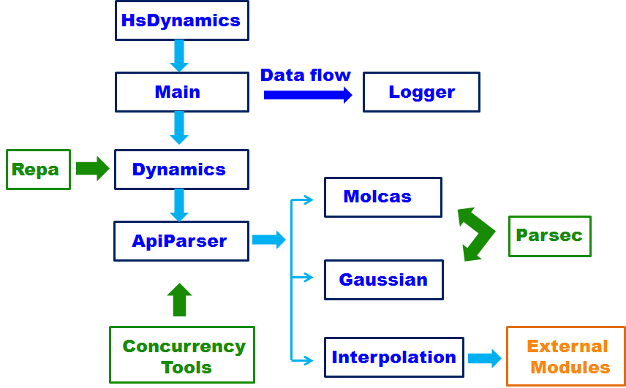

Figure 1. A diagram representing the structural organization of the HsDynamics software.

In order to compute the forces required by the integration of Newton’s equation, an external electronic structure package is called to calculate the gradient “on the fly” or in the case of an interpolation some other modules should be called. The Dynamics module ApiParser presents an API (application programming interface) to the Dynamics client code in such a way that once it is specified which kind of calculation is intended (“on the fly” or interpolation) the Dynamics module asks for a force vector without noticing how is calculating, effectively isolating the numerical computation from the external packages.

On the other hand, the ApiParser module makes intensive use of the concurrency set of utilities offered by Haskell, mainly Async. The purposes of the ApiParser module is to call external packages, to write their input then to parse the corresponding output file and to read all the necessary parameters: gradients, energies and wave functions. The module also handles errors and closes the process smoothly if there is any problem.

Once the ApiParser module calls the external packages the resulting output must be read, even though this is quite a naïve method of communication between different software it enables fast development. It is important to notice that one of the deficiencies on computational chemistry is the lack of parsing tools, meaning a lack of a modular set of utilities which allow the structural analysys of output files, supporting an easy way to lookup for important information. The vast majority of approaches in quantum chemistry are loops that searches for some keywords in a structureless stream of strings, which is a source of errors and very difficult to compose.

Our set of parsing modules offers a flexible collection of functions, which can be arranged in more complex functions to form general parsing tools. In this sense, the modules Molcas and Gaussian, contains the utilities necessaries to recognize output structures of both computational packages and to record in a structure the most relevant information. Both of these modules were designed using the Parsec libraries of Haskell, which is a collection of several functions to create parsers.

## List of Publications

1. M. A. Fernández-González, M. Marazzi, A. López-Delgado, F. Zapata, C. García-Iriepa , D. Rivero, O. Castaño, M. Temprado and L. M. Frutos. “*Structural Substituent Effect in the Excitation Energy of a Chromophore: Quantitative Determination and Application to S-Nitrosothiols”*. The Journal of Chemical Theory and Computation **2012**, 8, 3293‒3302.
2. C. García-Iriepa, M. Marazzi, F. Zapata, A. Valentini, D. Sampedro and L. M. Frutos. “*Chiral Hydrogen Bond Environment Providing Unidirectional Rotation in Photoactive Molecular Motors”*. Journal of Physical Chemistry Letters **2013**, 4, 1389-1396.
3. P. Farahani, D. Roca-Sanjuán, F. Zapata and Roland Lindh. “*Revisiting the Nonadiabatic Process in 1,2-Dioxetane”.* The Journal of Chemical Theory and Computation **2013**, 9, 5404–5411.
4. F. Zapata, M. Marazzi, O. Castaño, U. Acuña and L. M. Frutos. “*Definition and Determination of the Triplet-Triplet Energy Transfer Reaction Coordinate”*. The Journal of Chemical Physics **2014**, 140, 034102.
5. F. Zapata, M. A. Fernández-Gonzáles, D. Rivero, A. Álvarez, M. Marazzi and L. M. Frutos. “*Towards an Optomechanical Control of Photoswitches by Tuning their Spectroscopical Properties: Structural and Dynamical Insights into Azobenzene”*. The Journal of Chemical Theory and Computation **2014**, 10, 312–323.
6. García-Iriepa, C.; Marazzi, M.; Zapata, F.; Valentini A.; Sampedro, D.; Frutos, L. M. "*Molecular Design Concepts: Towards Highly Efficient Photoactive Molecular Motors*".
7. Zapata, F., Frutos, L. M. “*Triplet Energy Transfer Reaction Coordinate Determined from Molecular Dynamics Simulations*”

**List of Abbreviations**

**CASSCF**  Complete Active-Space Self-Consistent Field Method

**CASPT2** Multiconfigurational Second-Order Perturbation Method

**CI** Conical Intersection

**ESIPT** Excited State Intramolecular Proton Transfer

**FPs** Photoactive Fluorescent Proteins

**GHC** Glasgow Haskell Compiler

**HF** Hartree-Fock

**I/O** Input/Output

**MCSCF** Multiconfigurational Self-Consistent Field

**NAMD** Non-Adiabatic Molecular Dynamics

**PES** Potential Energy Surface

**TD-DFT** Time-Depended Density Functional Theory

**TET** Triplet Energy Transfer

**TET-RC** Triplet Energy Transfer – Reaction Coordinate